**RESPIRATORY POLICY**

**Dust Mask Usage**

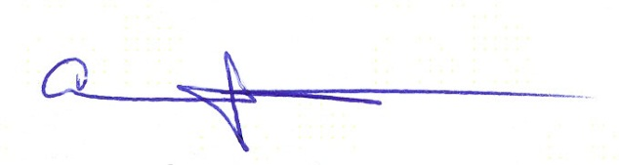

Approved:

Ahmed Boomrod, President / CEO

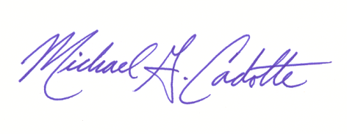Approved:

Michael G. Cadotte, VP Safety & Quality

**Change Record**

|  |  |  |  |
| --- | --- | --- | --- |
| Rev.: | Date: | Responsible Person: | Description of Change: |
| 0 | 03/04/14 | M. Cadotte/VP Safety | Initial Release |
| 1 | 01/04/16 | M. Cadotte | Addition of information on general respirators |
| 2 | 02/01/2019 | Safety | Audit |
|  |  |  |  |
|  |  |  |  |
|  |  |  |  |
|  |  |  |  |

1. **Purpose**

To establish a written policy in compliance with OSHA 1910.134 Appendix D on the use and limits of dust masks at the work site.

1. **Scope**

The following policy is established for ALL GDI Omni employees as a corporate safety policy and applicable to all GDI Omni work sites.

1. **Responsibility**
   1. VP of Safety

Has overall authority and responsibility for implementing and monitoring safety & environmental programs at GDI Services and is to be considered the program administrator for overall respirator policy.

* 1. Account Executives and GDI Omni Managers

Are responsible for monitoring all environmental programs and systems at their facility (ies) including researching new programs and systems to further enhance overall safety at the company and/or job site.

* 1. Employees

Each and every employee at GDI Omni has a primary responsibility to comply with all safety & policies, guidelines and laws. Furthermore, every employee must report any unsafe conditions, follow all policies, procedures and SSOPs in place to ensure their actions are in full compliance with GDI Omni’s safety programs.

1. **Procedure**
   1. Dust masks may be used on a voluntary bases for nuisance particles only. Environments beyond this scope are not authorized dust mask usage points. Such environments are to be considered prohibited for employees to enter and/or work unless trained, authorized and released to do so following GDI Omni’s respiratory work policy and procedures (NOT dust mask procedure or policy). G
   2. GDI Omni’s respiratory protection program allows the use of Dust Masks as good practice on a voluntary basis. GDI Omni employees have the option to use Dust Masks whenever they feel a situation or task may be dusty or wish to avoid conditions such as pollen exposure (such as lawn care associates or HVAC filter changes).None of these exposures would normally exceed recommended exposure limits but the use of a dust mask may be considered good practice to avoid unwanted particulate exposures or employee discomfort.

GDI shall provide (at no cost) respirators to trained and authorized employees when exposed to harmful vapors and oxygen deficient atmospheres.

* 1. Authorization to Use
     1. NOTIFICATION: Job sites where voluntary use of dust masks exist shall notify employees about the general safety issue in wearing such masks and to ensure that the employees notify their supervisor if they believe the exposure may be hazardous.
     2. TRAINING: Job sites where dust masks are provided for voluntary use shall provide the following training to all employees at the job site and reviewed annually:

1. Review of policy SP-15 Respiratory Policy – Dust Masks
2. Training PPT F300-0077
3. Completion of Acknowledgment form F300-0077.1
4. Completion of training validation quiz F300-0077.2
5. Employee Training Sign-off F300-0025
   1. Usage
      1. Read and heed all instructions provided by the manufacturer on use, maintenance, cleaning and care, and warnings regarding the dust mask limitations.
      2. All dust masks and respirators shall be certified by NIOSH (check labels and packaging for such certification) and are selected based on the hazards associated with the job/work.
      3. DO NOT wear dust masks into atmospheres containing contaminants for which it is not designed to protect against.
      4. Keep track of your dust mask to avoid using a mask that was assigned to another person.
      5. Discard and replace disposable masks when they become soiled, damp or in any way contaminated.
   2. Medical
      1. Medical evaluation is not needed for dust mask usage, however, it is for all other respirators prior to first use. This is provided during working hours at a company provided clinic to include fit-testing, physical and pulmonary exam all paid for by the company. The test shall be conducted by a physician and/or licensed health professional authorized to perform such exams. Any information and/or questions you may have about exam results may also be made available to individual employees upon requests.
      2. Fit testing shall be conducted at the clinic but may also be done additional on the job site by competent persons using quantitative methods. Fit testing also means certain conditions may not allow for a proper seal of a respirator and thus would not be allowed and as such may ‘disqualify’ an employee from respirator work until such conditions are abated. Such conditions include some glasses, facial hair or any other condition that would prevent a tight seal.
   3. Other
      1. In the event an employee using a respirator and needs to perform maintenance, wash, change a cartridge or if there is a potential a seal failure they must leave the work area to address such issues.
      2. Atmospheres / environments that are immediately dangerous to life (IDHL) and health are NOT situations that GDI employees are authorized to work in.
      3. It is the responsibility of assigned users to maintain their respirators in accordance with company SOPs (maintenance, storage, usage and general care) and to report all situations that do not allow full compliance to these standards.
      4. Beyond care, respirators shall be properly stored, and inspected, based on company SOPs.
6. **Related Documents**
7. F300.0077.1 Voluntary Use of Dust Mask (App D of 1910.134) Acknowledgment Form
8. SP15W.0001 Dust Mask Usage Procedure
9. F300.0077.2 Dust Mask Comprehension Quiz