Heat Stress Policy

Approved:


Ahmed Boomrod, President / CEO

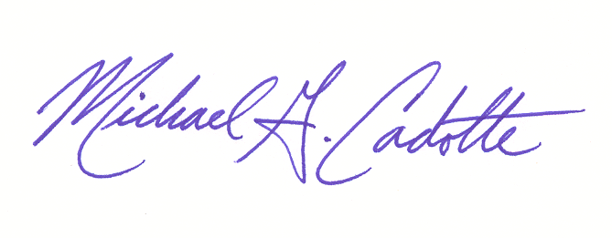
Approved:

Michael G. Cadotte, Vice President
Safety and Quality

Change Record

Rev.: | Date: | Responsible Person: | Description of Change:
0 | 04/29/2011 | M Cadotte – Safety Director | Policy implementation
1 | 07/17/2012 | M Cadotte – VP | Policy audit and re-write
2 | 02/06/2014 | M Cadotte – VP | Audit
3 | 06/25/2018 | M Cadotte | Audit
- POLICY:
  - It is the policy of GDI to maintain a safe work environment at all times especially during times of extreme heat within the work place. This policy is to set up standards on how GDI employees are to protect themselves while working in such environments.

- PURPOSE:
  - The purpose of this policy is to establish the working parameters for GDI working during periods of extreme heat and to communicate this program to all employees, agents and subcontractors working on GDI’s behalf.

  - Operations involving high air temperatures, radiant heat sources, high humidity, direct physical contact with hot objects, or strenuous physical activities have a high potential for inducing heat fatigue in employees engaged in such operations. Such places include: office environments where HVAC systems have been turned off/not working; manufacturing facilities where air-conditioning is not available; factories and power generation plants; food plants and other facilities where the production process includes ovens or other devices that produce heat.

- SCOPE:
  - This policy is in effect for all GDI job sites whether they are staffed, managed and/or sub contracted to other firms. Additional requirements unique to a specific company, job site or area may also apply.

- RESPONSIBILITY:
  - GDI Site Management –
    - Responsible for implementation, enforcement, monitoring, training, and procurement of all PPE and equipment pertaining to extreme work heat.
    - Responsible for monitoring work conditions to determine when extreme heat conditions are present and monitor levels to take appropriate action as stated in section 5.0 below.
    - Inform GDI Safety of any conditions where work is no longer safe and of any needs (such as PPE) that are required to avoid a dangerous work hazard.
    - Provide needed PPE, shade/cool area, and water/electrolyte hydration.
  - Employees –
    - Responsible for following all aspects of this policy, reporting any person or persons who does not and report any concerns or potential failures of this policy, equipment or PPE immediately.
    - Monitor one’s self for signs of heat related fatigue
    - Comply with all procedures and PPE as defined in section 5.0 below to maintain one’s physical health.

- PROCEDURAL ELEMENTS:
  - Casual Factors
    - Age, weight, degree of physical fitness, degree of acclimatization, metabolism, use of alcohol or drugs (forbidden at all times while working or immediately before working), and a variety of medical conditions such as hypertension all affect a person's sensitivity to heat. However, even the type of clothing worn must be considered. Prior heat injury predisposes an individual to additional injury.
    - It is difficult to predict just who will be affected and when, because individual susceptibility varies. In addition, environmental factors include more than the ambient air temperature. Radiant heat, air movement, conduction, and relative humidity all affect an individual's response to heat.

  - Type of Heat Disorders and Health Effects (source: OSHA Technical Manual – Heat Stress)
    - HEAT STROKE occurs when the body's system of temperature regulation fails and body temperature rises to critical levels. This condition is caused by a combination of highly variable factors, and its occurrence is difficult to predict. Heat stroke is a medical emergency. The primary signs and symptoms of heat stroke are confusion; irrational behavior; loss of consciousness; convulsions; a lack of sweating (usually); hot, dry skin; and an abnormally high body temperature, e.g., a rectal temperature of 41°C (105.8°F). If body temperature is too high, it causes death. The elevated metabolic temperatures caused by a combination of work load and environmental heat load, both of which contribute to heat stroke, are also highly variable and difficult to predict.
If a worker shows signs of possible heat stroke, professional medical treatment should be obtained immediately. The worker should be placed in a shady area and the outer clothing should be removed. The worker's skin should be wetted and air movement around the worker should be increased to improve evaporative cooling until professional methods of cooling are initiated and the seriousness of the condition can be assessed. Fluids should be replaced as soon as possible. The medical outcome of an episode of heat stroke depends on the victim's physical fitness and the timing and effectiveness of first aid treatment.
Regardless of the worker's protests, no employee suspected of being ill from heat stroke should be sent home or left unattended unless a physician has specifically approved such an order.

    - HEAT EXHAUSTION. The signs and symptoms of heat exhaustion are headache, nausea, vertigo, weakness, thirst, and giddiness. Fortunately, this condition responds readily to prompt treatment. Heat exhaustion should not be dismissed lightly, however, for several reasons. One is that the fainting associated with heat exhaustion can be dangerous because the victim may be operating machinery or controlling an operation that should not be left unattended; moreover, the victim may be injured when he or she faints. Also, the signs and symptoms seen in heat exhaustion are similar to those of heat stroke, a medical emergency.

Workers suffering from heat exhaustion should be removed from the hot environment and given fluid replacement. They should also be encouraged to get adequate rest.

    - HEAT CRAMPS are usually caused by performing hard physical labor in a hot environment. These cramps have been attributed to an electrolyte imbalance caused by sweating. It is important to understand that cramps can be caused by both too much and too little salt. Cramps appear to be caused by the lack of water replenishment. Because sweat is a hypotonic solution (±0.3% NaCl), excess salt can build up in the body if the water lost through sweating is not replaced. Thirst cannot be relied on as a guide to the need for water; instead, water must be taken every 15 to 20 minutes in hot environments.
Under extreme conditions, such as working for 6 to 8 hours in heavy protective gear, a loss of sodium may occur. Recent studies have shown that drinking commercially available carbohydrate-electrolyte replacement liquids is effective in minimizing physiological disturbances during recovery.

    - HEAT COLLAPSE ("Fainting"). In heat collapse, the brain does not receive enough oxygen because blood pools in the extremities. As a result, the exposed individual may lose consciousness. This reaction is similar to that of heat exhaustion and does not affect the body's heat balance. However, the onset of heat collapse is rapid and unpredictable. To prevent heat collapse, the worker should gradually become acclimatized to the hot environment.

    - HEAT RASHES are the most common problem in hot work environments. Prickly heat is manifested as red papules and usually appears in areas where the clothing is restrictive. As sweating increases, these papules give rise to a prickling sensation. Prickly heat occurs in skin that is persistently wetted by unevaporated sweat, and heat rash papules may become infected if they are not treated. In most cases, heat rashes will disappear when the affected individual returns to a cool environment.

    - HEAT FATIGUE. A factor that predisposes an individual to heat fatigue is lack of acclimatization. The signs and symptoms of heat fatigue include impaired performance of skilled sensorimotor, mental, or vigilance jobs. There is no treatment for heat fatigue except to remove the heat stress before a more serious heat-related condition develops.

  - Work Assessment Table
In order to provide a general guide (subject to specific site regulations (customer based) and unique site conditions) the following guide should be utilized when working in high heat conditions:
Table 1.

 | < 80˚ F | 80˚ F - 90˚ F | > 90˚ F
Normal working conditions | ✓
Increased Hydration Breaks to every 30 min. |  | ✓
Increased Hydration Breaks to every 15 min. |  |  | ✓
Water  Hydration | ✓ | ✓
Carbohydrate-Electrolyte Replacement Hydration | ✓ | ✓ | ✓

In conditions where extreme heat is not present (> 90˚ F) water or a carbohydrate electrolyte replacement liquid is acceptable, however, when extreme heat within the working environment is present water must be replaced with an electrolyte replacement liquid.

  - Apparent Temperature Heat Index: The apparent temperature heat index is a visual guide to further help you gage the dangers of working in above average to extreme heat conditions.
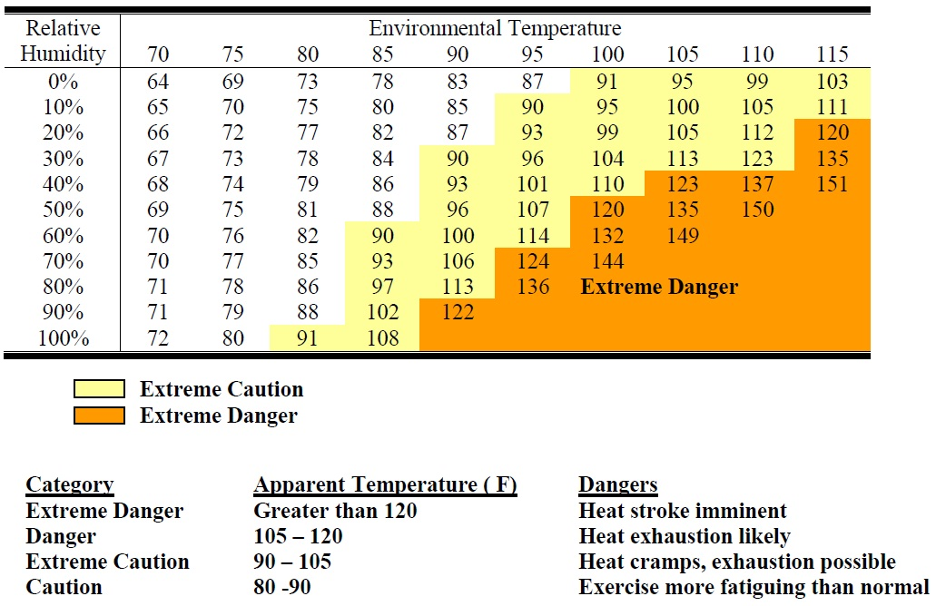
Table 2.

  - Hydration Distribution
    - Normal Conditions: under normal heat conditions (< 80˚ F) water distribution can be made either through accessible drinking fountains and water available via vending machines within easy access to employees during normal breaks.
    - High Heat Conditions: during high heat conditions (80˚ F - 90˚ F) access to water shall be available in the work area and easily assessable. In areas where water is not easily assessable water coolers shall be put into place in accordance with local site safety policies.
    - Extreme Heat Conditions: during extreme heat conditions (> 90˚ F) access to carbohydrate-electrolyte replacement liquids (such as Gatorade) shall be available in the work area and easily assessable in accordance with local site safety policies.
  - Site Manager / Supervisory Responsibility
    - Supervisors are those primarily responsible for the implementation of this program within their division, unit, etc. Supervisors have the ultimate responsibility for the safety of their employees.
    - Prior to the summer season (highest time period for heat stress) managers and supervisors shall be trained in heat stress awareness, prevention, and this GDI policy.

    - Their duties related to the prevention of heat-related disorders include but are not limited to the following:
- Evaluation/scheduling of work to be performed;
- Stay current on training and understanding of these parameters before such work is initiated;
- Employees ready access to hydration based on table 1 above;
- Encouraging workers to drink / hydrate frequently;
- Provision cool off environment during preventative recovery breaks as laid out above;
- Ensuring self and employees are familiar with signs, symptoms and appropriate first aid
- Employee acclimatization;
- Work/rest regimes (see Table 1);
- Ensuring employees receive Heat Stress Training;
- Monitoring for signs and symptoms of heat-related disorders in their employees;
- Ensuring the guidelines of this policy and procedure are followed

  - Employee Responsibility
    - Employees who work in high heat environments during periods of elevated temperatures have the following responsibilities:
- Participate in heat stress training. Learn the signs and symptoms of heat stress, as well as the risk factors and first-aid treatments.
- Take extra precaution if you are at high risk. High risk factors include being older, overweight, overexertion, chronic medical conditions including diabetes, heart or lung disease, thyroid disease, or high blood pressure. If you take medications you should check with your doctor to see if any of the medications put you at a higher risk for heat-related disorders.
- Compliance with this policy and procedure. Following the preventative measures listed in this policy as well as the County’s Heat Stress Training.
- Take time to acclimate to the heat and/or humidity. You will have a greater tolerance for heat if you limit your physical activity until you have become accustomed to the heat.
- Stay hydrated by drinking small amounts of cool water frequently throughout the day. Consider periodically supplementing some of your water with a sports beverage to ensure the minerals and electrolytes your body needs. Be aware of sports beverages as they contain high levels of salts and sugar, check with your physician before consuming these.
- Wear appropriate clothing. Choose light weight, light colored loose-fitting clothing.
- Monitoring self for signs and symptoms of heat-related disorders.
- Pace yourself.

  - Preventative Controls
    - Administrative
Administrative controls are strategies used by supervisors to limit exposures to a hazard. For example changes to work schedules can limit the amount of time an employee is exposed to the elevated temperatures. The following are all examples of administrative controls:

- Training – This is the key to good work practices. Unless all employees understand the reasons the chances of a program succeeding are greatly reduced. A good heat-stress training program should include the following:
  - Knowledge of the hazards of heat stress;
  - Recognition of predisposing factors, danger signs, & symptoms;
  - Awareness of first-aid procedures for, and the potential health effects of, heat stroke;
  - Employee responsibilities in avoiding heat stress;
  - How to provide directions to work location;
  - Dangers of using drugs, including therapeutic ones, and alcohol in hot work environments; and
  - Use of protective clothing.
  - Proper procedure to follow in the event OF heat stress:
    - Contact site medical services
    - If (i) above not available contact GDI regional medical services
    - If situation is severe enough (or above not available) go to / call emergency services (9-1-1)
- Acclimatization - Employees need to adapt to new temperatures. This adaptation period may take a few days.
- Weather Conditions - Check weather conditions frequently during the day and adjust the work schedule as it impact work area conditions. Heavy work should be scheduled for the cooler days when possible.
- Work/Rest Cycles - Heavy and minimal work activities should be alternated. Tasks should be rotated among workers. Employees should be allowed sufficient breaks based on Table 1 above in a cool area to avoid heat stress and promote recovery.
- Fluid Intake - Cool fluids such as water or electrolyte replacement drinks need to be conveniently available to workers so they can drink about 8 oz. of liquids every 20 minutes. Reference Table 1 above.

    - Engineering
Engineering controls are physical changes made to the work environment. Heat may be controlled through general ventilation and spot cooling by local exhaust ventilation at the point of high heat production. Shielding may be needed for protection against radiant heat sources. Another control measures would be the use of fans to create air flow. Outdoor work areas must have a shaded area accessible to the employees. Shaded areas can be created by using tarps or canopies. To be considered “shade” the employee must not cast a shadow while in the shade.

In most work sites the customer has direct control of Engineering controls and coordination and communication with the customer and/or their appointed safety manager shall be maintained with GDI’s site manager / supervisor to coordinate efforts.

    - PPE
Some examples of PPE that help in the prevention of heat-related disorders include hats, loose-fitting clothing, cool vests, etc. ANY PPE issued to an employee, including for prevention of heat-related disorders, must be utilized by the employee at all times required.

  - Monitoring for Signs and Symptoms of Heat Stress
    - Supervisors, co-workers and employees themselves are all responsible for monitoring for the signs and symptoms of heat-related illnesses. See the above table for signs and symptoms of heat related illnesses. Supervisors and co-workers are often in the best position to observe the on-set of heat related illnesses in co-workers.
    - When heat fatigue risks are present supervisors should check workers regularly (via observations and questions) for signs and symptoms of heat fatigue as laid out in section 5.2.6 above.
    - Supervisors & managers must monitor themselves for the signs and symptoms of heat-related illnesses.
    - When working in heat use the buddy system. Monitor the condition of your co-workers and have someone do the same for you.
    - Supervisors should check and ensure that employees are self-monitoring and complying with the required actions of this policy and the specific job site.

