Working at Heights: Policy

Approved:


Ahmed Boomrod, President / COO

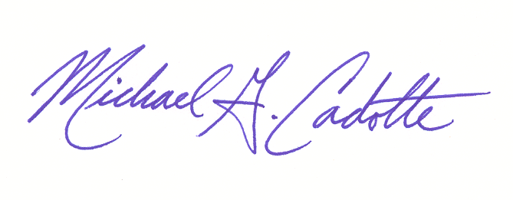
Approved:

Michael G. Cadotte, VP – Safety & Quality

Change Record

Rev.: | Date: | Responsible Person: | Description of Change:
0 | 04/13/10 | M Cadotte – Director of Safety | Policy implementation
1 | 9/28/10 | M Cadotte – Director of Safety | 5.4.4.2 revised annual audit freq.
2 | 03/04/14 | M Cadotte – VP Safety | Updated Sec: 5.2.4 & 5.4.4. Added Sec 6
3 | 04/06/15 | Safety Review Team | Annual Audit
4 | 11/18/15 | M Cadotte | Additions to Section 5.3 Moving Platforms
5 | 02/03/16 | M Cadotte | Annual Audit
6 | 12/03/18 | M Cadotte | Changes to 5.3.3 – further clarification & 5.3.9 addition
7 | 01/11/2019 | M Cadotte | Review
- POLICY:
  - It is the policy of GDI to maintain a controlled working at heights program that is in compliance with all applicable laws and regulations. Further, GDI does not approve, nor allow, any employee, agent or sub contractor to perform such work without being (1) properly trained and (2) approved my GDI. Such employees shall be trained to recognize and eliminate any fall hazards associated with related work at heights.

- PURPOSE:
  - The purpose of this policy is to establish the working parameters for GDI working at heights program and to communicate this program to all employees, agents and sub-contractors working on GDI’s behalf.

- SCOPE:
  - This policy is in effect for all GDI job sites whether they are staffed, managed and/or sub contracted to other firms. Additional requirements unique to a specific company, job site or area may also apply.

- RESPONSIBILITY:
  - Management - Responsible for implementation, enforcement, monitoring, training, and procurement of all PPE and equipment pertaining to high work.
  - Employees – Responsible for following all aspects of this policy, reporting any person or persons who do not and report any concerns or potential failures of this policy, equipment or PPE immediately.

- PROCEDURAL ELEMENTS:
  - High Work Identified
    - Any equipment that requires an employee to work at heights greater than 4 feet, or near the edge of a pit, hole or other type of shaft, is covered in this policy and considered high work and thus high work certification is required by the employee before proceeding with the utilization of said equipment.
    - Any work duty or task where there is the potential for a fall from an elevated height is considered high work. This includes working on raised platforms, walks or roofs where there are limited or no approved safety guard rails or other approved devices to prevent falls in place.
    - All high work requires proper fall protection and subsequent training.
    - This policy, in the area of harness and lanyard usage, maintenance and storage also applies to confined space work where rescue harnesses and ropes are utilized. Please refer to additional policies and information about confined space work and never enter a confined space unless properly trained and certified.
    - The overall operational plan, in regards to high work, shall be developed the a qualified person on site. The designated qualified person is the site manager unless otherwise notified to GDI Safety and area/regional operational management.

  - Types of High Work Equipment
    - Working Platforms (to include scissor lifts, boom lifts and other powered lifts) are to be utilized only by certified trained personnel. Such equipment owned or controlled by GDI shall have a properly maintained maintenance and inspection log per each unit. Operators shall carry on their person at all times certification cards showing they have received appropriate training for such equipment, issue date and authorized trainer’s signature.
    - Scaffolding may be utilized and assembled by either trained personnel or by certified vendors. Verification of safety after assembly but before use must be documented.

    - Ladders (over 4 feet) may be used on recognized floors and never on top of scaffolds or high work lifts of any type. Employees utilizing ladders must be properly tied down if over 4 feet with a double D-ring harness and double lanyards OR 3 points of contact (both feet and one hand) must be maintained at all times.

      - Ladder rungs must be uniformly spaced and meet all load and OSHA/ANSI specifications.
      - A pre-task assessment of the work should determine needed load capacity and verified that the ladder is rated for that load.
      - Ladders shall be used for their intended purposes and not ‘fitted’ or deployed in any manner beyond normal intent.
    - Annually ladders shall be inspected (visually) for damage. Any ladder found to be less than 100% shall be removed from service, tagged as not safe until repaired by a competent person OR disposed of.
    - Proper ladder placement shall follow a 4:1 ratio. For every 4 feet in height the ladder should be 1 foot away from the wall.
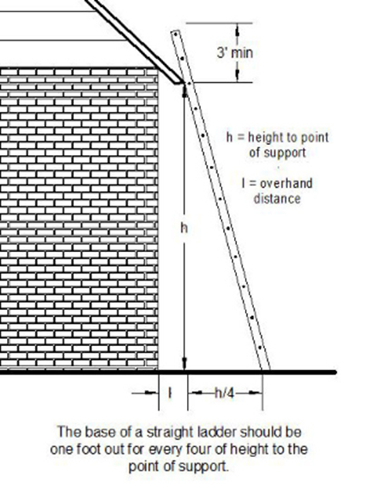

  - Moving platforms: any high work equipment that is powered through human or automation shall not operate without proper caution signage and/or spotter on the ground to guide personnel to avoid human collision. All regulations in regards to specific automated platform equipment shall be understood and followed at all times. Moving lifts shall have movement alarms (reverse minimum). Spotters should be utilized when moving in high pedestrian areas.
    - Travel areas must be walked in advance to spot areas of concern on the ground (travel surface) as well as Aerial clearances and collision concerns including electrical lines, equipment, pipes and conduit being no less than ten feet clearance.
    - Inspections of all lifts, booms, scaffolding must be performed prior to each use. DO NOT use if any deficiency or concerns are noted until cleared by a competent person.
    - General Safety:
      - An approved fall restraint system shall be word while working in any aerial lift (ie: scissor or boom) or other system that places the worker at height.
      - Hard hats or bump caps must be work when working at heights.
      - Workers shall stand firmly on the platform.
      - No ladders or other devices to reach further heights are allowed on the platform
      - Workers are not allowed to climb on/over safety rails or exit the lift
      - Security cage door, gate or chain must be deployed at all times while in lift.
      - Workers must be properly tied off when in a lift. The fall restraint system must be attached to the boom or basket at the approved tie off point(s) – never the rail.
      - All accidents and near misses shall follow GDI’s incident reporting and investigatory policies and reported immediately to site management, customer and GDI HR.

In such instances all high work must stand down, review the situation that just occurred and receive approval to assume work from GDI Safety.
      - Employees shall be promptly rescued. In the event an employee loses consciences before rescue can be achieved they are to be placed in a seated position (buttocks on floor and back against wall) – do NOT lay flat.
      - A worker who cannot be rescued immediately should be trained to "pump" his/her legs frequently to activate the muscles in the legs and reduce the risk of venous pooling which can be life threatening.

    - Operators of Aerial powered equipment must be certified to operate.
    - Workers on Aerial platforms must be trained in:
      - Working at heights safety
      - Harness usage & policy
      - Receive refresher training every 2 years OR earlier if any significant changes to policy or work changes.
    - Platforms not designed to be driven (such as scaffolding) shall not be moved while occupied by an employee.
    - Pre-use visual inspection shall be performed of the equipment and controls prior to each use of an aerial platform/lift. Any difficiencies found shall be repaird by certified person(s) only.
    - Loads: each lift has a load capacity. Users must verify, at each use, that the material, equipment and personnel on the lift will not exceed the maximum rated load capacity.
    - Modification shall not be made to equipment. All needed modification shall be made by the manufacturer or with written authorization from same and authorization from GDI safety to perform said modification.

  - Proper harness usage / PPE
    - Pre-use inspection: each harness and lanyard shall be properly inspected prior to every use. See SSOP SP13W.0001 for further information.

    - Lanyards shall be properly secured to a:
      - authorized tie down point
      - structural steel
      - NEVER around conduit, electrical conduit or hand safety rails / barriers

    - Storage
      - Never store a harness or lanyard in non-approved lockers, cabinets or other areas where they may come into contact with chemicals. Only store in approved locations.

      - Prevent harnesses and lanyards from being ‘bunched’ or piled up during storage. Lay flat, hang from wall hooks and in a manner that does not create damage.
      - Never remove harnesses or lanyards from the job site they are ‘assigned’ to with out authorization. Any removal shall also require the corresponding inspection form to travel with said units.
      - ALL heights PPE shall meet or exceed ANSI / OSHA requirements.

    - Inspections and Audits
      - Inspections: are to be conducted on a 43 point method per SP13W.0001 each time a unit is used by the using operator.
      - Audits: are to be conducted by competent authorized persons* once annually for each unit.
      - Audits, in the event such PPE is assigned to individuals, shall also include an inspection of each employee’s locker or storage location to verify the lanyards and/or harnesses are:
        - Hanging or
        - Stored in an organized manner
        - Away from chemical, food and/or drink
        - In a dry & clean environment
      - Failed units: are to be cut into multiple pieces and disposed of properly. Any harness or lanyard that has failed inspection is never to be placed in tact into the waste stream.
      - Log: all inspections and audits, as well as any maintenance and repair (legally performed by authorized person(s)) shall be documented on individual inspection / maintenance logs. OFS Form F414.0036
  - Training
    - Employees working at heights over 4’ (high ladders, areal platforom or boom lifts) shall receive training, safety harness usage (required at this height and above) and equipment training prior to work and;
    - Training shall be refreshed every 2 years or;
    - Whenever a significant change in policy or additional equipment (dis-similar from those in use) or new work areas are introduced into the service delivery mix.
    - All training to be sign off, files and uploaded into GDI’s training documentation system.

- Definitions
  - Authorized Persons: a person trained in policy and usage of heights PPE that is not a primary user.

