Safety Manual
Corporate Emergency Information


Approved:

Ahmed Boomrod, President / CEO

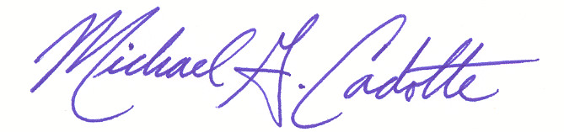
Approved:

Michael G. Cadotte
Vice President - Safety & Quality

Change Record

Rev.: | Date: | Responsible Person: | Description of Change:
0 | 10/28/05 | M. Cadotte/Director of Admin | Initial Release
1 | 2/01/2017 | M. Cadotte/VP Safety | Expansion of Policy – Evacuation

- Purpose
To establish a written policy to communicate the various persons and agencies to notify in the event of any form of emergency on the job site or in any GDI office.

- Scope
The information has been established for ALL GDI employees and will be made available to all employees through:
Safety Department
Job site postings

- Responsibility
  - Vice President of Safety
Has overall authority and responsibility for implementing and monitoring safety programs at GDI.

  - Safety Committee
Is responsible for monitoring the safety program, developing training schedules, researching new safety products and coordinating all safety related efforts within the company.

  - Employees
Each and every employee at GDI has a primary responsibility to comply with all safety policies, guidelines and laws. Furthermore, every employee must report any unsafe condition and/or incident to their supervisor immediately and notify the appropriate authorities in the event of a dangerous safety situation.

- Procedure
  - Reporting
    - All emergencies must be reported immediately to YOUR SUPERVISOR (on-site) or your facility safety captain/designated person. At client jobsites you must also notify the client’s designated representative (such as security) and calls to 9-1-1 should be handled through said representatives (whenever possible) so they can properly direct response teams within the facility.
    - All accidents that (1) result in 3 or more employees sent to the hospital, and/or (2) result in loss of a limb, and/or (3) result in a death MUST be reported to GDI Safety & HR Department immediately!
Safety Department Michael G. Cadotte, VP of Safety:
Direct @ 248.395.1185
After Hours @ 248.388.2481
Or your local HR department
You may also contact the above should you have any questions, or concerns, over this policy or your duties and responsibilities therein.
    - In the event of any SERIOUS injury CALL 9-1-1 FIRST
  - Communication
    - The emergency policy (and site action plans) shall be communicated via policy distribution, oral training sessions, and/or annual building safety reviews (annual review of evacuation, shelter, and other site-specific emergency planning each March).
    - This training shall also be conducted with new members joining the work site outside of scheduled group trainings.
    - Employees shall be trained, as part of their site safety training (4.2.1 above) of alarms and notification systems at their individual job site locations. Employees are further encouraged to download local weather apps to allow for live updates on potential inclement weather in their work area as well.

  - Evacuation
    - Employees shall muster at the designated evacuation point outside the facility for proper accounting of all employees post evacuation.
    - Site managers are designated safety captains and all GDI offices shall identify specific office and/or floor-department captains to communicate policy, aid in evacuations and sheltering, and account for personnel.

  - Local (SITE) Information (complete and post, along with this policy) on site communication board

POLICE: __ __________________/___ _______
Number City

FIRE: ____ __________________/___ ______
Number City

SITE SECURITY: ____________________________________________
Number

