Safety Manual
Job Site Safety Audits

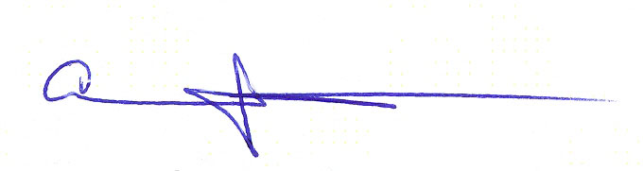
Approved:

Ahmed Boomrod, President / CEO

Approved:

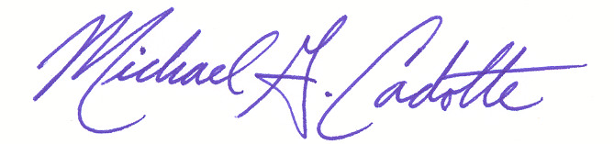

Michael G. Cadotte
Vice President - Safety & Quality

Change Record

Rev.: | Date: | Responsible Person: | Description of Change:
0 | 01/07/03 | M. Cadotte/Director of Admin | Initial Release
1 | 10/01/07 | M. Cadotte/Director of Admin. | Adjustments to frequency schedule in sec. 4.2 & changes to sec 4.3 record retention.

- Purpose
GDI Omni’s job site audit program is designed to look for known safety concerns on the job site and to also look for potential safety concerns. Through these audits we are able to verify a safe work environment for our employees and further enforce with our operational management the company’s commitment to an injury free safe work environment.

- Scope
The job site audit procedure applies to all GDI Omni of Detroit and Michigan job sites.

- Responsibility
GDI Omni’s Director of Safety has overall responsibility for job site safety audits. GDI Omni’s Safety Committee is responsible for updating the audit form and overseeing data collection and data review. GDI Omni’s Director of Safety further is responsible for reporting trend data to top management and the safety committee.

The Safety Committee is responsible for interfacing with our insurance company consultant to verify that any current safety concerns due to actual claim history is represented on the audit form and further that any real possible safety concerns are addressed as well.

We will provide a safe job environment for our employees at all times. It is the responsibility of every GDI Omni employee to take safety seriously at all times. This audit procedure is designed to verify this compliance at the job site, but does not replace the responsibility of individual employees from keeping a sharp lookout for potential safety concerns and reporting those concerns.

- Procedure
  - Audit Form
An audit form format will be used to focus the attention of site management to the following:
- Past safety issues due to actual injury claims
- Potential safety issues
- Governmental safety compliance
This form will be designed and revised by the Safety Committee with the support of our outside insurance provider’s safety consultant. The audit form in use (titled Managing Vital Performance) is: F300-0015.

  - Data Collection (audit)
All site managers/coordinators or area coordinators or area managers or members of the safety committee will randomly audit all job sites based on the schedule below:
Type of Account Frequency of Audit
‘Satellite’ Accounts <3 employees QUARTERY
Accounts with NO site manager MONTHLY
Accounts with a site manager MONTHLY
Manufacturing/Plant accounts WEEKLY

The following information should be supplied on every audit sheet (F300-0015):
- Job site name
- Auditor name
- Date of audit
- Regional job site belongs
- All data to be marked as instructed on form.

  - Record Maintenance
All completed audits will flow back to the office of the director of safety or their designated representative. Data will be reviewed for any immediate actions then tracked for overall review on a periodic basis. Forms may be directly fax to the safety department at: 248.200.3606

Hard copies of the data will be kept on file for a period of 12 months.

All manufacturing and plant accounts should maintain a hard copy on file for a period no less than two years. A copy should still be faxed to corporate safety at: 248.200.3606

  - Review
The Director, or Safety, a company employee appointed by the Director of Safety or the Safety Committee, will periodically review incidences that have been recorded for patterns of concern. Reviews should not look for blame but rather for areas of safety improvement. In the event a job site manager/coordinator is found to be allowing an unsafe job environment said manager/coordinator will be subject to standard company disciplinary procedures which lead up to, and include, termination.

The safety committee will review all data on a periodic basis from possible trends and areas of concern. Individual data will be reviewed by the director of safety, or appointed representative, and will report to the safety committee and violations and/or concerns.

- Related Documents
- SP-02 Safety Policies
- F300-0015 (Managing Vital Performance)

