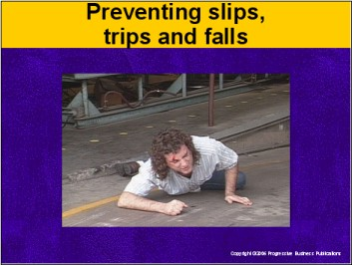

Speaker’s Notes
- Today’s topic is preventing slips, trips and falls. This training includes OSHA’s Walking and Working Surfaces and Fall Protection standards for general industry
(29 CFR 1910.22-28).
- We’re going to talk about:
- How slips, trips and falls impact people’s lives.
- Factors that commonly trigger slips, trips and falls.
- What to do if you spot a slip or trip hazard.
- How we can prevent accidents.

Suggestion for the Speaker
Your company may follow more specific slip, trip and fall requirements, depending on your industry. You’ll want to talk about those requirements and employees’ responsibilities in addition to this training.

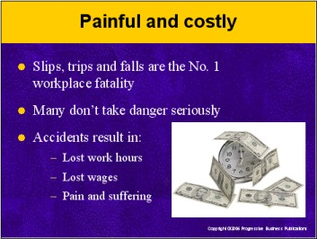

Speaker’s Notes
- Slips, trips and falls are the No. 1 fatal workplace injury. Not all fatal injuries result from slipping or tripping on a surface, but many do. They’re what OSHA calls “falls from the same level.”
- Many people don’t take slip/trip hazards seriously, because we’ve all fallen and gotten up. Others think slip, trip and fall lawsuits are all scams. The numbers tell a different story. Slips, trips and falls result in:
- Hundreds of thousands of lost work hours for employees
- Millions in lost wages for injured workers, and
- Years of pain and suffering, especially for people who can
never go back to their old jobs after a fall.

Suggestion for the Speaker
You can share this story: Housekeeping at a New York facility always propped up signs before mopping the cafeteria floor. One day they forgot. A worker slipped on the slick floor and fell hard. He needed multiple spinal surgeries just to walk, so he sued his employer. The jury awarded him $250,000 (Robinson v. U.S. Postal Service).

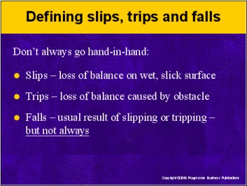

Speaker’s Notes
Before we go further, let’s define slips, trips and falls.
- Slips are a loss of balance. They’re caused by too little friction between
your feet and the floor. Slips most commonly occur on smooth surfaces. Somebody can slip without hitting the ground, and still get hurt. For example: While slipping, you reach awkwardly for a railing and strain your back. That’s still considered a “slip-and-fall” injury.
- Trips are triggered by an object, usually an obstacle that doesn’t belong there. They can happen on any surface, particularly on carpeted floors common in any office building. Once again you can still suffer an injury tripping over an object even if you don’t fall to the ground.
- Falls usually go hand-in-hand with trips and slips. For this training we’ll concentrate on same-level falls that result from slip and trip hazards.

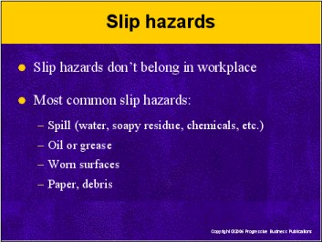

Speaker’s Notes
- When we talk about slips-and-falls, it’s important to focus on slip hazards. “Hazard” is defined as “something out of the ordinary causing danger or risk.”
- Simply put, slip hazards don’t belong in the workplace. They happen when people don’t do their jobs right, or somebody doesn’t speak up about it. One common excuse is, “Somebody will take care of it.”
- The most common slip hazards include:
- A spill (water, soapy residue, chemicals, etc.)
- Oil or grease
- Worn smooth surfaces (like concrete, tile, traction strips on steps), and
- Paper or debris (like smooth plastic wrapping).

Suggestion for the Speaker
To spur discussion, you can ask trainees if they’ve spotted a slip hazard in the facility. What did they do about it? Did they report it?

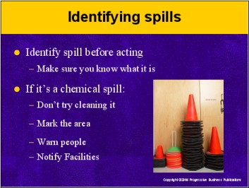

Speaker’s Notes
- So what do you do when you spot a spill? First things first: Make sure you know what it is before you act. That’s pretty simple to do when you’re the one who spilled a soda or a cup of coffee!
- Sometimes it’s not. Let’s say it’s a chemical spill, or what appears to be
a chemical. In that case, don’t attempt to clean it up yourself. If possible, mark the spill with a chair or some other type of object. That’ll let your coworkers know there’s a spill and help prevent somebody from slipping and falling on it.
- Then notify Facilities about it immediately. They’re trained to handle those kinds of problems and have the personal protective equipment necessary to handle it.

Suggestions for the Speaker
If your company uses or produces chemicals, you might want to discuss your hazardous communications rules in more detail. Check with your company’s Facilities Manager or Safety Director for help.

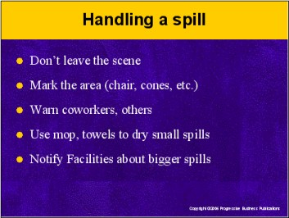

Speaker’s Notes
Most times a spill isn’t a dangerous chemical. Here’s what you should do if you come across a non-chemical spill:
- Don’t run off immediately to get help or grab a mop. In just those few short minutes, someone else can slip, fall and get hurt. Plenty of companies lose slip-and-fall lawsuits when they don’t clean up spills within minutes of them happening!
- Mark off the spill area with cones, a chair, or some other kind of object. That’ll make it less likely someone slips on it.
- Warn anybody working nearby not to go near the spill. If possible, write a note and post it, or lay it near the spill.
- If there’s a towel, paper towels or a mop nearby, use them to clean the spill. Most of us can clean up a small spill by ourselves.
- For larger spills: Once you’ve marked the area and warned nearby coworkers, go tell Facilities about it immediately.
- That goes for a smaller spill too, like a can of soda. The floor surface may still be sticky. Facilities will probably want to mop down a small spill area just to be on the safe side.

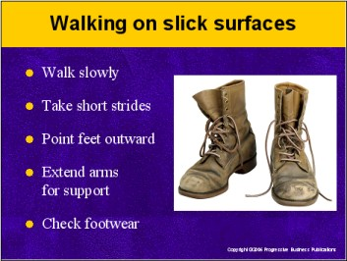

Speaker’s Notes
Under normal circumstances, we would never walk on a wet surface. That’s not always the case in an emergency. For example, a busted pipe is leaking. Or Housekeeping just mopped an area you’ve got to enter. To prevent slipping and falling:
- Walk slowly.
- Take short strides.
- Point your feet outward to keep better balance.
- Keep your shoulders and elbows extended out (similar to a bat’s wings) to improve balance. Your arms will be in better position to brace yourself if
you fall.
- If possible, change footwear. Boots with thick tread are optimal.

Suggestions for the Speaker
- You can demonstrate how you’d walk on a slick surface, and
- Ask trainees to imagine they’re standing on a slick surface. Then have them demonstrate how they’d walk. Point out ways they can improve, such as taking shorter strides.

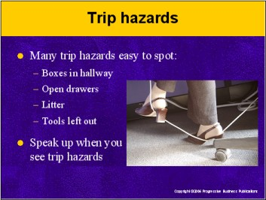

Speaker’s Notes
- Trip hazards are a little different than slip hazards. Many trip hazards are easy to spot and correct. For example:
- Boxes stacked in a hallway
- An open filing cabinet drawer
- Litter
- Tools left out in the open.
- For these kinds of simple trip hazards, you may be able to remove them.
Or you can ask the coworkers who left them there to remove them.
- Sometimes a coworker or a department may create a recurring trip hazard. For example: A department’s clearing out old files and stacks boxes in a walkway. Speak up about it – they’re probably not thinking about how it can cause an injury.

Suggestion for the Speaker
You can ask trainees if they’re aware of any trip hazards. Remind them that they’re responsible for spotting and correcting trip hazards

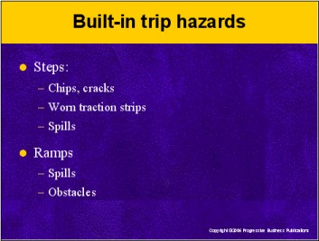

Speaker’s Notes
- Some trip hazards are permanent, yet people don’t view them as hazards; they’re just a part of the building. Think about the most common examples:
- Steps – Many trip-and-fall accidents occur on steps. That’s because people don’t always slow down and use caution when going up and down steps. Physical factors play a big role too, such as:
- Cracks or chips in the steps
- Worn traction strips, or
- A spill.
- Ramps – We’re even more likely to rush down a ramp than stairs. Before walking up or down a ramp, take a quick look down first. Are there any objects in your way? Or a spill? This advice goes for steps too.

Suggestions for the Speaker
Here’s a story you can tell trainees: A woman regularly used a handicap access ramp at a Texas facility, even though she wasn’t disabled. After all, what’s safer than a handicap ramp? Only problem was, the ramp was missing a railing in one spot. One day she didn’t look where she was going, lost her balance and fell hard. She sued and won damages for her medical bills (Vallery v. City of Jefferson).

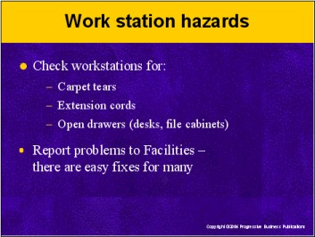

Speaker’s Notes
Our workstations can also pose trip hazards. Some of them we can fix, others require attention from Facilities:
- Carpet tears – Carpeting gets worn out over time. Check whether you’ve got a tear or snag in your work area. Covering a tear with a rug or plastic mat can do the trick. Make sure the rug or plastic mat doesn’t cause a trip hazard.
- Extension cords – Keep cords lined snugly against the wall to avoid tripping over them. Remove unnecessary equipment with power cords as well. Ask Facilities or IT about moving certain equipment.
- Open cabinet drawers – Remember to close desk or file cabinet drawers when you’re done retrieving items. It’s easy to forget about an open drawer, stand up, and trip over it. Also: Speak up when you see coworkers leaving a drawer open.

Suggestions for the Speaker
You may want to share some safety suggestions from your Facilities department. Or have the manager or a staff member sit in for training and ask them what else trainees can do to make their work areas safer.

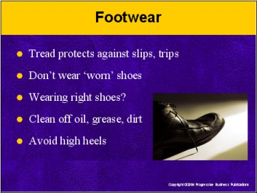

Speaker’s Notes
- Believe it or not, our shoes play a big part in preventing slips, trips and falls. Shoes lose their effectiveness as the tread naturally wears out. That’s true of boots, sneakers and dress shoes.
- Shoe selection is important too. Consider whether your shoes are right for your work area. Do they have enough tread?
- Also: Clean your shoes, especially the soles. Oil, grease and dirt buildup increases the chances of slipping and falling.
- High heels, even in a carpeted office environment, aren’t the safest choice. They cause stress on women’s feet. One study showed high heels are common in more than 60% of trips-and-falls involving women

Suggestion for the Speaker
Take a “levity” break: Ask trainees to lift a leg and show their tread! Ask them to check each other’s shoes and judge whether it’s time to wear a new pair instead.

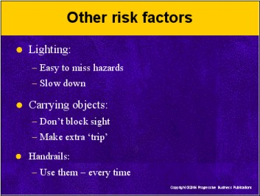

Speaker’s Notes
Other factors make a slip or trip more likely, such as:
- Poor lighting – Poorly lit areas hide slip and trip hazards. Always slow down when you can’t see well.
- Carrying too many objects
- Always keep objects you’re carrying well below your line of sight. We’ve all seen someone walking with a pile lined up to their nose! They’re an accident waiting to happen.
- Carry as few items as possible when walking up or down steps. Make an extra trip to avoid a “trip.”
- Not using a handrail – They’re there for a reason. It’s a good idea to always use a handrail on steps and ramps.

Suggestions for the Speaker
Ask trainees if they’ve got other suggestions. An obvious one to add, if nobody brings it up: Slow down and watch where you’re going.

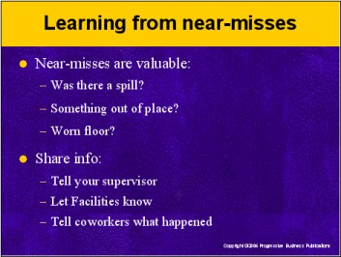

Speaker’s Notes
- Spotting, correcting and reporting slip or trip hazards is important. So is keeping our workstations clean and wearing proper footwear. One more valuable way to prevent slips, trips and falls: Learn from near-misses.
- We’re all better off looking at a near-miss as an opportunity to learn –
and prevent a real accident down the road. So if you or a coworker has
a slip, trip and fall near-miss:
- Check the risk factors: Was the floor wet? Was an object out of place? Is the floor surface worn in that spot?
- Report it: Tell your supervisor and Facilities about it.
- Bring it up: Let your coworkers know what happened. We can all learn a valuable lesson from each other’s experiences.

Suggestions for the Speaker
Share this story: Workers knew a staircase’s steps weren’t evenly spaced. They instinctively walked carefully on them. One day a visitor took the steps, and she slipped and fell. The woman sued and won. She claimed
the steps should’ve been evenly spaced like most steps. This accident could’ve been prevented if somebody spoke up (Phillips v. Walter Bay Management Corp.).

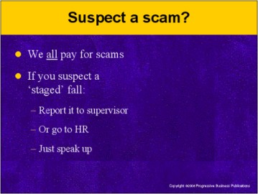

Speaker’s Notes
- We touched briefly on scams earlier. It’s true: A large percentage of
slips, trips and falls are fraudulent. We all pay for these scams, in higher insurance rates, taxes, lawsuits and workers’ compensation.
- If you suspect a slip, trip or fall isn’t on the up and up, talk to your supervisor immediately. Report what you’ve seen or heard. Better to help prevent an accident than not speak up.
- Or if your supervisor’s not available, go to Human Resources about it. That goes for whether you suspect a visitor, passerby or coworker.

Suggestions for the Speaker
Share this story: A little old lady with glasses trips in a parking lot pothole. She sues for $10,000 to cover medical bills. That low figure sounds reasonable, so the company pays. Only problem is, so did 49 other businesses in Pennsylvania and New Jersey when she sued them too! She scammed these businesses for more than half a million dollars through phony accidents – then lost it all gambling at casinos! (http://insurancefraud.org/hallofshame04/greedygranny.html)

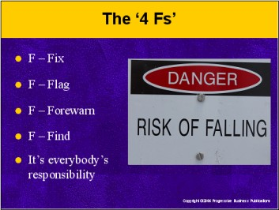

Speaker’s Notes
- That’s a lot of important information to digest in a training session. It’s always easier to remember important points with a catchy phrase. So when it comes to slip, trip and fall hazards, remember the “Four Fs”:
- FIX it: Determine whether you can fix a hazard. Then:
- FLAG it: Block or flag the hazardous area.
- FOREWARN: Let coworkers know so they can protect themselves.
- FIND – Your supervisor or someone in Facilities and report it.
- Everybody has a stake in preventing slips, trips and falls: your coworkers, visitors, the company, our families and yourself. It’s not “somebody else’s job” to flag a hazard and take care of it. It’s my job and yours.

Suggestion for the Speaker
Ask trainees if they have any questions. Present them with copies of the handout and quiz. Thank them for their time.

