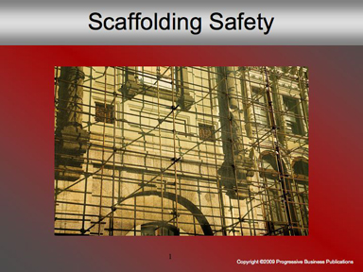

Speaker’s Notes
- Welcome. Today’s topic is Scaffolding Safety.
- You will learn about:
  - The types of scaffolding typically used in construction
  - The major hazards of working with scaffolding
  - How to practice safe working procedures

Suggestions for the Speaker
    - This training is required by OSHA’s scaffolding standards (29 CFR 1910.28(a-v))
    - Share a story of an injury or death that occurred in your workplace or use this true case report below:
    - An employee of a masonry contractor was working on the third level of a scaffold while standing on the second level. When he tried to set the frame into the pins, it flipped to one side. The momentum of the frame sent the employee backward, and he was killed when he hit the ground.

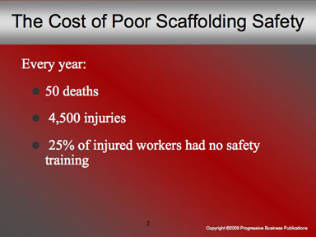

Speaker’s Notes
- 2.3 million construction workers make frequent use of scaffolding – that’s 65% of the industry.
- Every year, scaffold-related accidents account for 50 deaths and 4,500 injuries.
- Even more troubling: In these accidents, 25% of the workers didn’t have adequate safety training; and 77% of cases were caused due to a lack of guardrails and other protection.
- The key to lowering the number of accidents is making sure everyone knows how to handle themselves when they’re up there.

Suggestions for the Speaker
- Ask workers how many of them have spent time on a scaffold over the
last year.
- Ask what kind of safety precautions they took while they were up there.

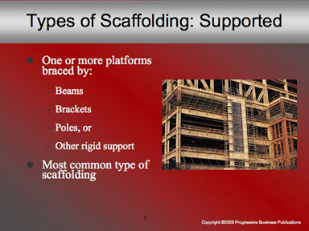

Speaker’s Notes
- First, let’s take a minute to look at the different types of scaffolding generally used on a job site. They break down into three categories: Supported, Suspended, or Other.
- Supported scaffolding consists of one or more platforms, supported by outrigger beams, brackets, poles, uprights, posts, frames, or other materials.
- This is the type of scaffolding that’s most commonly used in construction, since it’s versatile, economical, and easy to use.

Suggestions for the Speaker
- Show some examples of materials used to make support scaffolds – wood planks, poles, etc.
- Ask for examples of jobsites where they’ve made use of this type of scaffolding, and how high up the scaffolds were built for each example.

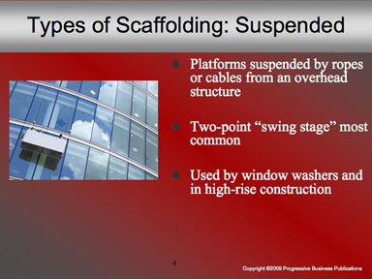

Speaker’s Notes
- The other major type of scaffolding is suspended.
- These are platforms, hung by ropes or cables connected to stirrups at each end of the platform from an overhead structure, like the roof of a building.
- While there are a lot of different types of suspension, the two-point, or “swing stage” design is the most common.
- Typically, these are used during high-rise construction, when it wouldn’t be practical to stack supported scaffolding at such heights.

Suggestions for the Speaker
- Show examples of the cable or rope used on such scaffolding.
- Ask workers if any of them have ever been on this type of scaffolding and what it felt like to be suspended so high up.
- Before moving on to the next slide, ask, based on the heights involved with scaffolding, what they think the biggest safety hazards are (they’ll most likely answer “falls” and “dropped equipment,” or some variation).

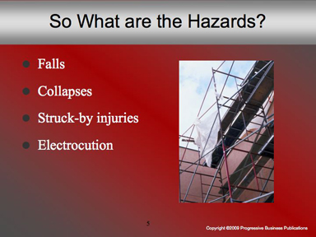

Speaker’s Notes
- The safety hazards that come with working on scaffolds are all those associated with working with heights. We’re talking about falls from the scaffold, collapses of the structures, struck-by hazards from dropped equipment or materials and electrocution from power lines.
- We’ll look at each hazard, and talk about a few ways to prevent related accidents.
- Falls are the number one hazard. Every year, falls consistently account for the greatest number of fatalities in the construction industry. Even a height of six feet can be dangerous if a worker’s not taking the proper precautions.
- Collapses are next. A scaffold that’s unstable or overloaded by equipment is an immediate threat to workers standing on the scaffold, and anyone working in the surrounding area.
- Struck-by hazards are a major danger to anyone working underneath the scaffold if tools, work materials or debris fall from above.
- Electrocution is a concern whenever a scaffold’s in close proximity to overhead power lines.

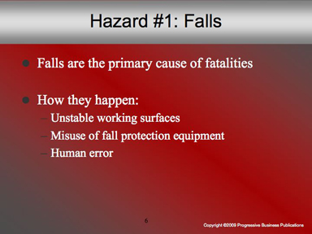

Speaker’s Notes
- Every year, falls account for the greatest number of fatalities in the construction industry.
- How does it happen?
- Unstable working surfaces can cause a worker to lose his footing, if the planks or guardrails aren’t properly in place.
- Misuse of fall equipment: It’s not enough to have a harness and lifeline on the site – everyone has to know how to use them, and be encouraged to use them any time heights are involved.
- Human error: None of us are perfect, and we will make mistakes from time to time – which is all the more reason to put extra time and effort toward taking the right safety steps.

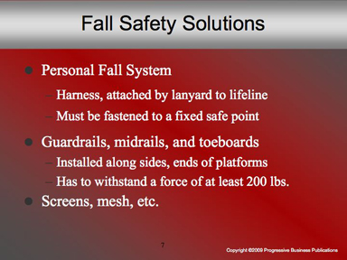

Speaker’s Notes
- What kind of fall precautions can you take?
- First, personal fall-arrest systems are required. A fall-arrest system consists of a harness, hooked to a lifeline and secured on a safe point on the building.
- Guardrails are next. These need to be installed along all open sides and ends of platforms – before any worker is allowed on the scaffold to work. These guardrails have to withstand a force of at least 200 pounds.
- Screens, mesh, and other nets are recommended, too – and these need to be able to withstand a force of at least 150 pounds applied downward.

Suggestions for the Speaker
- Make sure you have an actual fall protection system available for view (this will be useful for the next slide, too); also have examples of screens and mesh on-hand as well.
- Have picture examples of guardrails in the employees’ workspace.

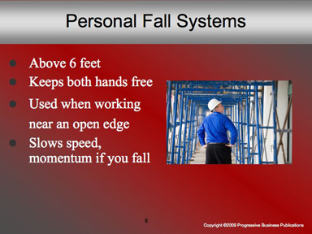

Speaker’s Notes
- The best way to limit your chances of falling from scaffolding is to wear fall arrest equipment – a harness and lifeline.
- In addition to allowing you to keep both hands free when working up high, it can keep you safe when working near an open edge, where there’s nothing to hold onto if you slip.
- And in the worst-case scenario that you do slip, the fall arrest equipment system is designed to slow both your speed and momentum, greatly reducing your risk of injury.

Suggestions for the Speaker
As you’re speaking, display each part of the fall arrest system – the lifeline, the harness, and all latches and rings.

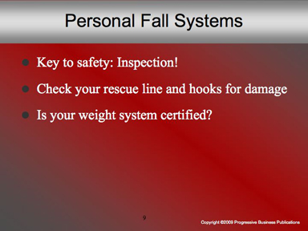

Speaker’s Notes
- The key to making sure your equipment will do what it’s supposed to – save your life in the event of a fall – is simple: You have to inspect and maintain it.
- Check the line. Look for tears, cracks, or ripped stitches.
- Check the rings and hooks. If the metal is cracked or burred, there’s a good chance it could cut your line.
- Do the rings lock properly? They’re supposed to be self-locking to keep them from slipping during a fall. Any damage or alteration to the ring could impair that ability.
- Remember, your fall system should be certified to work with your weight.
- If you have any questions about the upkeep of your system, make sure to ask a supervisor for help – before you climb onto the scaffold with it.

Suggestions for the Speaker
Before starting the slide: Here you can show workers some examples of broken equipment: frayed rope lines, broken or burred metal, etc. Pass it around and ask workers how the damage might affect their safety.

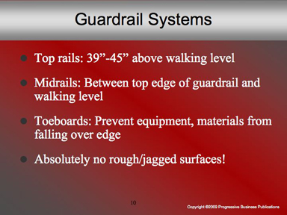

Speaker’s Notes
  - In addition to personal fall systems, guardrails should be put into place when setting up the scaffolds.
  - Think of them as top, middle, and bottom rails, set up to keep you and your equipment from falling over.
  - Top rails are between 39 and 45 inches high, and need to be capable of withstanding 200 pounds of force in any direction.
  - Midrails (this includes screens, mesh, or any other intermediate nets) need to withstand 150 pounds of force.
  - Toeboards are placed at the base of the guardrail system – they’re used to block tools, equipment, or materials from sliding off the walking area and potentially striking someone underneath.
  - When inspecting rails, it’s important to keep an eye out for rough or jagged edges. These can cause punctures, lacerations or snagged clothing.

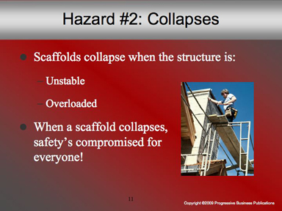

Speaker’s Notes
- Our second major hazard is a collapse.
- A scaffold collapse can usually be attributed to one of the following errors: Either the structure was unstable – meaning it wasn’t put together right or parts of it became unsafe through use, or it was overloaded – meaning it couldn’t support the excess weight of the workers and/or equipment and materials placed on it.
- Either scenario can lead to a scaffolding collapse. And if it does, everyone’s at risk.
- That includes the workers on the scaffolding, even if they’re wearing fall protection; and those underneath, even if they’re wearing hardhats.

Suggestions for the Speaker
This is a good time to play “What’s Wrong With This Picture?” Gather some photographic examples of scaffolding that’s damaged, improperly built, or otherwise hazardous. If the pictures are big enough to display, do so, and ask workers if they can point out the dangers in each photo. (Hazards to look for will be discussed in the next few slides.)

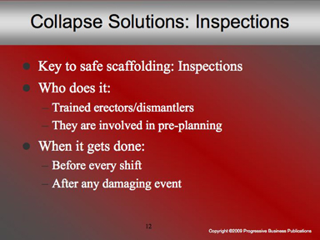

Speaker’s Notes
- The key to making sure the scaffolding structure is safe is constant, thorough inspections.
- Inspections are performed by an employee who has received training and/or certification in erecting and disassembling scaffolding. This is a worker who can identify existing and predictable hazards and has authorization to take corrective measures to eliminate those hazards.
- This also involves pre-planning, including: determining the type of scaffold needed for the job; calculating the maximum load; assuring a good foundation; and avoiding electrical hazards.
- Inspections need to be taken care of before every work shift, to ensure all materials are in strong working condition and can take the strain of the next shift’s workload. In the case of a damaging event, the inspection is required to locate and swap out any damaged piece of the structure if needed.

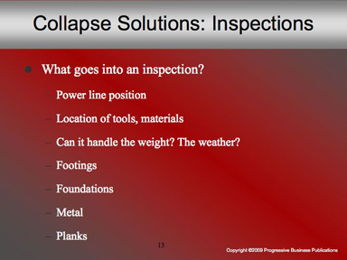

Speaker’s Notes
- What goes on during a scaffolding inspection? These are just a fraction of what’s covered:
- Power lines are checked to make sure they’re de-energized and at least 10 feet from the scaffolding and any tools and materials on the scaffold.
- The scaffold is verified as the right type for the loads, materials, workers and weather conditions it’ll have to withstand.
- Footings are checked to see if they are level, sound, rigid, and capable of supporting the loaded scaffold.
- Legs, posts, frames and uprights are checked to make sure they’re firmly on baseplates and mudsills.
- Metal components are examined for cracks, bends, rust, broken welds or any other damage.
- So are the wooden planks: Are there cracks? Splits? Are they close together?
- There are plenty more boxes to be checked off, too – ask your supervisor for a complete list.

Suggestions for the Speaker
Before beginning this slide, present the question to the workers: What goes into a pre-shift scaffolding inspection? Write down the answers on a whiteboard.

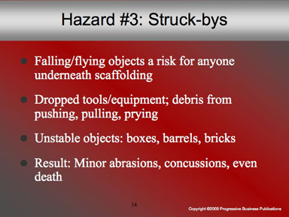

Speaker’s Notes
- Scaffolding safety doesn’t just mean being safe on scaffolds – it includes being safe when you work around them, too. And a major hazard for those underneath scaffolding is struck-bys from falling or flying objects, including:
- Dropped tools
- Debris that becomes airborne thanks to pushing, pulling, or prying, and
- Unstable objects like barrels, boxes, bricks and other materials.
- For those underneath, a struck-by injury could result in anything from minor abrasions to concussions, blindness, and even death.

Suggestions for the Speaker
- Have examples of drop hazards – a hammer, a piece of drywall, a brick – and drop them from a normal height.
- Ask workers to imagine the damage any of these objects could do from an elevated height.

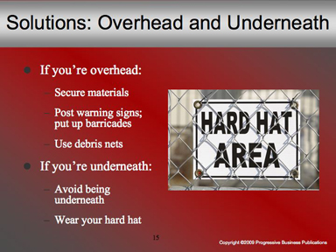

Speaker’s Notes
- Struck-by hazards are everyone’s concern, because if they happen, you fall into one of two camps: Either you got hit, or you dropped something!
- If you’re on the scaffolding, your job is to keep everything secure.
- Make sure equipment and materials are neatly stacked, and set up toeboards to prevent falling objects.
- Let people know you’re up there. Post warning signs whenever activity’s occurring. Barricade the area in high hazard times.
- Set up debris nets, catch platforms or canopies to catch or deflect falling objects.
- If you’re underneath, your job is simpler: Don’t get hit!
- The easiest way to do that, of course, is not to be underneath if an object falls. Observe warning signs and barricades – they’re for your safety.
- If you have to be underneath, protect yourself. A hard hat will give you a better chance of avoiding a head injury if a hammer falls above you.

Suggestions for the Speaker
- Show warning signs that should be posted when workers are on scaffolding.
- Have debris nets on hand as an example.
- Place a hard hat on the floor, and drop a hammer on it, to show what impact from a normal height is like.

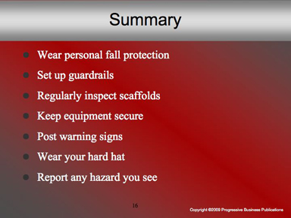

Speaker’s Notes
In conclusion:
- When you’re on scaffolds, make sure you’re wearing a personal fall system. Regularly inspect every part of it – lifeline, harness, rings – for any sign of damage.
- Set up guardrails, midrails and toeboards to prevent yourself and your equipment from falling.
- To prevent a collapse, make sure scaffolding is inspected before every shift to ensure the material’s right, the footings are secure, the planks are tight and the whole structure is braced.
- If you’re on the scaffold, secure all equipment and work materials to prevent them from sliding off and causing a struck-by hazard.
- Let ’em know you’re up there: Post warning signs, tape and barricades if needed.
- If you’re working underneath, protect yourself. Wear your hard hat, and you may avoid a serious head injury.
- And if you see anything that might be a hazard, speak up! Report it to a supervisor ASAP.

