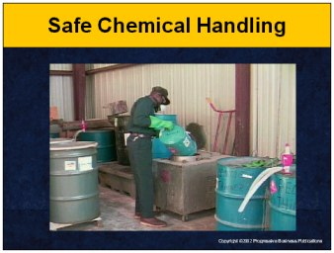

Speaker’s Notes
- Today we will be discussing Safe Chemical Handling. This training is part of OSHA’s standard on Hazard Communication (29 CFR 1910.1200).
- You will learn about:
  - The types of hazardous chemicals we have at our facility.
  - How these chemicals can enter your body.
  - How you can reduce your exposure to these chemicals.
  - The location of and how to read Material Data Safety Sheets.
  - What to do in case of a spill or leak of a hazardous chemical.

Suggestions for the Speaker
  - An effective ice breaker is to ask the trainees the following questions:
- Has anyone ever worked with hazardous chemicals in the office
or at home?
- What types of precautions did you take when you were working
with these chemicals?

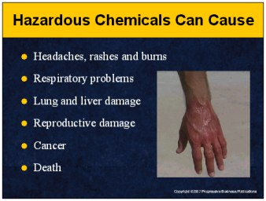

Speaker’s Notes
- It is important to understand the health hazards caused by chemical exposure because it could save your life one day.
- Symptoms from these health hazards can occur immediately after being exposed. Examples are headaches, dizziness, nausea and chemical burns. You may have difficulty breathing, feel a burning sensation when you breathe, break out in a rash or have a burning sensation in your eyes.
- Other types of illnesses from hazardous chemical exposure are referred to as chronic. These are more dangerous because you may not notice the damage at first, but later in life you will develop respiratory problems, lung or liver damage, reproductive damage, cancer or even death. Examples are lung cancer from cigarette smoking and black lung from coal mine dust.

Suggestions for the Speaker
- Share a story of an injury or illness cause by unsafe chemical handling. If you do not have one, you can use the following true story:
- A company’s regular forklift was broken, so they borrowed a gas-powered forklift from a nearby trucking company. The forklift’s motor had not been adjusted for fumes. Dangerous levels of carbon monoxide built up inside the enclosed area. Thirteen employees were affected. Some lost consciousness completely, while others suffered severe nausea and lingering dizziness.

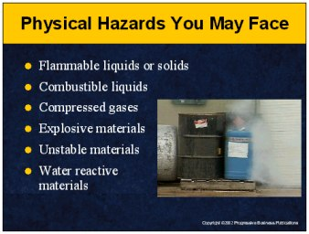

Speaker’s Notes
In addition to the health hazards, you need to be concerned about physical hazards created by chemicals on the job:
  - Flammable liquids or solids are materials that can easily catch fire. Under certain conditions, they can lead to explosions. Some examples of flammable materials include paints, propane and gasoline.
  - Combustible liquids, while not igniting as easily as flammable liquids, still can ignite under certain circumstances.
  - Compressed gases are stored under high pressure, allowing the gases to rush out quickly if their container or piping is punctured. They may cause serious burns or respiratory difficulties when released.
  - Explosive materials can cause widespread damage to life and property if ignited or pressurized.
  - Unstable materials are highly sensitive to certain conditions such as exposure to air, high pressure, light, high temperatures or sudden shocks, such as dropping them. These conditions cause them to change and become very dangerous.
  - Water reactive materials become highly dangerous when exposed to water.

Suggestions for the Speaker
For each category, point out specific examples in your facility.

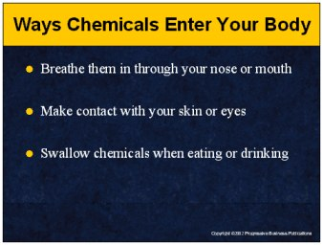

Speaker’s Notes
- We’ve discussed the risks of chemical hazards, but how do the chemicals actually get into your body?
- The majority of hazardous chemical exposures occur through breathing vapors or fumes. The damage can occur if you breathe them in through your mouth or your nose. Initial symptoms are headaches, nausea or dizziness.
- You can be exposed to chemical hazards when hazardous materials touch your
skin or eyes. Splashes are the most common cause, but there are other ways, for example, if you work with a chemical and rub your eyes or skin without washing your hands. This is particularly dangerous when working with corrosive materials that can burn your skin or eyes. Typical symptoms are irritation, itchiness, blisters and hives.
- You can swallow hazardous chemicals when eating or drinking. If you don’t wash you hands when you take a break to eat, you could contaminate your food with chemicals. If you leave a soda or coffee mug in a hazardous area, it may become exposed and you could end up drinking hazardous chemicals. Nausea, vomiting and dizziness are typical reactions.

Suggestions for the Speaker
- Ask the trainees to name some of the hazardous chemicals that they may come in contact with during their work.
- This would be a good time to point out the locations of the hazardous chemicals in your facility.

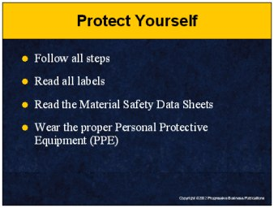

Speaker’s Notes
- Protect yourself from hazardous chemicals by following all the proper steps when handling chemicals. Skipping steps could put your life at risk.
- Your first line of defense is to read the chemical label. This will give you the basic information about a chemical and will let you know if there are any risks.
- For more detailed information, refer to the Material Safety Data Sheets. These sheets contain information prepared by the manufacturers that explain how to safely use the chemical and how to respond to an emergency.
- Personal protective equipment will reduce your direct exposure to harmful chemicals. It can be your best defense against potential hazardous health effects caused by direct exposure to a hazardous substance. By simply wearing the proper equipment when working with a hazardous chemical, you’ve greatly reduced your risk of injury or death.

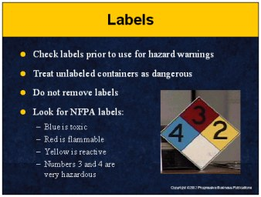

Speaker’s Notes
- The easiest way to begin protecting yourself is by always reading the label before using an unfamiliar chemical or substance.
- In most cases the label will indicate if the chemical is hazardous. Look for keywords like hazardous, toxic, dangerous, corrosive, irritant or carcinogen. In some cases the label itself will provide information on appropriate personal protective equipment, safe handling practices and proper emergency response if something goes wrong.
- All containers must be labeled. Do not work with chemicals stored in unlabeled containers. Do not remove or deface existing labels on containers.
- You can determine the risk level of a chemical by examining the National Fire Prevention Association Labels. These labels are found on chemical containers, tanks and doorways to chemical storage areas.
- Blue indicates the severity of the health hazard, red indicates flammability, and yellow indicates reactivity. The higher the number on the color, the greater the risk. The numbers 3 and 4 represent hazardous situations.

Suggestions for the Speaker
- Pass out examples of labels used in your facility.
- Bring in examples of NFPA labels that are used in your facility to identify hazardous substances.

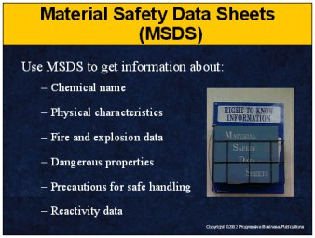

Speaker’s Notes
Material safety data sheets are documents prepared by the chemical’s manufacturer or importer. Our facility has Material Safety Data Sheets for every chemical you work with here. Use these sheets to get more information about:
- The name of the chemical, manufacturer’s or importer’s name, address and telephone number.
- Physical characteristics of the chemical. This includes a description of the chemical’s appearance and odor.
- Fire and explosion data which will tell you the conditions under which the chemical may ignite or explode.
- The dangerous properties of the chemical, including whether the chemical is listed as a carcinogen, which can cause cancer.
- Precautions for safe handling and use of the chemical which include control measures, personal protective equipment and first aid procedures if exposure occurs.
- Reactivity data, which will identify substances that will dangerously react with the chemical.

Suggestions for the Speaker
Now is a good time to hand out sample Material Safety Data Sheets used at
your facility and point out where they are stored.

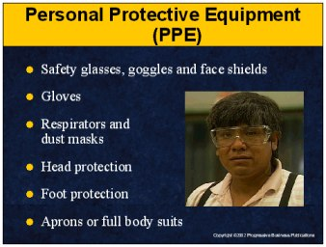

Speaker’s Notes
- When handling hazardous chemicals it is important to reduce your direct exposure to the chemical. Personal protective equipment (PPE) will help you achieve this goal. This equipment will reduce the likelihood that you will accidentally inhale, ingest or have direct skin contact with hazardous substance. Do not use a hazardous chemical without checking for the personal protective equipment requirements.
- Safety glasses, goggles and face shields should be worn for protection from splashes, sprays or mists.
- Gloves should be worn to protect you from chemical hazards when handling them.
- Respirators and dust masks should be used when working in areas where hazardous vapors, fumes or dusts are present.
- Foot, head protection and full body protection are worn to protect against skin contamination if, for example, you are working with strong acids, acid gases, organic chemicals, strong oxidizing agents and the like.
- Remember, first check the label for PPE requirements. If none are given, go to
the material safety data sheets.

Suggestions for the Speaker
- Ask one of the trainees to come up and demonstrate the proper way to put on and wear personal protective equipment.
- Point out to the trainees where your personal protective equipment is stored.

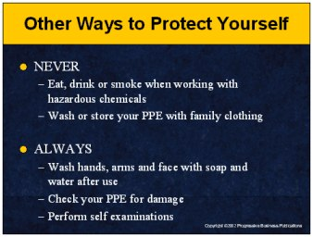

Speaker’s Notes
- Never eat, drink or smoke when working with hazardous chemicals. The risk is that your food, drink or cigarette will become contaminated and you’ll wind up putting hazardous chemicals into your body.
- Never wash or store your PPE with your family’s clothing. Traces of the substance can contaminate your family’s clothing and cause burns, rashes or even allergic reactions that can lead to death.
- Always wash your hands, arms and face before eating, drinking or smoking. The hazardous substances can remain on your body, causing injuries and illness.
- All personal protective equipment should be inspected for cracks, tears, scuffs or any other factor that may make the equipment ineffective. Using damaged equipment will result in the same types of injuries as if you were not wearing any equipment at all. If you believe your protective equipment is damaged, give it to your supervisor for disposal.
- Perform self-examinations to ensure there are no burns or rashes on your body. If anything suspicious is found, immediately consult your family physician.

Suggestions for the Speaker
- Pass out examples of damaged equipment, so that trainees understand what they should be looking for.

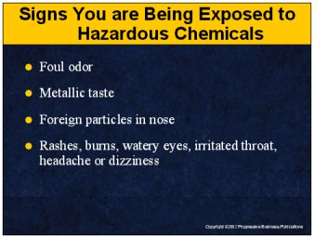

Speaker’s Notes
- We hope it never happens, but you should always be aware of the signs that you are being exposed to hazardous chemicals. Some example are:
- Foul odors
- Metallic taste
- Foreign particles in your nose
- Rashes
- Burns
- Watery eyes
- Irritated throat
- Headaches
- Dizziness
- You should rely on your senses and be aware of your physical health. If you think there may be an exposure, the first thing you should do is protect yourself and leave the area where the potential hazardous exposure is taking place.

Suggestions for the Speaker
Ask the trainees what they would do if they or their co-worker were exposed to hazardous chemicals. This is a good “lead in” to the next slide.

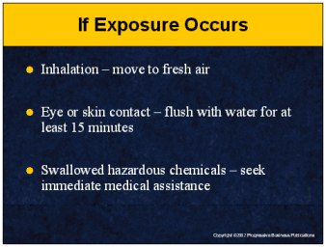

Speaker’s Notes
- If you are exposed to a hazardous chemical, be prepared to react fast. In all cases, report the incident immediately to your supervisor. Describe the chemicals you were working with when the incident occurred. If possible, bring the MSDS.
- If you think you are inhaling hazardous fumes or vapors, leave the source of the fumes or vapors and move to an uncontaminated area.
- If hazardous materials get into your eyes, flush them with running water for at
least 15 minutes.
- If you have a spill on your skin, immediately run cold water on the spill for 15 minutes. If you notice a rash or other types of discoloration, report this to your supervisor and seek immediate medical attention. If chemicals are spilled on you in large amounts, quickly remove all contaminated clothing and use a safety shower or other available source of water to rinse yourself thoroughly.
- If you believe you’ve swallowed or drunk a hazardous chemical, notify your supervisor and seek immediate medical attention.

Suggestions for the Speaker
Review your facility’s specific emergency response procedures related
to chemical exposure and point out the location of any first aid kits, eyewash stations and showers.

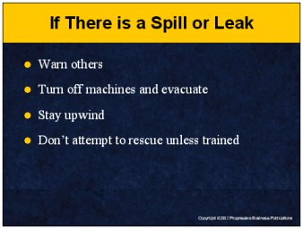

Speaker’s Notes
- If you suspect a hazardous chemical spill or leak, warn your co-workers in the immediate area and get out of there. Alert your co-workers by yelling or setting
off an alarm.
- Evacuate to an established meeting area that is a safe distance from the spill
or release. If you can do so quickly, turn off all machinery that is near the spill. Many types of hazardous materials are flammable and the sparks from machinery can start a fire.
- A chemical release or spill can cause a toxic cloud. When evacuating, protect yourself by staying upwind of the release or spill.
- It may be tempting to go back and help your co-workers, but you must only help
if you are trained to do so. If you are not trained in emergency rescue procedures, do not re-enter the hazardous space. Many deaths are from “would-be rescuers.”
In some cases, unsuccessful rescuers have died while the initial victim lived.

Suggestions for the Speaker
- Describe the alarms or signals that are to be used in your facility when hazardous materials are identified.
- Now is a good time to discuss your company’s evacuation procedures.

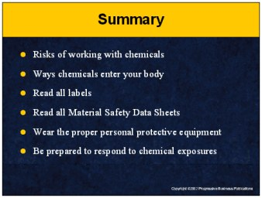

Speaker’s Notes
- It is important to understand the health hazards caused by chemical exposure because it could save your life one day. These chemicals can cause headaches, rashes, burns, respiratory problems, lung and liver damage, reproductive damage, cancer and even death.
- Hazardous chemicals enter your body by breathing them in through your nose or mouth, making contact with your skin or eyes or swallowing them when eating or drinking.
- Your first line of defense is to read the chemical label. This will give you the basic information about a chemical and will let you know if there are any risks. Never work with a new chemical or substance without first examining the label.
- For more detailed information about a chemical, refer to the Material Safety Data Sheets. These sheets contain information prepared by the manufacturers that explain how to safely use the chemical and how to respond to an emergency.
- Personal protective equipment will reduce your direct exposure to harmful chemicals. It can be your best defense against potential hazardous health effects caused by direct exposure to a hazardous substance. By simply wearing the proper equipment when working with a hazardous chemical, you’ve greatly reduced your risk of injury or death.
- If you are exposed to a hazardous chemical, be prepared to react fast. In all cases, report the incident immediately to your supervisor. Describe the chemicals you were working with when the incident occurred. If possible, bring the MSDS.
- If you inhale a hazardous chemical, move to fresh air.
- If chemicals contact your eye or skin, flush with water for at least 15 minutes.
- If you swallow or drink hazardous chemicals, seek immediate medical assistance.

