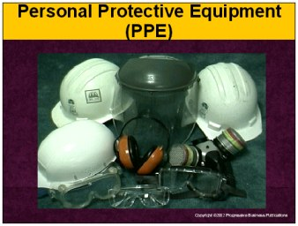

Speaker’s Notes
- Today’s topic is personal protective equipment. This training is a part of OSHA’s Personal Protective Equipment Standards (29 CFR 1910.132-139).
- You will learn about:
  - Risks to your head, eyes, ears, hands, body and feet in the workplace.
  - Types of personal protective equipment that will reduce the chance
of injury.
  - The location of this protective equipment in this facility.
  - How to wear and care for your personal protective equipment.

Suggestions for the Speaker
An effective ice breaker is to ask the trainees the following questions:
- Has anyone ever injured themselves in the workplace?
- If so, what were you doing and how could you have prevented
your injury?

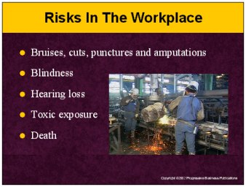

Speaker’s Notes
- Accidents can happen at any time in our workplace. The damage can range from a simple cut or bruise to death. All accidents have the potential to require painful rehab or lost income. Some examples are:
- Flying pieces of wood or metal from a grinding wheel or saw, causing bruises, cuts, punctures and even amputation.
- Tools crashing into your face, damaging your eyes or causing blindness.
- Prolonged exposure to machine noise, causing hearing loss.
- Dangerous, unseen particles in the air exposing you to toxic injuries requiring long term and painful recovery.
- Flying objects, chemical exposure and even excessive heat or cold resulting in serious injuries or death.

Suggestions for the Speaker
- Share a story about someone who was injured, as a result of not wearing personal protective equipment. If you do not have one, you can use the following true story:
- A 40-year-old man was working in the vicinity of high-voltage power lines. He left his super-insulated gloves in his truck, but decided to continue working anyway. He contacted the high-voltage wires and was electrocuted. Had the man went back and got his gloves, he would still be alive today.

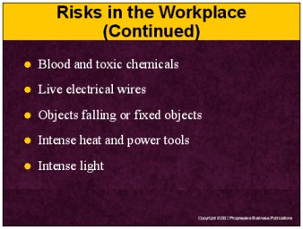

Speaker’s Notes
- We have talked about some risks in the workplace already, but there are many more that you need to be concerned with.
- Blindness, infection, long-term illness or even death can be caused by blood or toxic chemicals leaking from their containers.
- Electrocution, disability and death all are potential outcomes when you come into contact with live electrical wiring.
- Puncture wounds and amputations are real possibilities when tools fall from up above and strike you. Even fixed objects, such as a low column or beam, can cause a serious head injury if you are not aware of their location.
- You can be burned by intense heat from molten metal when it splashes. Burns and permanent skin damage can be caused by explosions caused by gasoline-powered tools.
- Blindness can occur from the intense light from welding or lasers.

Suggestions for the Speaker
Ask the trainees if they can name other risks in your facility that require personal protective equipment.

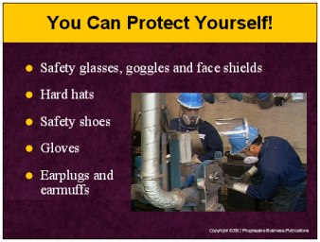

Speaker’s Notes
- Personal protection equipment will reduce your risk of injury in the workplace. If you are ever unsure if you are properly protected, talk to your supervisor.
- Safety glasses, goggles and face shields will protect your face and eyes from hazards such as flying pieces of wood or metal that can lodge into your eye and cause damage or blindness.
- Hard hats will help protect your head from falling objects and other hazards in the workplace that could fracture your skull.
- Safety shoes are available to protect your feet from:
- Rolling objects such as barrels and forklift tires.
- Falling objects such as metal parts or tools.
- Sharp objects such as nails and spikes.
- Gloves will protect you from burns, serious cuts or even amputation.
- Earmuffs and earplugs will protect you from hearing loss.

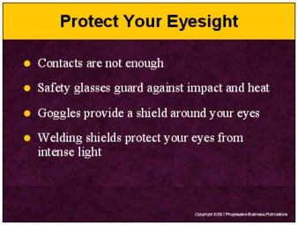

Speaker’s Notes
- Your eyes are very delicate and can easily be damaged from injury. If the injury is severe enough, you may lose your vision or need to have your eyes removed.
- If you wear contacts, they will not protect you. Prescription safety glasses are available and will keep your eyes protected.
- Safety glasses are the most widely used type of eye protection. While they may look similar to regular glasses, they are much stronger and more resistant to impact and heat than regular glasses.
- Goggles will protect you from hazards that may not be directly in front of you, such as small flying particles from grinding, chiseling, sanding or hammering.
- If you are welding, you will need a face shield with filtered lenses to protect your eyes from the intense light.

Suggestions for the Speaker
- Ask the trainees if they can name any activities in the workplace that require protective eyewear.
- Demonstrate how to properly put on and take off protective eyewear.
- Point out to the trainees where your protective eyewear is stored.

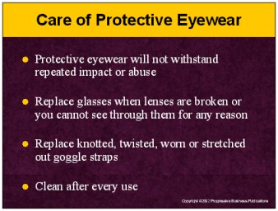

Speaker’s Notes
- Protective eyewear is designed to guard against accidental injury. They will not withstand the repeated impact of abuse. Inspect them regularly for scratches, cracks or other wear and replace them if they are scratched, bent or uncomfortable. Scratches not only interfere with your ability to see what you are doing, they can weaken the structure of the lenses and its resistance to impact.
- Clean lenses after every use with soap or mild detergent and water or special solution designed for that purpose. Never use abrasive soaps, rough paper or cloth towels. These items will scratch and damage your equipment. Avoid rough handling that can scratch lenses. Scratches impair vision and can weaken lenses.
- Store your eye protection equipment in a clean, dry place where it cannot fall or be stepped on. Keep it in the case when it is not worn.
- Disinfect eyewear if it’s contaminated by a hazardous chemical, or if it may be worn by another person.
- Replace glasses when lenses are scratched, broken, bent or you cannot see through them for any reason. Replace knotted, twisted worn or stretched goggle straps. Damaged glasses interfere with vision and do not provide protection.

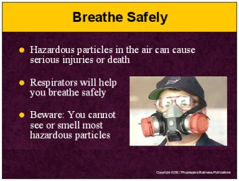

Speaker’s Notes
- Working without proper protection in an area with hazardous particles in the air can cause cancer, lung disease and death, as well as problems with the liver, kidneys, heart and nervous system.
- Some of the most common hazards that can harm you are dust, fog, smoke, mists, fumes, gases, vapors, sprays and the lack of oxygen.
- Use a respirator whenever you enter an area with hazardous particles in the air. If you are unsure if you need to wear a respirator, ask your supervisor.
- You must make the decision as to whether or not a respirator is required before work begins. Many times you will not be able to see or smell hazardous particles in the air, and it’ll be too late once you realize you’re in danger.

Suggestions for the Speaker
- Ask a trainee to demonstrate how to properly put on and use a respirator.
- This would be a good time to point out all of the hazardous conditions in your facility that require respirators.

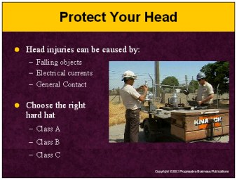

Speaker’s Notes
- Head injuries happen quickly and have serious consequences, such as lost time from work, income loss, disability and even death. Head injuries can be caused by:
- Objects falling from above and striking you on your head.
- Electrical hazards coming in contact with your head.
- Bumping your head against fixed objects, such as exposed pipes or beams.
- The right hard hat will protect you from these risks:
- Class A hard hats are for impact protection. They will protect you from injuries caused by falling objects but provide limited protection from electrical shocks and burns.
- Class B hard hats will protect you from injuries caused by both falling objects and electrical shocks and burns.
- Class C hard hats, also known as bump caps, are designed for comfort. They will protect you from injuries caused by bumping into objects within your facility, but provide limited protection against falling objects and electrical shocks and burns.

Suggestions for the Speaker
- Let the trainees know which hard hats are recommended for tasks within
your facility.
- Let the trainees know where your hard hats are stored.

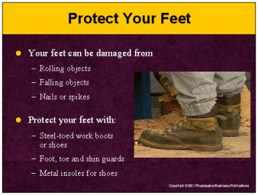

Speaker’s Notes
- A broken foot will keep you out of work for a long time and require long painful rehab. You can seriously damage your foot in the workplace when you come in contact with:
- Rolling objects such as barrels and forklift tires.
- Falling objects such as metal parts or tools.
- Sharp objects such as nails and spikes.
- Protect your feet with:
- Steel-toed work boots or shoes.
- Foot, toe and shin guards which are used when greater impact protection is needed.
- Metal insoles in shoes that protect against puncture wounds.

Suggestions for the Speaker
- Ask the trainees if they can describe a task in your facility that would require foot protection.
- Let the trainees know where your foot protection equipment is stored.

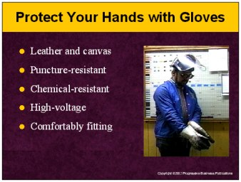

Speaker’s Notes
- Have you ever noticed how quickly a circular saw cuts through wood or how easily a nail gun can shoot through wood? These are just two of the many risks to your hands in the workplace. Choosing and wearing the right type of gloves will protect you from serious cuts or even amputation.
- Leather and canvas are the most common type of gloves and will protect you from sparks, moderate heat and rough objects.
- Puncture-resistant gloves will protect you from saws, drills or knives. If needed, you can attach cut-resistant sleeves to protect your arms.
- Chemical-resistant gloves should be used to protect your hands from irritation and serious burns. Do not touch any chemicals unless you are sure the gloves you have chosen will protect you.
- High-voltage gloves will protect you from dangerous electrical contact. These gloves are black rubber with a red interior so that any cuts or damage to the glove can be seen from the outside.
- Hand protection should fit comfortably and should not be so tight that it limits hand movement or so loose that it presents a hazard of being snagged.

Suggestions for the Speaker
- Ask the trainees if they can name activities that require using hand and arm protection.
- Let the trainees know where your gloves are stored.

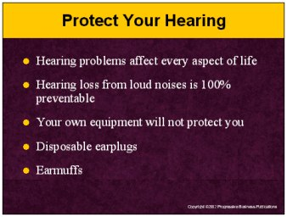

Speaker’s Notes
- How would your life change if you could not hear? Can you picture what your life would be like if you could not listen to music or the sounds from the television? If you develop a hearing problem, it affects every aspect of your life. It can make life uncomfortable for you, your friends and your family.
- Hearing loss from loud noises is 100% preventable. But once you lose your hearing, you will never get it back.
- Personal hearing protection is anything that can be used to reduce the level of the sound entering your ear. Earmuffs, ear canal caps, disposable and reusable ear plugs are the main types of devices used. Do not use your own equipment as protection. For example, personal headphones will not protect your hearing.
- Disposable earplugs are expandable foam plugs made of a pliable material designed to expand and conform to the shape of your ear canal. They fit snugly in your ear canal, providing protection from noise.
- Ear muffs fit over the whole ear with cushions, which can be filled with foam, liquid or air. These cushions work to block out noise by completely covering the outer ear and sealing against the side of the head.

Suggestions for the Speaker
- Ask trainees to come up and demonstrate the proper method of wearing hearing protection.
- Let the trainees know where you store your personal hearing protection.

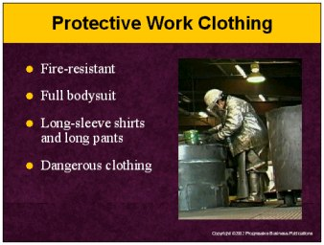

Speaker’s Notes
- Many jobs require more than gloves, boots and eyewear for protection. These dangerous jobs have specific clothing requirements to reduce the chance of injury.
- Fire-resistant clothing should be worn by welders and grinders who are exposed
to hot sparks, to protect against the painful burns caused by the sparks.
- If you work with dangerous chemicals, you may need to wear full bodysuits made of rubber, neoprene or plastic to guard against burns and toxic exposures.
- Long-sleeve shirts and long pants will help protect you from hot and cold materials that cause skin damage. This clothing will also help protect against sharp or rough materials, such as wood or metal, which can cause cuts or bruises.
- Avoid wearing loose sleeves, ties, cuffs or jewelry when working on machines with rotating parts. These machines can pull you into the machine and can cause severe fractures and crushing injuries.

Suggestions for the Speaker
- Let the trainees know what types of clothing they should wear to help
protect themselves.
- If there is specific protective clothing, let the trainees know where it is stored.

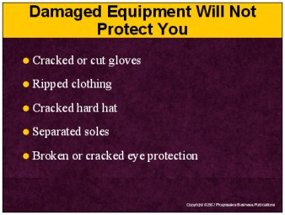

Speaker’s Notes
- All personal protective equipment should be inspected for cracks, tears, scuffs or any other factor that may make the equipment ineffective.
- Using damaged equipment will result in the same injuries as if you were not wearing any type of equipment at all. If you believe your protective equipment is damaged, give it to your supervisor for disposal.
- Here are some examples of what you should be looking for:
- Scratches on protective eyewear not only interfere with your ability to see what you are doing, they can weaken the structure of the lenses and its resistance to impact. Using glasses when lenses are broken will cause even greater injury, potentially to other body parts.
- Gloves that are cracked or cut, will not protect you from punctures or cuts.
- Hard hats that are cracked will not protect you from head injuries.
- Shoes with separated soles will not protect you from toxic spills or electrical contact.
- Clothing that is ripped will not protect your body from sharp or rough materials that can cause cuts and bruises. Tight-fitting clothing that loses its elasticity does not provide protection from cold or warm conditions.

Suggestions for the Speaker
Pass out examples of damaged equipment, so that trainees understand what they should be looking for.

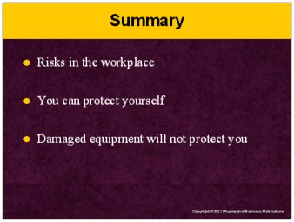

Speaker’s Notes
- Remember that accidents can happen at any time in our workplace. The damage can range from a simple cut or bruise to death and all accidents have the potential to require painful rehab or lost income.
- You can protect yourself:
- Safety glasses, goggles and face shields protect your eyes.
- Ear plugs and muffs protect your hearing.
- Gloves protect your hands.
- Respirators protect your hearing.
- Hard hats protect your head.
- Protective clothing guards your body.
- Safety shoes protect your feet.
- Using damaged equipment will result in the same types of injuries as if you were not wearing any type of equipment at all. If you believe your protective equipment is damaged, give it to your supervisor for disposal. Look for:
- Gloves that are cracked, cut or discolored.
- Clothing that is ripped.
- Hard hats that are cracked.
- Soles that are separated from the shoe.
- Protective eyewear that is cracked.

