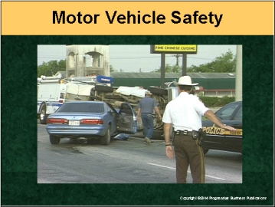

Speaker’s Notes
- Today’s topic is Motor Vehicle Safety. The reason we’re here today is because driving is such an important part of our jobs.

- You will learn about:
- How you can be safer behind the wheel.
- Preparations for driving in all sorts of conditions.
- Driving defensively.
- What to do in emergency situations.

Suggestions for the Speaker
An effective icebreaker is to ask the trainees the following questions:
- Ask for a show of hands: Has anyone ever been in a car accident?
- What are some of the reasons people get into accidents?
- How can these types of accidents be avoided?

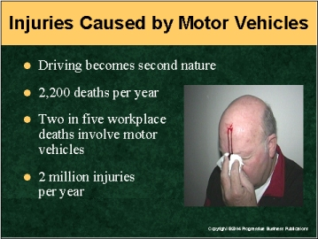

Speaker’s Notes
- We may take driving for granted because we do it all the time. Everyone has a story about a horrible car crash that involves broken bones, time out of work or maybe even death. Our goal is for you to work safely and get back safely to your family and friends.
- Here’s why motor vehicle safety while driving for work is important:
- Motor vehicle accidents account for 2,200 workplace deaths each year.
- Two in five workplace deaths involve motor vehicle crashes. It’s the leading cause of work-related deaths for U.S. workers.
- About 2 million people suffer disabling injuries each year due to motor vehicle accidents.

Suggestions for the Speaker
- Now would be a good time to ask someone to tell a story about someone who was injured or killed in a motor vehicle accident. If no one has one, you can use the following story.
- A man was driving for work when he took his eye off the road for just a moment to adjust his rear-view mirror. He swerved onto the road’s shoulder and hit a car parked there. A man inside the car was killed.

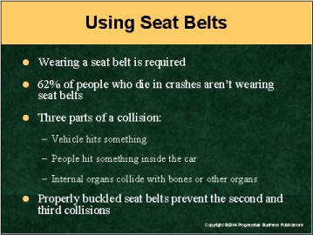

Speaker’s Notes
- Do you automatically buckle your seat belt when entering a vehicle? It’s our policy that all employees driving for business must wear their seat belts, whether they’re a driver or passenger.
- Here’s why we require seatbelt use: 62% of people who die in motor vehicle accidents aren’t wearing theirs.
- Why wear seat belts? Because a vehicle collision is really three collisions in one.
- First, the vehicle hits something.
- Then people hit something inside the vehicle such as the steering wheel or windshield. When people hit something inside the car, they hit it at the speed the vehicle was traveling. So, if the vehicle was going 55 miles per hour, the people will hit the windshield at the same speed, causing serious damage to the body. This second collision can cause serious injuries or even death.
- Then organs inside the person’s body collide with other organs or bones. This can cause serious permanent damage or even death.
- During a crash, properly fastened seat belts can keep you from hitting a windshield or another hard car part. Also, they distribute the force of the crash over stronger parts of your body, such as the chest, hips and shoulders, to help prevent internal injury.

Suggestions for the Speaker
This might be a good time to remind workers that seat belts also protect you in accidents that are caused by other vehicles. Here’s an example:
Two men were driving on a highway when their sport utility vehicle was hit from behind by a tractor-trailer. Neither man in the SUV was wearing his seat belt. Both were thrown from the vehicle and killed.

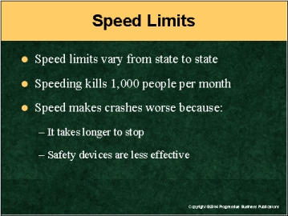

Speaker’s Notes
- Driving above the speed limit is very common. Many people do it. You may think, I haven’t had an accident while driving over the speed limit. But speeding is the cause of many accidents that cause serious injuries or
even death.
- Know the speed limits for the area you’re traveling in. If you’re traveling outside of our state, be aware that states now set their own speed limits on interstate highways. Highway speed limits vary from 55 mph to 75 mph.
- Speeding is a factor in 30% of all fatal crashes, killing 1,000 people
every month.
- Speed makes crashes worse in two ways:
- It increases the distance needed to stop in an emergency.
- Safety devices such as seat belts are less effective at higher speeds.
- The larger the vehicle, the more time it takes to stop. Larger vehicles traveling at higher speeds take even longer to stop.

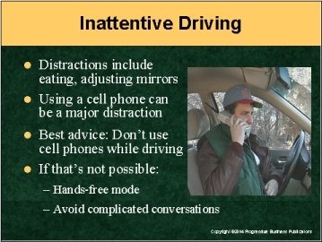

Speaker’s Notes
- Taking your eyes off the road for even a moment can lead to an accident that can seriously injure or kill you and other people involved.
- There are many potential distractions while you’re driving, such as eating, changing a radio station, adjusting mirrors, etc. All of these are better done when the vehicle is at rest, such as at a traffic light, or safely pulled off to the side of the road.
- A newer distraction to many drivers is their cell phone. It’s a particularly dangerous distraction because of the number of ways it occupies a person: They have to pick up the phone, listen, speak and drive all at the same time.
- The best advice is not to use a cell phone while you’re driving. Pull off somewhere to place or answer a call.
- If that’s not possible, follow these tips on cell phone use while driving:
- Use the cell phone in the “hands-free” mode.
- Avoid intense or complicated conversations.

Suggestions for the Speaker
- Now might be a good time to explain your company’s policy about using cell phones while driving.
- Even pulling over to the side of the road to make a cell phone call has its downsides. You might want to tell workers this story: A woman pulled over to the side of the road to make a cell phone call. She was struck from behind by another vehicle. Her car flipped upside down, and she was trapped until rescuers could help her. She didn’t have major injuries only because she was wearing her seat belt.

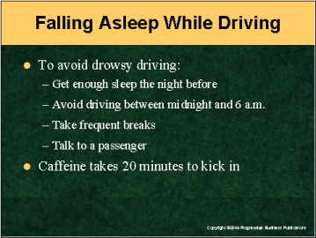

Speaker’s Notes
- Of course, no one tries to fall asleep while driving. But studies show at least 20% of all drivers have fallen asleep while driving.
- Here are some ways that you can avoid feeling drowsy while driving:
- Make sure you get enough sleep, at least seven hours for most adults, the night before your trip.
- Plan on driving during the hours when you’re most alert.
- If possible, try not to drive between midnight and 6 a.m. The body naturally needs sleep during this period.
- It’s also a good idea to take a break from driving during
the mid-afternoon (2 to 4 p.m.). That’s another time most
people feel drowsy.
- Schedule a break every two hours or 100 miles, whichever comes first.
- Talk with a passenger if you have one in the car. It will help you
stay alert.
- If you drink a beverage with caffeine (cola, coffee, tea) to help stay awake, do so during a rest break. Since it takes at least 20 minutes for the caffeine to have an effect on your body, you can use the time to rest. Then you’ll be refreshed to continued driving.

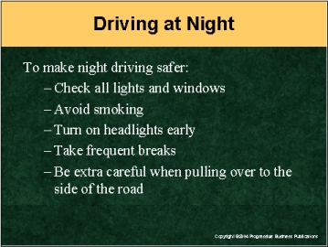

Speaker’s Notes
- Traffic deaths are three times more likely at night than during the day. So if you can drive during the day, it’s better to do that than drive at night.
- There are several things you can do to make night driving safer:
- Seeing and being seen are very important to safe night driving. So make sure headlights, taillights, signal lights and windows -- inside and out -- are clean.
- Make sure your vehicle’s headlights are properly aimed by shining them against a building. Misaimed headlights not only make it more difficult to see what’s in front of you – they make it more difficult for others to see you. If you think they’re not aimed properly, notify the proper person at your company.
- Avoid smoking while you drive. Nicotine build-up on the inside of windows reduces your ability to see clearly.
- There’s no such thing as turning on your headlights too early in the evening. Even if it doesn’t improve your ability to see in front of you, it’ll help drivers coming from the other direction to see you.
- If an oncoming vehicle shines its high beams at you, look toward the right-hand side of the road to avoid glare.
- When driving after 7 p.m., make frequent stops to rest.
- If you have to pull off onto the shoulder, do everything possible to make sure other vehicles will see you. Turn on your flashers and inside dome light. Set up a reflective triangle 300 feet behind your car.

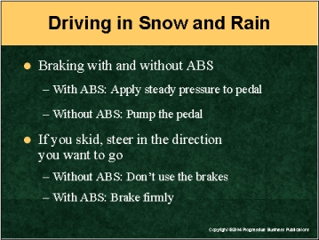

Speaker’s Notes
- You know that driving in the rain or snow is more dangerous than driving on dry pavement. The three most important things to know about driving on slippery surfaces are: braking, skidding and hydroplaning.
- Braking in slippery conditions differs for cars with or without anti-lock brakes, also known as ABS.
- If your vehicle has ABS, apply steady pressure to the brake pedal. Do not take your foot off the pedal if you feel it shake or hear a rumbling noise. That’s the ABS system pumping the brakes for you. Remember: Stomp and Steer. Keep your foot on the pedal and continue to steer around hazards.
- If you don’t have ABS, pump the brakes yourself, pumping more rapidly as the vehicle slows down.
- If your vehicle goes into a skid, take your foot off of the gas and carefully steer in the direction you want the front of the vehicle to go. If you don’t have ABS, don’t use your brakes. If you have ABS, brake firmly as you steer into the skid.

Suggestions for the Speaker
Now might be a good time to discuss ABS. Let trainees know whether your vehicles have ABS. If your employees rent vehicles or your fleet has some with and without ABS, here’s a way for them to know whether the vehicle has it or not: Suggest they watch for the ABS indicator light on the dashboard when they start the engine. If the vehicle is equipped with it, they will see a light on the dash.

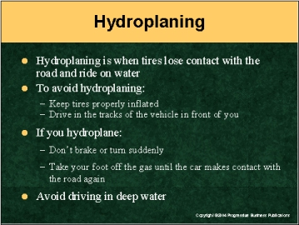

Speaker’s Notes
- In heavy rain, or when there’s a lot of melting snow or ice, water can start to puddle on roads. Hydroplaning happens when the tires of the vehicle lose contact with the road surface and begin to slide on the accumulated water.
- To avoid hydroplaning, keep tires properly inflated and try to drive in the tracks of the vehicle in front of you.
- If your vehicle hydroplanes, don’t brake or turn suddenly. Just take your foot off the gas until the car slows down and makes contact with the road again. If you have to brake, use the braking methods described for skidding.
- Hydroplaning can happen with just a little water on a road. Even more dangerous is when deeper amounts of water are in a roadway. Cars can be carried away in as little as a foot-and-a-half of water and then crash into something.
- If you see water that’s more than a few inches deep, don’t drive through it. Your vehicle could be carried away and crash into something. Even worse, people have become trapped in their cars in floods and have drowned.

Suggestions for the Speaker
You may want to ask the trainees: Has anyone ever hydroplaned? If so, ask the employee to tell their story. If no one has an example, here’s one: Two men were traveling in a vehicle during a rain storm. The vehicle hydroplaned, skidded off the road, traveled more than 300 feet and then overturned in a drainage ditch. The passenger in the vehicle was killed.

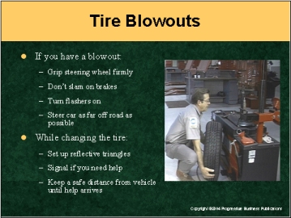

Speaker’s Notes
- Having a tire blowout while traveling at highway speeds can lead to a crash
that can severely injure or kill you and the passengers in your vehicle.
- There are ways to bring your vehicle to a stop safely if you have a tire
blowout on a highway:
- First, grip the steering wheel firmly.
- Don’t slam on the brakes. That can make it more difficult to bring the vehicle under control.
- Turn your flashers on after you have the vehicle under control and when you slow down below 40 mph.
- When you’ve slowed down to 30 mph, steer your car off to the side of the road.
- Getting the car as far off the road is very important. Proceed even if the blown-out tire is flapping badly.
- Once you’re off the road, there’s a danger from oncoming traffic while you change the tire or wait for emergency help. To keep yourself safe on the side
of the road:
- Put reflective triangles behind your vehicle to alert other drivers. Keep your emergency flashers on.
- If you need help with changing the tire, raise the hood of the vehicle,
tie something white to the antenna or hang a piece of material out
the window.
- If you have to wait for help to arrive, don’t stand behind or next to your vehicle. Stand as far away from it as you can while you wait for help.

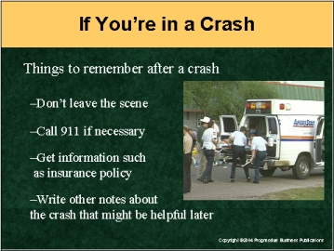

Speaker’s Notes
If you’re involved in a crash there are several things to remember:
- Don’t leave the scene of an accident. In most states, that’s a punishable offense.
- Call 911 if someone is hurt or if there’s been more than $500 damage to
the vehicle.
- If you’re seriously injured, don’t move. Stay in your vehicle and wait for help.
- If you don’t call 911, you still have to exchange information with the driver of
any other vehicles involved, even if no one was hurt and little damage was done to the vehicles.

Suggestions for the Speaker
Now might be a good time to tell employees about the information they need to get from another driver if they’re in an accident. Ask employees for suggestions on information to collect. Then, you can complete the list with the information below:
- Here’s the information you need to get: Name, address, telephone number, driver’s license number, name of insurance company and policy number. Information that’s not required but is helpful: make, model and color of the vehicles and their license plate numbers.

- Here are some other notes to write down that may be helpful: Time of day, weather conditions, street lighting, and the presence and length of any skid marks. A hand-drawn diagram of the road or intersection may also help.

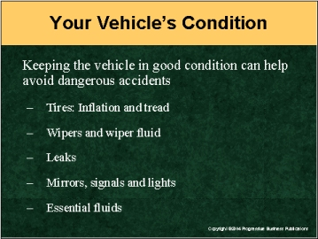

Speaker’s Notes
- Checking the condition of your vehicle can help you avoid accidents that cause injury or death.
- Here are some things to check:
- See if tires are properly inflated and that the tread isn’t worn bare. Improperly inflated and bald tires are a major cause of accidents, especially in rain, ice and snow.
- Wipers should clear the windshield without smearing or streaking. Also see if there’s enough wiper fluid in the vehicle’s reservoir. If your windshield isn’t clear, you might not see something ahead and may crash into it.
- Look for leaks under the vehicle. They can indicate a mechanical problem. It might cause you to be stranded on the side of the road with
a breakdown.
- Mirrors, directional signals, head-, tail- and brake-lights are all working. All these devices help you see other vehicles and help them see you.
- Essential fluids such as oil and washer fluid are topped off.

Suggestions for the Speaker
- To illustrate the importance of proper vehicle repair, you might want to tell this true story:
- One man was killed and two others injured after a wheel on a vehicle broke off, causing the vehicle to crash into a guardrail and flip over. It turns out, the bolts for the tire were damaged when a used tire was put on following a flat.

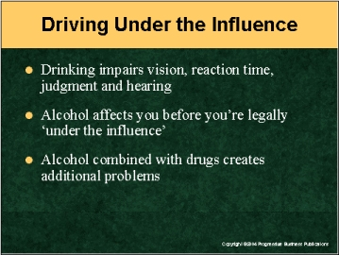

Speaker’s Notes
- Several of the skills necessary for safe driving – vision, reaction time,
judgment, hearing and doing two things at once – are impaired by drinking
or using illegal drugs.
- Alcohol use affects driving long before someone is considered legally “under the influence.” Impairment starts with your first drink.
- Doing two things or more at one time can be affected after just one drink -- one shot of liquor, 12 ounces of beer or five ounces of wine -- for someone who weighs 150 pounds.
- For the same person, steering a vehicle can become more difficult after just two drinks.
- Drinking even small amounts of alcohol can affect your ability to drive more if you’re also taking certain prescription or over-the-counter medications.

Suggestions for the Speaker
It’s often the case that the victim in a drunk driving crash isn’t the driver. Here’s one story you can share with employees: A man was driving with one passenger in his vehicle. His pickup truck ran off the road and hit a tree. His passenger died in the crash. The driver had more than twice the amount of alcohol in his blood to be considered legally drunk. The driver was found guilty of involuntary manslaughter.

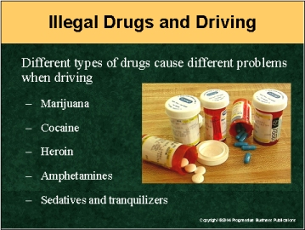

Speaker’s Notes
Using even a small amount of illegal drugs can affect your ability to drive and cause an accident that can result in serious injuries and even death.

Various types of illegal drugs have different effects on the ability to drive.
- Marijuana: Concentration is affected and there is difficulty in perceiving time
and distance.
- Cocaine: It masks fatigue, and at high dosages it impairs judgment and the ability to concentrate.
- Opiates -- morphine, heroin, codeine, opium: They cause drowsiness, confusion, visual impairment and poor judgment.
- Amphetamines: They interfere with concentration, impair vision and increase a driver’s tendencies to take risks.
- Sedatives – barbiturates and tranquilizers: These can cause drowsiness, poor coordination, altered perception and slow reaction time.

Suggestions for the Speaker
Now might be a good time to remind employees that even legal,
over-the-counter medications can cause trouble while driving. That includes some over-the-counter allergy and cold medicines that can make you drowsy. You might want to remind workers that they should read the warning labels on medications to see if drowsiness is a side effect. If so, it might be a good idea to avoid driving long distances while taking the medicine.

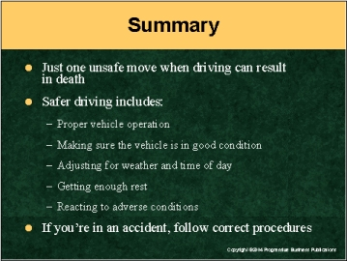

Speaker’s Notes
- Driving becomes second nature to us. Even the best drivers sometimes forget important safety measures to take behind the wheel. But just one mistake can lead to an accident that can cause serious injuries or even death.
- There are steps you can take to make driving safer. Some of these steps involve:
- Proper vehicle operation
- The condition of your vehicle
- The outdoor conditions: weather, time of day
- Making sure you’re well rested before getting behind the wheel
- Reacting when a vehicle starts to go out of control, such as during a skid or when hydroplaning
- Not drinking alcohol or using illegal drugs before driving.
- If you’re in an accident, follow the procedures we discussed.

