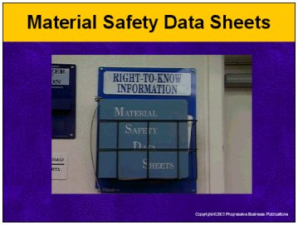

Speaker’s Notes
- Today’s session is on the topic of Material Safety Data Sheets - MSDSs.
- At first glance, MSDSs may not look friendly, but in terms of protecting yourself and your co-workers from serious harm and injury when working with materials containing hazardous substances, they’re the best friends you’ve got. Some of you may have looked at an MSDS in the past and said, “This stuff is all too confusing. I’m not a chemist.” Well, we’re here today to end that confusion. Your going to learn what type of information is contained on an MSDS, why it is important, and how to take this information and use it on the job to work safer.

Suggestions for the Speaker
To break the ice, consider asking for a show of hands from the members of your audience to such questions as: “Have you ever found MSDSs too confusing?”, “Do you find MSDSs to be too intimidating?”, etc.

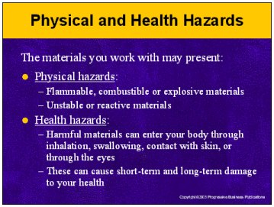

Speaker’s Notes
- Some of the materials you work with may present physical hazards and health hazards that can cause serious harm and injury to yourself and co-workers.
- By physical hazards, we mean that some of the materials you work, by their very nature, increase the danger in your work environment. Some may be flammable (they may catch fire easily); some are capable of exploding. Others may react to changes in temperature or react to other materials and become even more dangerous. If you don’t handle them or store them in the right way, accidents and injuries can occur.
- These materials may present health hazards as well. By breathing them in, swallowing them (like after handling them and then grabbing lunch without washing your hands), having them contact your skin or get into your eyes, you risk doing both short-term and long-term damage to your health.
- Short-term, health effects may include headaches, dizziness and nausea. You may have difficulty breathing or feel a burning sensation when you breathe. You may break out in a rash or have a burning sensation in your eyes. A more serious case could even involve chemical burns.
- Long-term health effects may not appear for months, if not years. But over time, overexposure can result in a wide variety of lifelong illnesses. Some of these include damage to your central nervous system, sterility, heart ailments, liver, kidney or lung damage; and cancer. The effects of some of these are irreversible and many have no known cure. In some cases, these illnesses are deadly.

Suggestions for the Speaker
You may want to ask audience members to give an overview of some of the chemicals they deal with on a daily basis and describe the physical and health hazards associated with each.

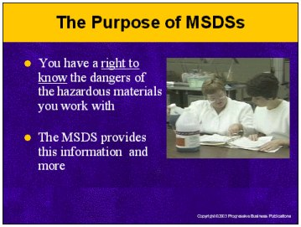

Speaker’s Notes
- You have the right to know and the need to know about the chemicals you work with on the job. To stay safe, you must know what they are, their properties, their potential safety hazards and risks, and how to protect yourself from any dangers they present. Knowing these things will help you minimize the risk of illness or injury and may even save your life or the life of a co-worker.
- How do you protect yourself? One way is to know what you are working with. The best source of information on this is our topic for today - the Material Safety Data Sheet. Information on an MSDS gives you the information that can help you avoid accidents and prepare for and respond effectively in an emergency situation.

Suggestions for the Speaker
- Training on MSDS sheets is sometimes given as part of formal HazCom or Right-to-Know training. The Safety Training Toolkit also contains a module on Hazard Communication.
- Now may be a good time to ask for a show of hands regarding who has had any prior Hazard Communication or “Right to Know” training.

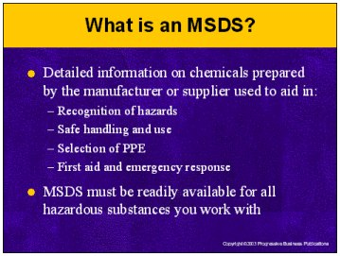

Speaker’s Notes
- Material Safety Data Sheets are detailed information bulletins prepared by the manufacturer or supplier of a chemical that give you information that you must know before you work with any chemical. Information on an MSDS can help you avoid injuries, illnesses and accidents by informing you of the dangers and hazards of the chemical you’re working with, giving you precautions for safe handling and use, helping you select appropriate protective gear and prepare you to respond effectively to daily exposure situations as well as to emergency situations.
- As part of its Hazard Communication standard, OSHA requires that accurate MSDSs be made readily available to all employees who work with hazardous materials on the job. MSDS sheets are available. Know how to obtain them for the chemicals and hazardous substances you work with.
- Prior to working with any new chemicals or substances that may contain hazardous materials, you must always review the MSDS in order to know how to work with it safely on the job.

Suggestions for the Speaker
Use this time to explain to your audience where they can obtain MSDSs at your facility for the products they work with.

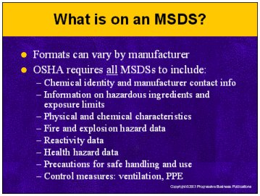

Speaker’s Notes
- Although OSHA requires by law that an MSDS be prepared by the chemical’s manufacturer, OSHA does not mandate a precise format for the presentation of its contents. As a result, MSDSs can differ dramatically in their organization and appearance depending on which manufacturer prepared it. Many MSDS sheets use an 8-section format. Others are broken down into 16 sections.
- Regardless of how they are organized, OSHA requires all MSDSs to contain certain basic information. This includes:
- Chemical identity and manufacturer contact information
- Information on any hazardous ingredients
- Physical and chemical characteristics
- Fire and explosion hazard data
- Reactivity data
- Health hazard data
- Precautions for safe handling and use
- Control measures: ventilation, PPE
- That may sound like a lot to digest, but we’re going to break it down and show you how this information can be used in your daily work routines.

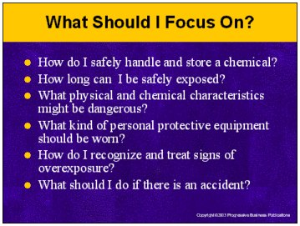

Speaker’s Notes
- Keep in mind two things about MSDSs: They are intended to be comprehensive information sources and they are intended for all types of users. So there may be information on an MSDS that may not necessarily be relevant to your unique situation. What you need to do is to concentrate on the information that is relevant to your situation. Before handling any hazardous product, you should be able to answer the following questions:
- How do I safely handle and store a chemical?
- How long can I be safely exposed to a chemical?
- What physical and chemical characteristics might be dangerous?
- How do I recognize and treat signs of overexposure?
- What kind of personal protective equipment should I wear?
- What should I do in case there is an accident?
- If you can’t honestly answer those questions about the materials you work with, you really need to review their MSDS sheets.
- Now we’re going to walk through some of the information in greater detail.

Suggestions for the Speaker
- Now would be a good time to pass out copies of any sample MSDSs you have brought.
- You may wish to distribute samples utilizing a variety of formats.

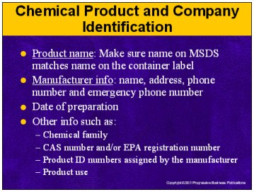

Speaker’s Notes
- The first thing to do when reading an MSDS is to make sure you’ve got the right one. Chemicals are often known by different names. For example, “Jiffy Clean” may be the trade name the manufacturer gives the product. There are also chemical family names -- for example “chlorinated hydrocarbons.” Use the chemical product name. The chemical product name appears on both the MSDS and the container label of the chemical in question. By law, the name of the material on the MSDS must appear exactly the same, including spelling, as on the container. Take the time to make sure that the label matches the MSDS and vice versa. If it doesn’t match, you may have the wrong MSDS. Don’t be afraid to ask your supervisor for help.
- The manufacturer’s name, address, telephone number and the emergency phone number of the manufacturer are usually included in the very the first section of an MSDS. Check that the name of the manufacturer or supplier matches the name on the label as well.
- The date that the MSDS was prepared also appears in this section as well as an optional signature of the preparer.
- Depending on who prepared it, the MSDS may also include other information in the first section or elsewhere, such as:
- The name of the chemical family this specific chemical belongs to.
- A CAS number - a number given by the Chemical Abstracts Service to each chemical.
- Some manufacturers may also include their own specific product numbers, EPA registration number, and other identifying numbers as well as brief description of product uses.
- The most important thing about this first section is, again, making sure you have the correct MSDS for the product you are using.

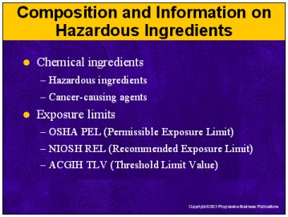

Speaker’s Notes
- Many products aren’t just made up of a single chemical, but a mixture of chemicals. The MSDS will also contain a section informing you of the product’s individual hazardous chemicals and their relative percentages. The manufacturer may list the ingredient in one of two ways. If it was tested as a mixture, the MSDS will list all chemicals which contribute to its hazardous nature. If it was not tested as a mixture, the MSDS will list the chemical name of all hazardous ingredients which make up more than 1% of the mixture and more than 0.1% for cancer-causing substances.
- Exposures to certain hazardous materials may be acceptable, but only for periods of time not to exceed certain time limits and at concentrations under certain levels. The MSDS will spell out exposure limits. These are used to assist health and safety professionals in establishing safe levels of exposure in the workplace.
- The MSDS will give the OSHA Permissible Exposure Limit (PEL) for each hazardous ingredient. It’s usually expressed in parts per millions parts of air (ppm) or milligrams of dust or vapor per cubic meter (mg/m3). It’s usually a time weighted average – a concentration averaged over an eight hour day.
- In addition to the OSHA PEL, many will also contain two other recommended limits – the Threshold Limit Values (TLVs) recommended by the American Conference of Governmental Industrial Hygienists and the Recommended Exposure Limits recommended by NIOSH (the National Institute for Occupational Safety and Health). These are important because ACGIH and NIOSH often recommend exposure limits that are more up-to-date and protective than OSHA’s.

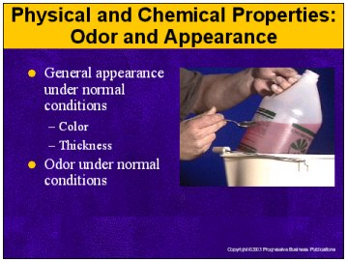

Speaker’s Notes
- The MSDS will contain a section outlining the physical and chemical properties of the material. These characteristics provide important information for working safely with the material, understanding what conditions you need to be sensitive to, and recognizing exposure.
- The most important feature of this section is the description of the chemical’s appearance and odor. Know what the material you’re using should look like in terms of its color and consistency. Make sure it matches what’s on the MSDS. If doesn’t, you either have the wrong MSDS or the material may have decomposed over time and changed. These type of changes are dangerous. If this is the case, notify your supervisor.
- You should also read the MSDS to get a heads up on what the materials should smell like at room temperature. However, be careful when it comes to relying on smell. Many chemicals are hazardous at levels lower than they can be smelled and some, such as hydrogen sulfide and ammonia, cause “olfactory fatigue,” which means that you’ll lose your ability to smell their odor. Again, if something is wrong, notify your supervisor.
- The takeaway here is - be conscious of what’s normal and be ready to recognize any deviations from the norm. Knowing this ahead of time may help you identify a substance that spills or leaks in your work area and prevent a bad situation from getting worse.

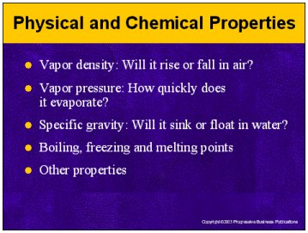

Speaker’s Notes
- The MSDS will also note additional physical and chemical properties to help you understand how the material may behave in different temperatures or conditions. Important items in this section include the following:
- Vapor Density: Is the weight of a gas or vapor compared the weight of an equal volume of air. Density less than 1 indicates it is lighter than air and will rise; greater than 1 indicates that it is heavier than air, and it will fall in air. Take note of this, because vapors heavier than air can flow along just above the ground or concentrate in the bottom of tanks or confined spaces where they may pose a fire or explosion hazard.
- Vapor Pressure: Measures how volatile a substance is and how easily it evaporates. A high vapor pressure indicates that a liquid will evaporate easily. This means that air concentrations can build up quickly, even though the substance is in liquid form. Liquids with high vapor pressures may be especially hazardous if you are working with them in a confined space or an enclosed area. This knowledge could help determine whether to use a ventilators and where to place them.
- Specific Gravity: This is the ratio of volume weight of material to an equal volume weight of water. If the specific gravity is greater than one, the substance will sink in water; if less than one, it will float on top of water.
- Boiling Point: This is the temperature at which the liquid boils or becomes a gas. The lower the boiling point, the quicker it evaporates and the easier it is to inhale. Chemicals with boiling points below 1000 degrees Celsius or 212 degrees Fahrenheit require special caution. Freezing point (the temperature at which a liquid becomes a solid) and melting points (the temperature at which a solid begins to change to a liquid) may also be given.
- Solubility in Water: This is the percentage of material that will dissolve in water, usually at ambient temperature. Since much of the human body is made up of water, water soluble substances are more readily absorbed and distributed throughout the body.
- Evaporation Rate: This is the rate at which a substance evaporates compared to either ether, which evaporates quickly, or butyl acetate, which evaporates slowly. If the substance has an evaporation rate greater than one, it evaporates faster than the comparison substance. So be sure to ensure adequate ventilation or use respirators if needed.

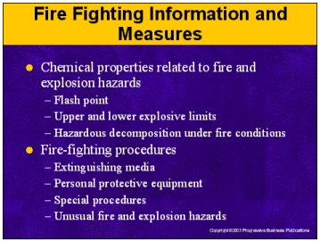

Speaker’s Notes
- Every MSDS will contain information describing the material’s potential for fire and an explosion along with basic fire-fighting information. Key items here include:
- Flash Point: This is the lowest temperature at which a liquid gives off enough vapor to form a mixture with air than can be ignited if a spark is present. Liquids with very low flash points are dangerous fire hazards. Those with flash points below 100⁰F are considered flammable, and those with flash points between 100⁰F and 200⁰ F are considered to be combustible. Flammable and combustible liquids require special handling and storage precautions.
- Autoignition temperature: This the approximate temperature at which the liquid will set itself on fire without a flame or spark. Vapors and gases will spontaneously ignite at lower temperatures in oxygen than in air.
- Flammable limits: the lower explosive limit (LEL) and upper explosive limit (UEL) provide the minimum and maximum concentration of a flammable gas or vapor (% by volume in air) in which an explosion can occur if a flame or spark are present. In other words, how much of the material has to escape before it becomes a significant fire or explosion hazard.
- This section will also give you information on any special fire-fighting procedures, such how to limit hazards encountered during fire situations, as well extinguishing agents, such as fire extinguishers, and other equipment. Know the proper extinguishing agent(s) for the material. Not every fire extinguisher can be used for every fire. Some chemicals (such as corrosives) must not be extinguished with water. Know the proper emergency procedures to follow in case of fire.
- In most fires, the greatest danger to human life is not the heat of the flames, but the toxic smoke that can fill the area. The MSDS will note all the anticipated hazardous products of combustion as well.

Suggestions for the Speaker
Use this time to point out the locations of fire equipment and find out who (if any) in your audience require additional fire extinguisher or emergency response training.

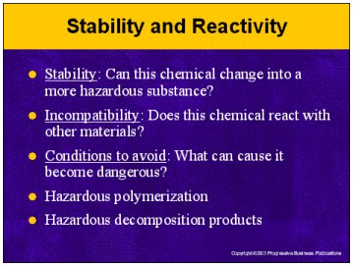

Speaker’s Notes
- The MSDS will include a section containing information about the stability and reactivity of the material – can the material undergo sudden changes that make it even more hazardous and what conditions cause this? You need to know the information in this section in order to store and handle the material safely. You’ll receive information on the following items:
- Stability: Some chemicals may decompose (or break down) and cause fires and explosions at certain temperatures, different pressures, or when subjected to shocks. Know if the material you’re using is unstable. For example, if one of the conditions to avoid is sources of ignition, then do not use this material in an area where burners/flames are being used.
- Incompatibility: Certain chemicals, when mixed or stored near each other may react violently or explosively or produce dangerous by-products. For example, bleach and ammonia can both be used safely if not mixed, but when mixed they form a potentially deadly vapor. Know if chemicals you’re working with are incompatible with any others take the care to store them separately and not mix them.
- Hazardous Polymerization: Some chemicals undergo a chemical reaction in which small molecules combine to form large molecules. This process may generate large amounts of heat or pressure that may burst the container.
- Hazardous Decomposition Products: When a chemical decomposes or burns, it may produce hazardous byproducts which are even more hazardous than the substance.
- Conditions to Avoid: With some chemicals, conditions such as heat and sunlight and can cause the chemicals to break down. Know what to avoid at all time. You can handle the material more safely – and prevent serious accidents – if you know how it will react to changes in temperature or contact with other materials. For example, if the chemical reacts with metals, don’t store it on metal shelves. If it reacts with natural rubber, then don’t wear natural rubber gloves when handling this material.

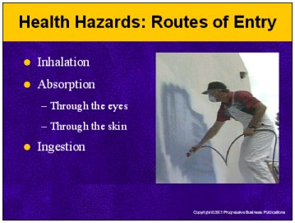

Speaker’s Notes
- Every MSDS will contain a section describing the health hazards of the product – the ways you can be exposed to the product and the harmful health effects it may have.
- The MSDS will tell you routes of entry – ways the hazardous ingredients can get into your body and make you sick. There are three principal routs of entry: inhalation (you breathe it), absorption (it contacts your skin or may get in your eyes), and ingestion (you swallow it). You should know the routes of entry for all chemicals you work with. By knowing this, you can help minimize exposure by being more knowledgeable when it comes to selecting PPE or designing work practices.
- The principle route of entry into the body is by inhalation. Many hazardous substances do not have a strong unpleasant odor, but can still harm the body. Many organic hazardous chemicals can quickly fatigue your sense of smell so you are no longer aware of the concentration of the vapors you might be breathing.
- Many hazardous substances can also be absorbed through the skin and into body tissue or the bloodstream. These substances can accumulate in a particular organ or tissue. After repeated absorption, the substances can accumulate to such a concentration that the organ may fail.
- The eyes are especially vulnerable to corrosive hazardous chemicals. Permanent damage or even blindness can result from liquid splashes or solution vapors.
- Ingesting a dangerous chemical is a lot easier than you think. If you’ve been working with a chemical and forget to wash your hands before eating a sandwich at lunch – guess what? You’re vulnerable. Remember, with these types of dangerous chemicals, it doesn’t take that much for them to harm you.

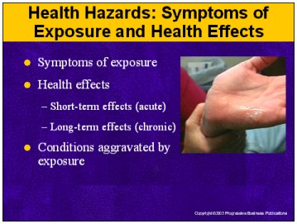

Speaker’s Notes
- How do you know if you’ve been exposed? Read the MSDS. Among other things, it will give you the warning signs and symptoms of exposure – specifically what you may be feeling or how a co-worker might look or act. For example, you skin starts to itch. You start to feel a burning sensation in your lungs. You begin to feel dizzy. By knowing the warning signs, and acting on them, you can prevent even greater injury to yourself or a co-worker.
- The MSDS will list both acute effects (short-term) and chronic (long-term effects) of overexposure,
- Acute (or short-term) effects occur over a short period of time - minutes, hours or days. You need to know what the short-term effects of exposure are because they can alert you to the fact that you have been exposed. And in that situation, the sooner you can get help the better.
- Some materials can cause chronic effects – medical symptoms that may occur years after you’ve been exposed even if you didn’t experience discomfort at the time of exposure. For example, if you’re exposed to asbestos you might not feel and respiratory symptoms at the time, but you may develop lung cancer years later. Some MSDSs will list target organs that are affected (heart, liver, brain, kidneys or central nervous system).
- MSDSs will also list any medical conditions that are generally aggravated by exposure. For example, severe asthma.

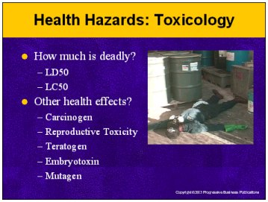

Speaker’s Notes
- Information concerning the hazardous chemical's toxicity is often given in terms of figures used as the results of animal studies and expressed in weight of chemical per kg of body weight. On occasion human data may be used, in cases where accidental human poisoning occurred and the amounts of exposure are known.
- The LD50 (or lethal dose) is the amount of a substance which has caused the death of 50% of the laboratory animals used in experimental testing. This figure is used for exposures involving contact with skin, ingestion or eyes.
- LC50 is the concentration of the substance in air which has caused the death of 50% of the laboratory animals used in experimental testing. This figure is used to express inhalation exposures.
- Some MSDSs may also describe some of the other health effects in this section discovered in laboratory testing. Some of these items might include:
- Whether the chemical is a carcinogen (causes cancer)
- Whether it affects the reproductive system
- Whether it is a teratogen (can cause birth defects) or an Embryotoxin (can cause toxic effects on a developing embryo)
- Whether it is a mutagan (can cause changes in a cell’s DNA).

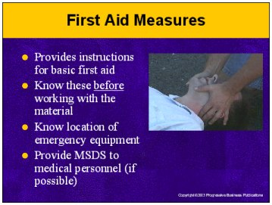

Speaker’s Notes
- The MSDS will also include information on what to do in the event of a medical emergency. If an accidental exposure were to occur, this section of the MSDS tells you the immediate first aid response for accidental exposure as a result of inhalation, ingestion or contact with skin or eyes. Your prompt response can mean the difference between life and death or between a minor injury and a long-term debilitating injury. Remember, first aid is just you lending a hand until trained medical personnel arrives.
- Usually, only basic first aid training is needed. In most cases, skin and eye exposure are standard (i.e. immediately flush eye or skin with plenty of water for at least 15 minutes). Inhalation can also be standard (i.e. remove to fresh air, if not breathing, give artificial respiration, if breathing is difficult, give oxygen). The first aid response to ingestion does vary. You might think that inducing vomiting would be the standard response. However, in many cases, this would result in greater respiratory damage than the damage by ingestion. Often times, an antidote may be listed which can be administered by a lay person or a trained medical personnel. In some cases, you may need more advanced training, like if you’re required to perform CPR.
- The important thing about this section is to know it before you start using the chemical. When the difference between life and death can be second in some situations, the last thing you want to be doing is scrambling to get a hold of the MSDS because you hadn’t read it ahead of time.
- You should also know the locations of the facilities and equipment you may need to provide first aid. For example, eyewash fountains, safety showers, and first aid kits.
- If the victim requires professional medical assistance, try to be able to give the MSDS sheet to the healthcare professionals at the scene or make sure it is taken to the emergency facility. If you can’t find the MSDS, send the material’s label. Occasionally, the MSDS may contain additional instructions which may be useful to an emergency room doctor.

Suggestions for the Speaker
Make sure you audience knows the locations of eyewash fountains, safety showers, and first aid kits.

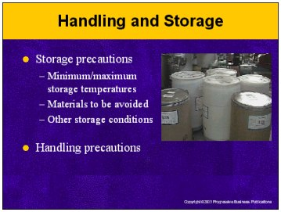

Speaker’s Notes
- OSHA requires all MSDSs to contain instructions on safe storage and handling.
- General handling precautions and practices are described which, if followed, will help prevent releases or spills, head off overexposure during contact with the material and minimize continued contact after handling. These can also include recommended industrial hygiene practices and precautions to be taken during repair and maintenance of equipment. This section will also include any special equipment that may be required.
- The storage precautions for chemicals will vary depending on the chemical’s reactivity and flammability. Read the MSDS to understand the necessary types of storage conditions that must be avoided. For example, protect against sunlight, refrigerate, keep container tightly closed, and store separate from oxidizing materials. If you store chemicals in the wrong environment, allow them to be stored in damaged containers, or allow them to come into contact with other materials, you run the risk of hazardous reactions that could lead to illness or injuries.
- When you're done using a chemical, make sure you’ve read the MSDS and know how to store it properly.

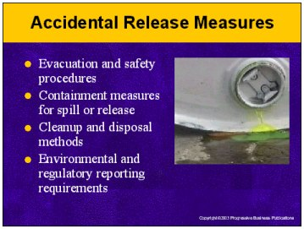

Speaker’s Notes
- As much as we try to avoid it, there are times when hazardous materials will be accidentally spilled or released. You’ll minimize the risk if you make the immediate proper response. And that response is found on the MSDS.
- Every MSDS contains a section outlining the general procedures for responding to an accidental release or cleaning up a spill or accidental release. Therefore, reviewing this section before using a chemical will prepare you in the event of a hazardous spill.
- You need to read this section to learn the specific steps to take if a spill or leak occurs. These steps may include evacuation procedures, containment procedures, and cleanup techniques – including the best equipment to use – appropriate waste disposal methods, and other emergency advice like personal protective equipment and respirators.
- Information from this section will also help you to ensure that you have on hand or know how to get the necessary equipment to quickly contain and clean up a spill or leak.
- In most cases, if the spill is small, the advice in this section can be very useful. However, if the spill is large, evacuate the area, make sure that the doors of the affected area are closed and people are posted at them to prevent anyone from entering and call 911.

Suggestions for the Speaker
Make sure your audience is familiar with your facility’s emergency response plan and specifically who to call in the event of an accidental spill or release.

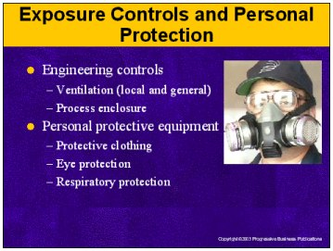

Speaker’s Notes
- Another section of the MSDS will list any exposure control measures than can reduce or eliminate the hazard. These include engineering controls and personal protective equipment.
- Engineering controls help reduce potential hazards either by isolating you from the hazard or by removing the hazard from the work environment. It’s common to see suggested ventilation or air flow schemes.
- Most important is the information telling you what personal protective equipment (PPE) you need to wear during use to stay safe. You should never use a chemical without having read the PPE section of the MSDS. There are many types of PPE available and the MSDS often includes details about what specific materials the PPE should be made of.
- The MSDS will include recommendations for proper clothing such as body suits, aprons, boots, gloves, and any other protective clothing or equipment. Again, keep in mind that since we’re dealing with hazardous chemicals you have to take care to make sure the materials really do protect you. For example, not all gloves will protect against all chemicals.
- The MSDS will include recommendations for eye protection (typically goggles, face shields or other items) as well as respiratory protection, such as the appropriate respirator for conditions exceeding the recommended occupational exposure limits.

Suggestions for the Speaker
- Make sure the members of your audience know where to obtain recommended PPE.
- Workers should not use respirators without proper respirator training. Use this time to find out which members of your audience require respirator training.

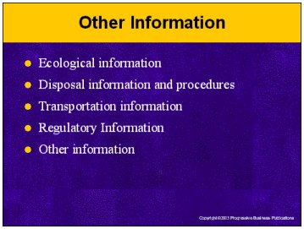

Speaker’s Notes
- The MSDS may also include information targeted to individuals other than the end-user.
- Ecological information: Some provide data that may be useful in evaluating the impact if the material is released into the environment.
- Disposal information is provided for the person responsible for waste management activities at the facility to stay within the law when disposing of chemical waste. This section usually contains information on special disposal methods and waste management operations like recycling. Also included are limitations directed by federal, state or local governments. However, you should also be aware of disposal aspects of the chemical so you don’t accidentally dispose of the waste in an improper manner.
- Transportation information is intended for those responsible for shipping the materials off the premises. This section provides information on the appropriate placards and ID names and numbers. Any special precautions for shipment will be provided. For example, some products may be sensitive to shocks or high temperatures.
- Regulatory information is a section used by environmental or regulatory compliance personnel. It provides references to applicable environmental laws and regulations and may list reporting requirements.
- Some MSDSs have a section titled “other information.” This section is intended to be used for any additional important information not listed in other sections. This can include: references, keys, legends, creation and revision data, and hazardous ratings such as the NFPA codes.

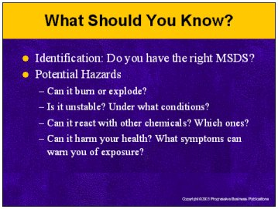

Speaker’s Notes
- We’ve covered a lot of ground today. Hopefully, we’ve cleared up any confusion about exactly what’s on an MSDS and why it’s so important. Let’s wrap things up by taking a few minutes to review just exactly what information you should know after reading an MSDS.
- Identification: Start by making sure you have the right MSDS. Does the name on the label match the name on the sheet?
- Know the potential hazards of the material
- Can it burn or explode?
- Is it unstable? What conditions can cause it to change and become even more hazardous?
- Can it react with other chemicals? If so, which ones?
- Can it harm your health? What symptoms can warn you of exposure?
- Can it harm the environment?

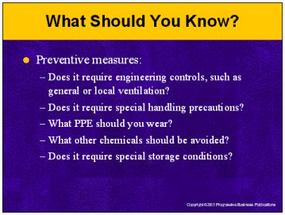

Speaker’s Notes
- After you’ve seen and understood the hazards, you’ve got to think about preventive measures – ways to minimize them.
- Does use of this material require engineering controls, such as general or local ventilation or process enclosure?
- Does it require special handling precautions?
- What PPE should you wear? Is it made of adequate materials?
- Are there any other chemicals that you need to keep it separated from?
- Does it require special storage conditions? For example, is it okay to store it in sunlight?

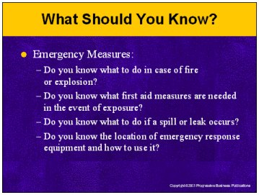

Speaker’s Notes
- And finally, what happens when an accident occurs?
- Do you know what to do in case of fire or explosion?
- Do you know what first aid measures are needed in the event of exposure?
- Do you know what to do if a spill or leak occurs? How should it be contained? How should it be cleaned up?
- Do you know the location of emergency response equipment and how to use it?

Suggestions for the Speaker
- Now would be a good time to open up the floor for questions about any of the material covered.
- After the Q&A session, have your audience take the quiz included with this MSDS module in order to evaluate their comprehension.

