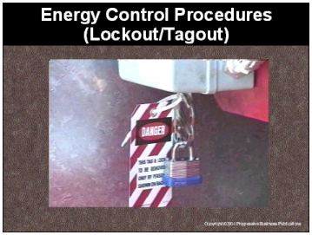

Speaker’s Notes
- Today’s topic is the Lockout/Tagout sometimes referred to as LOTO. This training is required by the OSHA’s Control of Hazardous Energy Standard (29 CFR 1910.147)

- You will learn the:
- Definition and reasons for lockout/tagout
- Dangers associated with lockout/tagout
- Ways to safely perform lockout/tagout

Suggestions for the Speaker
An effective ice breaker is to ask the trainees the following questions:
- Has anyone ever locked out or tagged out equipment?
- Does anyone know what types of equipment requires lockout/tagout?
- Has anyone had an incident when equipment accidentally started on them?

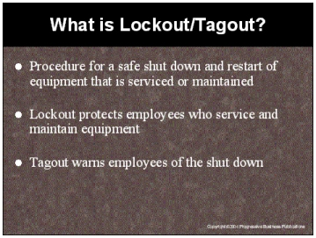

Speaker’s Notes
- Lockout protects employees who service and maintain equipment by placing a lock on
a device that prevents the energy from reaching the machine that is being serviced or maintained. This lock ensures that the equipment cannot be turned on while the work
is occurring.

- Tagout is the placement of a tag on the energy isolating device to warn others that you are working on the equipment and it must not be started.

- Picture in your mind what can happen if you’re servicing or maintaining machinery and don’t properly perform a lockout/tagout procedure. You or any of your co-workers could accidentally start-up the machinery. This accidental start-up can cause serious injury or death.

Suggestions for the Speaker
Ask the trainees for examples of equipment in your facility that requires lockout/tagout procedures. Point out that any time an employee removes equipment guards; lockout/tagout is a must.

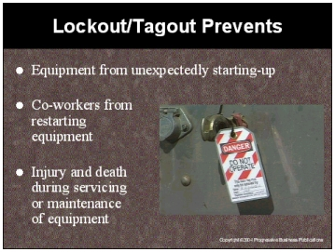

Speaker’s Notes
- If you don’t properly lockout/tagout your equipment, it can unexpectedly start-up while you’re servicing or maintaining it. All the machine needs is an accidental bump of the “on” switch and it will start up with you right in the middle.

- Many injuries occur when a co-worker starts-up machinery while another employee is still working on it. These coworkers see machinery unplugged or a switch facing the wrong direction and they think they’re doing the right thing by reenergizing the equipment. They don’t realize that they are placing you in danger. Locking and tagging out machinery will ensure that this never happens.

Suggestions for the Speaker
- Share a story with the trainees of someone who didn’t properly lockout/tagout equipment and was injured or killed. If you do not have one, you can use this true case report:
- An employee was cleaning the paddles of an asphalt mixing machine when a co-worker accidentally hit a toggle switch while dusting in the control room. This toggle switch closed the mixer door, hitting the employee on the head and killing him.

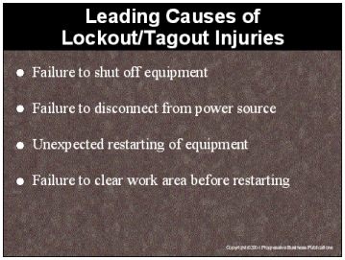

Speaker’s Notes
- Many injuries are caused by employees who think they can maintain or service equipment
without first shutting off the equipment. Take the extra time to shut of the equipment and
prevent injuries to yourself and others.

- You must shut off the equipment and the power source behind it to be entirely safe. If
you don’t shut off the power source, the equipment can still be accidentally started-up
and injure you.

- The unexpected restarting of equipment can be caused by yourself or your fellow employees. The only way to ensure your safety is to lockout/tagout the equipment prior
to servicing or maintaining it.

- Once you’ve completed servicing or maintaining the equipment, make sure you clear
the work area before restarting the equipment. Tools or spare parts can get caught in the machinery when it’s restarted, injuring you or those around you.

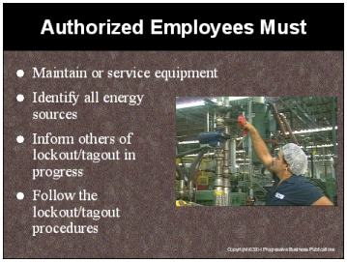

Speaker’s Notes
- You’re classified as an authorized employee whenever you maintain or service equipment. You’re the person who is most at risk of being injured from an unexpected start-up of equipment.

- It’s your responsibility to recognize all of the dangerous energy sources in the work place identify their potential hazards and know how to avoid the dangers associated with them.

- You must inform all other employees why the equipment is being taken out of service, and for how long - written in advance is preferable. This will help prevent other employees from trying to restart equipment when you’re working on it.

Suggestions for the Speaker
Ask the trainees if they know who is an authorized employee.

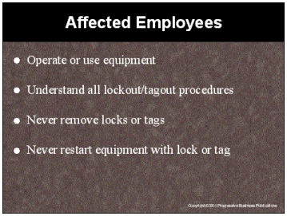

Speaker’s Notes
- You’re classified as an affected employee if you operate or use the equipment that is being serviced or maintained. Affected employees must understand all lockout/tagout procedures so that they’ll not unintentionally restart the equipment. An unintentional restart could result in injury or death of an employee servicing or maintaining the equipment.

- An affected employee shall never remove locks or tags that they didn’t attach themselves.
Removal would place the authorized employee in immediate risk of injury or death.

- An affected employee shall never try to restart equipment if it is locked or tagged.
Always assume that machines with locks or tags are being serviced or maintained by
an authorized employee

Suggestions for the Speaker
Ask the trainees if they know who’s an affected employee.

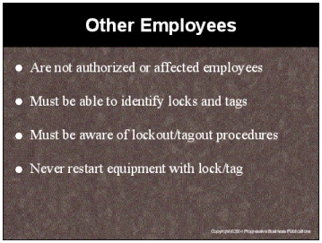

Speaker’s Notes
- Other Employees don’t operate, service, or maintain equipment, but these employees work in
the area where these activities occur. They must be aware of the procedures so that they don’t unintentionally restart equipment that’s locked or tagged out.

- All people should avoid equipment when they see it marked with a lock or tag. This is the best
way to prevent unintentional start-ups.

- Like authorized employees, these employees shall never try to remove locks/tags or attempt to restart equipment that has been locked/tagged out.

Suggestions for the Speaker
Point out other employees who may be in the area of a lockout/tagout procedure.

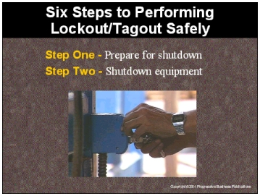

Speaker’s Notes
- The only way to prevent unexpected start-ups is to follow proper procedures. Skip one step and you put yourself at risk!

- Before starting a lockout/tagout procedure, be sure you check what type and how much energy the equipment produces, and review the correct procedures.

- Notify your co-workers of the shutdown before it occurs. Letting people know ahead of time reduces the chance of an accidental restart.

- Each piece of equipment will have specific directions for shutdown. Don’t assume that what works for one piece of equipment will work for all of the others. The energy control procedures will have specific directions for shutdown.

Suggestions for the Speaker
- Hold up and describe an example of your energy control procedures.
- Point out where written copies can be found for all equipment that’s covered under the standard.

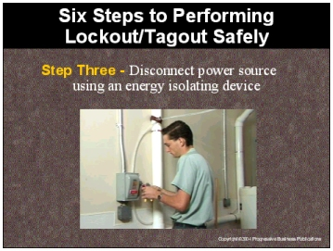

Speaker’s Notes
- An energy isolating device prevents the flow of energy from the power source to the equipment that you intend to service or maintain.

- Be sure you’ve identified all energy sources associated with the equipment. Some equipment
has multiple energy sources and all must be identified and separately isolated from the equipment.

- An energy-isolating device is capable of being locked-out if it has a locking mechanism built in such as a hasp or can be locked without dismantling, rebuilding or replacing the energy-isolating device.

Suggestions for the Speaker
Show an example of an energy isolating device used in your facility.

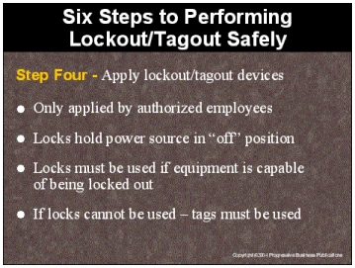

Speaker’s Notes
- Only authorized employees can attach locks or tags, and only the specific employee who attached the lock/tag has the authority to remove it.

- Locks ensure that the power source can’t be activated. Tags should be used with locks
to inform employees of the lock-out and identify the authorized employee who attached
the lock.

- If you have equipment that isn’t capable of being locked out:
- Attach the tag in same location that the lock would have been.
- Attach it securely so it can’t be accidentally removed.
- Place the tag in a position so that anyone attempting to operate the device will understand that moving the device form the “off” position is prohibited.

Suggestions for the Speaker
Show examples of locks and tags used in your facility.

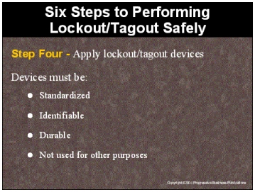

Speaker’s Notes
- Only use locks and tags that have a standardized color, size and shape. The tags are uniform in print and format and must include words such as: Do Not Start”, “Do Not Open” or “Do Not Operate”.

- Each authorized employee should have an individual, identifiable lock and key. The locks or tags should be immediately identifiable to anyone attempting to operate the device. Never use another employee’s lockout or tagout device.

- Lockout devices must only be removable by bolt cutters or like equipment. Both lockout and tagout devices must be capable of withstanding the environment to which they’re exposed.

- It’s important not to use lockout/tagout devices for another purpose. Otherwise, someone may become confused and attempt to start equipment that’s being serviced or maintained.

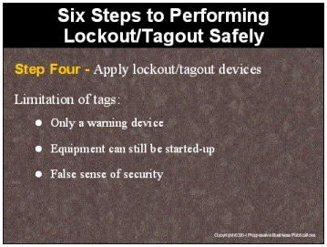

Speaker’s Notes
- Tags are only used as a warning that an energy isolating device has been shut down. They don’t provide the protection of a lock. You need to be aware that equipment that’s tagged, can still be started-up and injure or kill you while servicing or maintaining equipment.

- Tags by themselves provide a false sense of security. Tags won’t protect you from an accidental start-up. They merely alert people that you’re working on the equipment.

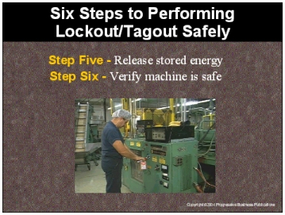

Speaker’s Notes
- After the lockout/tagout devices have been applied, the authorized employee must ensure that no hazardous energy is still being stored in the equipment. Employees can still be injured or killed by equipment that’s shut down if all of the energy is not released.

- Prior to starting work on equipment that has been locked out or tagged out, the authorized employee must verify that the machine is safe. The employee should turn all controls to the
“on” position to ensure that the machines will not start-up.

- If any power source activates after the procedure is complete, you must perform all six steps over again. Any energy can kill you.

Suggestions for the Speaker
Ask the trainees if there’s any equipment in your facility that could have stored energy.

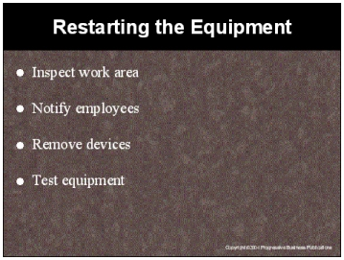

Speaker’s Notes
- The authorized employee should verify it’s safe to reenergize the equipment. They must ensure that tools, spare parts, and debris have been removed from the area, safety guards replaced and equipment is in the same condition as before the procedure.

- Before you remove devices, alert others in the area make sure they’re out of the way, and then let them know when it’s safe to return.

- The only person who can remove a device is the person who attached it. If it isn’t yours, don’t touch it.

- If equipment that’s being locked or tagged out must be tested, follow the same procedures for restarting equipment, test the equipment and then perform the six lockout/tagout steps.

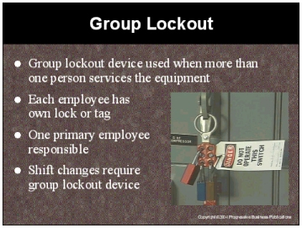

Speaker’s Notes
- A group lockout situation occurs when more than one person must service or maintain a piece of equipment.

- Each employee must attach their own lock or tag to a group lockout device when they’re working on the equipment. This assures that the equipment won’t be started up while they’re working on it.

- One employee must have the primary responsibility for the lockout/tagout procedure. This employee makes sure that the lock/tag isn’t removed while employees are still servicing or maintaining the equipment.

- If there are shift or personnel changes, a group lockout device is used. The outgoing employee must wait until the incoming employee attaches their lock or tag before removing their own. This process ensures that there’s always one primary person responsible for the lockout/tagout procedure.

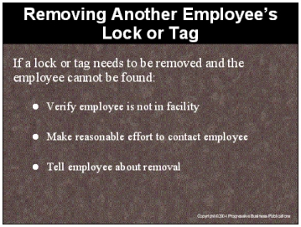

Speaker’s Notes
- In most cases, never remove a lock or tag that another employee has attached. There may be a situation where equipment that’s being serviced needs to be used and, the employee who attached the lock or tag cannot be found.

- In this situation, first verify the employee who attached the lock or tag isn’t in the facility. Then make a reasonable effort to contact the employee to have him or her remove his or her lock or tag.

- If you still can’t contact the employee, remove the lock or tag using the proper procedures and inform the employee about the removal when he or she returns. This is to make sure they don’t attempt to service the equipment without locks or tags attached to the energy isolating device.

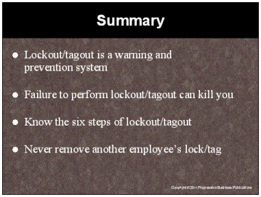

Speaker’s Notes
- Lockout protects employees who service and maintain equipment by placing a
lock on a device that isolates the energy from the machine that’s being serviced
or maintained.
- The lock ensures that the equipment can’t be turned on while the work is occurring.
- Tagout is the placement of a tag on the energy isolating device to warn others that you’re working on the equipment and it must not be started.
- Equipment that isn’t properly locked/tagged can unexpectedly restart while you’re right in the middle of it. This accidental start-up can cause serious injury or death.
- The six steps to performing lockout/tagout safely are:
- Prepare for shutdown
- Shutdown the equipment
- Disconnect power source using an energy isolating device
- Apply lockout/tagout devices
- Release stored energy
- Verify machine is safe
- Removing someone’s lock or tag immediately places them in danger. The lock/tag are the only assurance an employee has that equipment won’t accidentally restart while they’re servicing or maintaining it.

