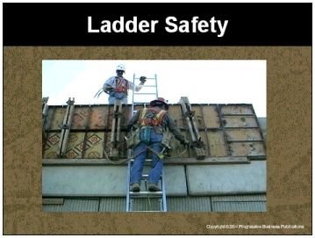

Speaker’s Notes
- Today’s topic is Ladder Safety. This training is a part of OSHA’s Portable Wood and Metal Ladder Safety Standards (29 CFR 1910.25-26).

- You will learn about:
- The common causes of ladder accidents.
- The different types of ladders and their uses.
- How to work safely on and around ladders.

Suggestions for the Speaker
An effective ice breaker is to ask the trainees the following questions:
- Has anyone ever fallen off of a ladder or know someone who has fallen
off of a ladder? If yes, ask what that person was doing when he or she fell.
- Does anyone know the most common causes of ladder accidents?

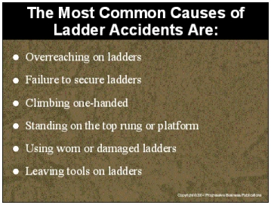

Speaker’s Notes
- The most common causes of ladder accidents are:
- Overreaching while on a ladder, instead of moving the ladder.
- Failing to properly secure the ladder, allowing the ladder to fall backward or
slide to the ground.
- Climbing one-handed or carrying something while climbing.
- Standing on the top rung of a ladder or platform and losing your balance.
- Using a worn or damaged ladder which could break while you are on it.
- Leaving tools on ladder rungs or at the top of a stepladder.
- Most ladder accidents are the result of careless or improper ladder usage. A fall from a ladder can disable you for the rest of your life, cut off your earning power or even kill
you. These dire consequences can be avoided by working safely on and around ladders.

Suggestions for the Speaker
- Share a story about someone falling off of a ladder. If you do not have
one, you can use the following true story - A maintenance employee was descending from a fixed ladder and fell five feet to the floor. The employee sustained injuries to the left ankle and right knee, and required surgery on both. The employee was out of work for more than three months.
- Even the most simple and repetitive of tasks, such as climbing a fixed ladder, require your attention. Tasks that are often considered low hazard and routine often result in the most significant injuries.

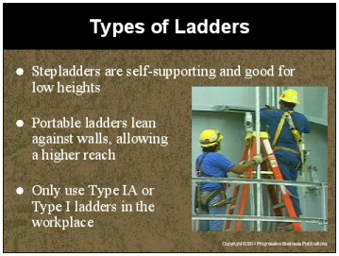

Speaker’s Notes
- A stepladder is a self-supporting ladder, non-adjustable in length, having flat steps, a
hinged back and a metal spreader that locks the ladder open. They should only be used
when all four legs are on a solid, level, non-slippery surface.
- Do not use a stepladder if the height you need to reach is three feet higher than the stepladder. You would be forced to stand on the top two steps leaving the base unstable,
and potentially causing a fall.
- A portable ladder is not a self-supporting ladder, but can be leaned against a wall to reach higher than a stepladder. They should be placed on firm, stable footings and use leg extensions or non-slip feet.
- A ladder’s duty rating tells you its maximum weight capacity. There are four categories
of duty ratings:
- Type III - Withstands loads up to 200 pounds
- Type II - Withstands loads up to 225 pounds
- Type I Withstands loads up to 250 pounds
- Type IA - Withstands loads up to 300 pounds
- For your safety, only use Type I or Type IA in the workplace to ensure the ladder will withstand the load. Management will provide you with the proper ladders.

Suggestions for the Speaker
Show examples of the types of ladders used in your facility.

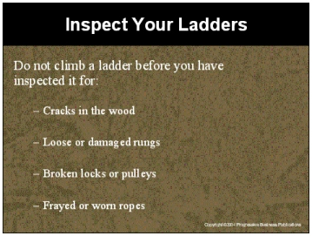

Speaker’s Notes
- Never climb a ladder before inspecting it for damage. If the ladder has damaged or missing parts, mark it as broken and take it out of service. One way to do this is to place a “Do Not Use” sign on it. Don’t try to fix a ladder yourself; ask your supervisor for help or leave it
for maintenance to fix.
- Inspect wooden ladders for cracks and splits in the wood. Wooden ladders should not be painted. But if you find one that is painted, pay close attention since the paint could be hiding defects. Even a small crack can cause a ladder to break, sending you crashing to
the ground.
- Check all ladders for loose or damaged rungs, steps, cleats, rails or braces. They are loose
if you can remove them with your hand.
- Make sure the stepladder spreaders are sturdy and can be locked in place. Be sure that all hardware and fittings are properly and securely attached before climbing.
- Test movable parts to make sure they do not stick or are so loose that they may fall apart. Locks and pulleys should be checked to make sure they are lubricated. Ropes that are used for extending ladders should be replaced if they become frayed or badly worn.

Suggestions for the Speaker
- Ask someone to come up and demonstrate how to inspect a ladder.
- Describe your policy on taking damaged ladders out of service.

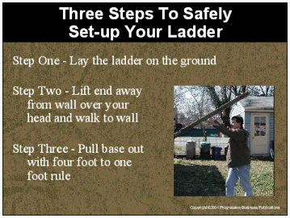

Speaker’s Notes
- Step One - Lay the ladder on the ground with the base resting against the bottom of the
wall and the top pointing away from the wall.
- Step Two - Starting at the top of the ladder, lift the end over your head and walk under the ladder to the wall, moving your hands from rung to rung as you go. If it’s an extension ladder, raise the fly section by using the rope and pulley. Check for overhead clearance, especially electrical hazards.
- Step Three - When the ladder is vertical, and the top touches the wall, pull out the base using the four feet to one foot rule. This means that the ladder should be placed one foot away from the base for every four feet in height to the place where the top of the ladder rests. For example, if a ladder is supported at a point 20 feet above the ground, its base should be five feet from the wall. Twenty feet divided by four is five feet.
- Keep one foot on the base rung of the ladder to provide firm footing for the ladder. If a ladder is too close to the wall, it is likely to tip back. If it is too far from the wall, it’s
likely to slide out from the bottom.

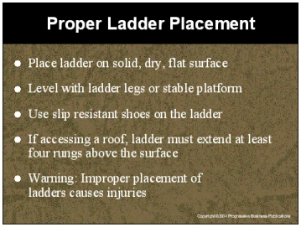

Speaker’s Notes
- Place the ladder on a solid, dry flat surface to prevent accidental movement. The feet of
the ladder should be level. If the surface is not level, use ladder leg levels to adjust for
slight variations.
- If the ladder legs are not enough to level the feet, it may be necessary to use a wide stable platform such as a large board as the base. Do not try to level the base or make a ladder reach higher by setting it on boxes, bricks or other unstable bases.
- Avoid placing a ladder on a slippery surface such as liquid, ice or snow. If you must work
in these conditions, use ladders with slip resistant shoes. For ice and snow, use spike or
spur type safety shoes.
- When positioning a portable ladder that will access a platform or the roof, the ladder must extend four rungs, or at least three feet above the surface. That way you can safely get on and off the ladder.
- Improper placement of ladders causes injuries. Never:
- Use a ladder as a horizontal platform, scaffold or to lift anything
- Lean stepladders against a wall for use.
- Use a ladder on a scaffold platform.

Suggestions for the Speaker
- Ask someone to demonstrate how ladder leg levels work.
- Show examples of a ladder with slip resistant shoes.

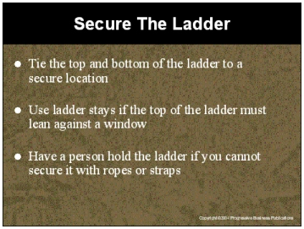

Speaker’s Notes
- Secure your ladder from slipping if you are working with power equipment or if the base or top seem unstable. Working with power equipment on a ladder is especially dangerous. One slip can cause the equipment to jump and injure you.
- Secure the bottom by tying the base to stakes in the ground, fixed blocks or sandbags to
help guard against slipping. The rope or strap should be tied to both side rails. Do not try
to secure it to the rungs because the ropes or straps will slide.
- Securing a ladder at the base does not prevent sliding at the top. You must also anchor the top of a ladder to prevent accidental movement. Your support point at the top must be as stable as your base.
- Use ladder stays when the ladder must lean against a window, or other surface that cannot support the weight of the ladder. Extend the ladder stays across the window for firm support against the building walls or window frame.
- Station a person at the foot of the ladder when it is not possible to secure the ladder with ropes, straps or anchors. The person at the foot of the ladder should face the ladder with
a hand on each side rail and one foot resting on the bottom rung.

Suggestions for the Speaker
- Ask someone to come up and demonstrate securing a base.
- Show an example of a ladder stay and ask someone to come up and demonstrate how it is attached.

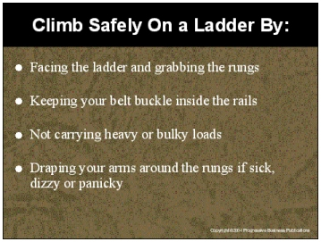

Speaker’s Notes
- When ascending or descending a ladder, face the ladder and take only one step at a time with your feet in the center of the steps. Grab the rungs of the ladder, not the side rails.
The rungs are easier to hold on to if your footing slips. Do not try to move, shift or extend
a ladder while you are on it by rocking, shifting or pushing it away from a supporting wall.
- Overreaching is the most common cause of falls from ladders. A good rule of thumb is to always keep your belt buckle inside the rails of the ladder. When you can no longer reach comfortably and safely from this position, get down and move the ladder to a new position. Do not stand higher than the second step from the top of a stepladder or the third rung from the top of a portable ladder. The higher you go on a ladder, the greater the possibility it will slip out from its base.
- Never carry heavy or bulky loads up the ladder. The extra, awkward weight can cause you to fall. Climb up first by yourself, and then pull up the material with a rope or carry tools in your tool belt. Never climb a ladder one-handed. Do not leave tools or materials on top of ladders. If they fall on you, you can be hurt. If they fall on someone else, you and the company can be sued.
- If you get sick, dizzy or panicky while on a ladder, do not try to climb down in a hurry. Wait! Drape your arms around the rungs and rest your head against the ladder until you
feel better. Then climb down slowly and carefully. If you do not feel better, call for help.

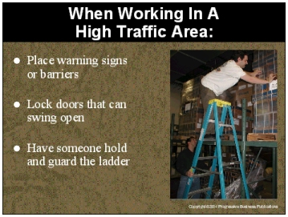

Speaker’s Notes
- Ladders placed in high traffic areas such as passage-ways, doorways, or driveways must be secured to prevent accidental contact which could knock the ladder over. It is very easy for
a person to turn a corner or open a door and accidentally knock you off of your ladder by bumping in to it.
- A ladder should never be placed in front of a door unless:
- The doors have been locked to prevent use,
- The doors have been blocked with barrier tape or a sign that warns that there is a person on the ladder or
- A person is standing on the other side of the door to prevent anyone from entering when the ladder is being used.
- When using a ladder in an area where many people can potentially bump in to it, place warning signs or barricades to guide people away from the foot of the ladder. If this is
not possible, have someone hold and guard the bottom of the ladder.

Suggestions for the Speaker
Ask for examples of high traffic areas in your facility where ladders would require these extra precautions.

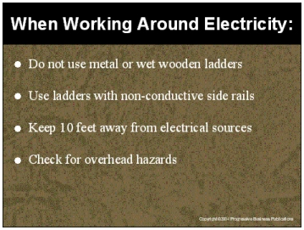

Speaker’s Notes
- Metal and wet wooden ladders conduct electricity and should not be used when working
on, with or around electrical equipment or electrical power sources. If a live electrical current touches a metal or wet wooden ladder, electricity will run through your body, injuring and potentially killing you.
- If you plan on using a ladder in an area where it could come in contact with electrical equipment or other sources, make sure the ladder has non-conductive siderails, such as fiberglass. These siderails will protect you if live electrical currents touch the ladder.
If you are not sure if your ladder is equipped this way, ask your supervisor.
- If you must work near electrical equipment or power sources, keep the ladder, yourself
and tools at least 10 feet away from overhead wires. Electricity can “jump” and cause injuries, even if you are not touching the source. A fiberglass ladder is your best bet if
there is a remote chance that you will be working near electricity or overhead power lines.
- Before putting a ladder up, check for overhead clearance and ensure that electrical lines
are not in the vicinity. Leaning a ladder against electrical lines will give you a dangerous electrical shock.

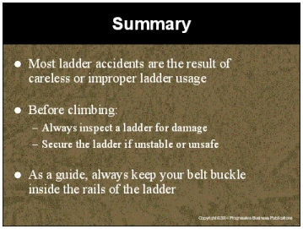

Speaker’s Notes
- Most ladder accidents are the result of careless or improper ladder usage. A fall from a ladder can disable you for the rest of your life, cut off your earning power for a long time
or even kill you. These situations can be avoided by working safely on and around ladders.
- Never climb a ladder before inspecting it for damage. If the ladder is damaged or missing parts, mark it as broken and take it out of service. One way to do this is to place a “Do Not Use” sign on it. Do not try to fix a ladder yourself; ask your supervisor for help or leave it for maintenance.
- Secure a ladder by tying the top and bottom of the ladder to a secure location. Use a ladder stay if the top of the ladder must lean against a window. Have a person hold the ladder if you cannot secure it with ropes or straps.
- Overreaching is the most common cause of falls from ladders. A good rule of thumb is to always keep your belt buckle inside the rails of the ladder. When you can no longer reach comfortably and safely from this position, get down and move the ladder to a new position. Do not stand higher than the second step from the top of a stepladder or the third rung from the top of a portable ladder. The higher you go on a ladder, the greater the possibility that it will slip away from its base.

