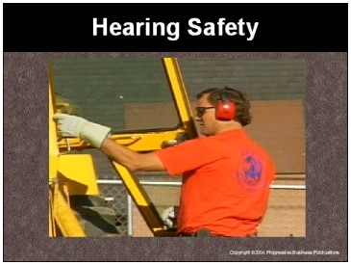

Speaker’s Notes
- Today’s topic is Hearing Conservation and Safety. This training is required by OSHA’s Occupational Noise Exposure Standard (29 CFR 1910.95).

- You will learn about:
- The risks of hearing loss in this facility.
- The symptoms of hearing loss.
- How to prevent hearing loss.

Suggestions for the Speaker
An effective ice breaker is to ask the trainees the following questions:
- Does anyone have any friends or family who has lost their hearing?
- How has it affected those people?
- Can anyone name an activity in this facility that may be loud enough to damage your hearing?

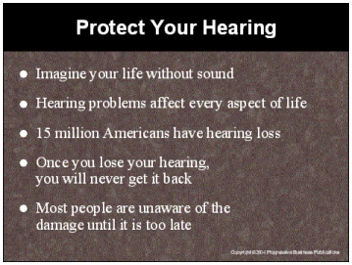

Speaker’s Notes
- How would your life change if you could not hear? Can you picture what your life would be like if you could not listen to music or the sounds from the television? How would you feel if your lack of hearing made it difficult to have a simple conversation with your friends and family?
- If you develop a hearing problem, it affects every aspect of your life. It can make life uncomfortable for you, your friends and your family.
- Hearing loss from loud noises is 100% preventable. But once you lose your hearing, you will never get it back.
- Unless you know someone who has a hearing problem, you may take your ability to hear for granted. More than 15 million Americans currently have measurable hearing loss. There are 15 million people living in New York City. Try to imagine, all of New York City having a hearing problem.
- Because hearing loss creeps up on us slowly, many people are unaware of the damage until it is too late.

Suggestions for the Speaker
Ask the trainees to pretend they are deaf. Let them picture what life would be like if they could not hear. Then explain that this is why prevention is important.

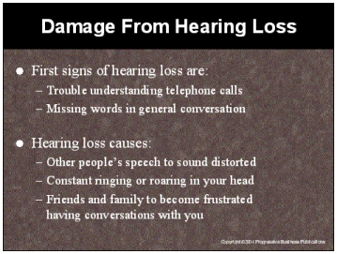

Speaker’s Notes
- The first signs that you may be losing your hearing are trouble understanding telephone conversations and missing words in general conversation.
- Unfortunately, by the time you realize that damage has been done, it is too late to recover what has been lost. At the earliest stages, you may have lost the ability to hear some high frequency sounds such as the consonants “s” and “ch” or low frequency sounds such as the rustling of leaves.
- Do not think that people with partial deafness simply live in a quieter, calmer world. The sounds that they can hear are distorted. For example, speech frequently seems garbled, sounding as if the speaker has hi or her head in a barrel.
- If you have partial hearing loss, you may experience pain and discomfort when exposed to very loud noise. You may also suffer from ringing, roaring or other constant sounds in your head.
- Plus, there are other mental side affects the hard-of-hearing person faces. Imagine your friends becoming less interested in having conversations with you because of the frustration it causes, when you keep asking them to repeat what they said.

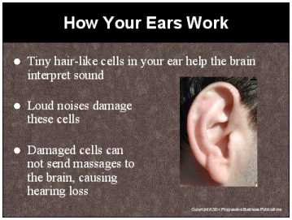

Speaker’s Notes
- There are thousands of tiny hair-like cells in your ear. These cells change sound vibrations into electrical impulses which are then interpreted by the brain. Most hearing loss is caused from damage to these hair-like cells.
- The damage is similar to wind blowing in a tree. A little wind is fine because the tree springs back into an upright position between breezes. However if the wind blows too hard or for too long the tree will become permanently bent or broken.
- Similarly, the hair-like cells in your ear will become damaged by too much noise for too long. The cells may recover if they are given enough quiet time, but repeated loud noises will lead to permanent damage.
- Often damage occurs gradually over a number of years and remains unnoticed until it is too late. The damaged cells can no longer send the messages to the brain and hearing is lost.

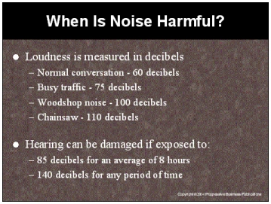

Speaker’s Notes
- Loudness is measured in decibels. A normal conversation takes place at about 60 decibels. Busy traffic is 75 decibels. A woodshop noise is 100 decibels and a chainsaw noise measures at 110 decibels.
- You can permanently damage your hearing if you are exposed to noise above 85 decibels for an average of 8 hours in one day without hearing protection.
- Never put yourself in a situation where you are exposed to 140 decibels or more, for any period of time. A single exposure to extreme noise can permanently damage your hearing. These situations are called traumatic hearing loss.
- You are entitled to observe noise monitoring testing and to be notified of the results of the testing to see if you are being exposed to extreme noise that could damage your hearing.

Suggestions for the Speaker
- Tell employees they should never believe the myth, “They will get used to the noise over time.” The only time loud noises stop bothering people is when their hearing becomes so damaged they can no longer hear the loud noise.
- Point out examples of noises in your facility that measure above 140 decibels.

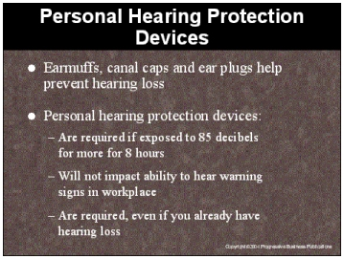

Speaker’s Notes
- Preventing hearing loss from loud noises is accomplished by reducing both the time and intensity of exposure. You can reduce exposure time by avoiding areas known to have loud noises that can damage your hearing. You can reduce the intensity by wearing personal hearing protection.
- Personal hearing protection is anything that can be used to reduce the level of the sound entering your ear. Earmuffs, ear canal caps, disposable and reusable ear plugs are the main types of devices used. Do not use your own equipment as protection. For example, personal headphones will not protect your hearing.
- You are required to wear hearing protection if you are exposed to noise above 85 decibels averaged over 8 working hours.
- Wearing hearing protection will not impact your ability to hear warning signs in the workplace. This is because hearing protectors will bring both the noise and the warning sound down equally. If you are able to hear the warning sound without the hearing protector, you will be able to hear it with the hearing protector.
- If you have hearing loss, it is still important to wear protection to save the hearing you still have. Loud noises can continue to damage your hearing, making it even more difficult to communicate at work and with your family and friends.

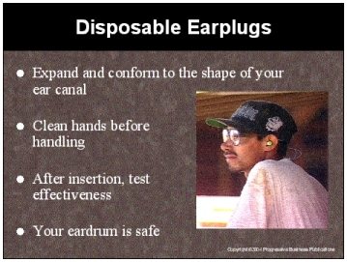

Speaker’s Notes
- Disposable earplugs are expandable foam plugs made of a pliable material designed to expand and conform to the shape of your ear canal. They fit snugly in your ear canal, providing temporary protection from noise, dirt and grease.
- The advantage of disposable earplugs is that they will fit in the ear canal of all ears. The disadvantage is that you put yourself at risk of ear infection when working in dusty, dirty conditions and you put dirty earplugs in your ear. Make sure your hands are clean when handling earplugs.
- The proper insertion technique is to roll the plug into a tight cylinder shape, pull back the outer part of the ear, insert the plug well into your canal and hold the earplug with your fingertips to give it time to expand. You can test effectiveness by placing your hand flat over your ear. If the plug is in correctly, there should be no reduction of the level of noise.
- Do not worry about poking out your eardrums with hearing protection. The average ear canal is about 1¼ inches long. The typical earplug is only ¾ of an inch long. Even if you insert the entire earplug, it will not touch your eardrum. Second, the path from the opening of the ear canal to the ear drum is shaped irregularly. This prevents you from poking your eardrum with foreign objects.

Suggestions for the Speaker
Ask someone to come up and demonstrate how disposable earplugs are inserted.

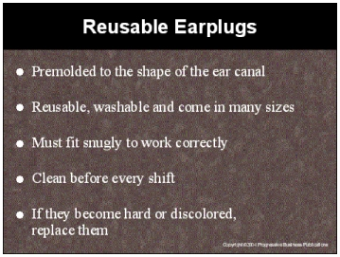

Speaker’s Notes
- Pre-molded, reusable earplugs are made from silicone, plastic or rubber and come in a wide variety of shapes and sizes to fit the different varieties of ears. You may need a different size earplug for each ear. The earplugs should seal the ear canal without being uncomfortable.
- Advantages of pre-molded plugs are that they are reusable, washable, convenient to carry and come in a variety of sizes. Nearly everyone can find a plug that will be comfortable and effective. The disadvantage is that they must fit snugly, or they will not work properly.
- Insert this type of earplug by reaching over your head with one hand to pull up on your ear. Then use your other hand to insert the earplug with a gentle rocking motion until you have sealed the ear canal.
- Reusable earplugs should be washed in lukewarm water using hand soap, rinsed in clean water and dried thoroughly before use. Wet and damp earplugs should be dried before being placed in their containers. Store in a dry box or other clean safe place. If earplugs become hard or discolored, replace them.

Suggestions for the Speaker
Ask someone to come up and demonstrate how reusable earplugs are inserted.

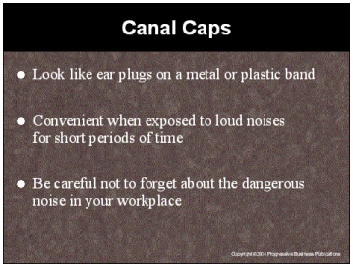

Speaker’s Notes
- Canal caps resemble earplugs on a flexible plastic or metal band. They are attached to a headband which creates uniform pressure by keeping the earplugs firmly in your ears. The earplug tips of a canal cap may be similar to disposable or reusable earplugs. Some have headbands that can be worn over the head, behind the neck or under the chin.
- Canal caps are a popular type of reusable earplug for situations where you are exposed to loud noises for short periods of time.
- The main advantage of canal caps is convenience. When it’s quiet, employees can leave the band hanging around their necks. They can quickly insert the earplug tips when hazardous noises start again.
- Be careful not to forget about the loud noises in your workplace. You can damage your hearing if you are exposed to loud noise and forget to insert your earplug tips.

Suggestions for the Speaker
Ask someone to come up and demonstrate how canal caps are inserted.

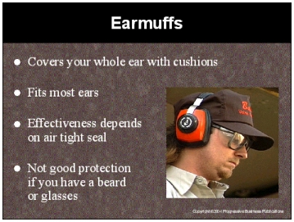

Speaker’s Notes
- Ear muffs fit over the whole ear with cushions, which can be filled with foam, liquid or air. These cushions work to block out noise by completely covering the outer ear and sealing against the side of the head. For noise levels of more than 100 decibels, you should wear both earmuffs and plugs for better protection.
- The advantage of earmuffs is that they will fit properly over most ears, but the effectiveness depends on an air tight seal. Workers who have heavy beards or sideburns or who wear glasses may find it difficult to get good protection from earmuffs. The hair and the arms of the glasses break the seal that the earmuff cushions make around the ear.
- If you have a beard or glasses, earplugs are recommended, especially since there is extra danger if the earmuffs do not seal properly. Earmuffs alone may actually increase the decibel level since the noise will echo before entering your ear. This picture shows the space created when someone wears glasses and earmuffs.

Suggestions for the Speaker
- Ask someone to come up and demonstrate how earmuffs are worn.
- Discuss how to clean the earmuff cushions. You can mention how the inside of the muffs should not get wet, and they should be replaced if they become ripped.

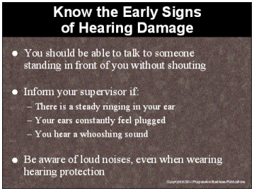

Speaker’s Notes
- We will test the environment and provide you with personal hearing protection to make sure your hearing is safe. But you should always look out for changes in the environment that could damage your hearing.
- If the workplace becomes so loud that you have to shout to talk to someone standing right next to you, let your supervisor know that you are concerned about your hearing.
- Early detection of hearing loss can save you from greater damage down the road. If you encounter any of the following, you may be at risk of hearing loss and you should notify your supervisor immediately:
- Do you have ringing in your ears after you leave the workplace?
- When you leave work, do your ears still feel plugged?
- Do you hear a mild ringing or whooshing noise that goes away after an hour or two?
- Do not become overconfident when you are wearing hearing protection. Hearing protection filters out loud noise, but does not block out sound completely. If you ever think you are being exposed to hazardous noises, inform your supervisor.

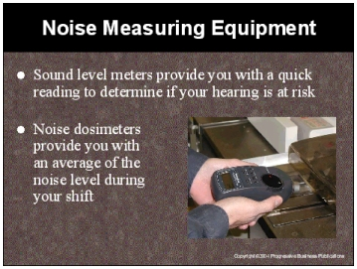

Speaker’s Notes
- There is equipment that will measure the decibel level in the workplace to determine if any area presents a risk of damaging your hearing.
- A sound level meter provides a “snap shot” measurement of noise levels at a particular time. These meters are used as a preliminary test to determine if any area exceeds 85 decibels, which is the level at which you are required to wear hearing protection.
- The advantage of the sound level meter is that you get a quick reading to see if you are safe. The disadvantage is that the level of noise will vary over time and a sound level meter will not be as effective at picking up this variation. The risk of only using a sound level meter is that the noise may be quieter when you take the reading and give you a false sense of safety.
- If you are looking to get a true average of the noise level, use a noise dosimeter, which measures and stores energy over time. It can be carried in your shirt pocket or attached to your belt. The microphone is positioned in your hearing zone while you go about a normal work shift. At the end of the shift, the reading will provide an average of the noise level you were exposed to during the shift.

Suggestions for the Speaker
- Perform a demonstration of how noise monitoring equipment works.
- If you have a “noise map” describing the areas of the facility that have hazardous noise levels, this is a good time to pass it out and explain it.

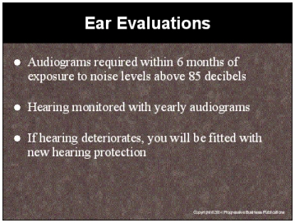

Speaker’s Notes
- If you are ever exposed to noise levels exceeding 85 decibels, you are required to get a hearing test called an audiogram, within six months of the exposure. This test, which we will conduct for you, establishes a reference point against which future annual audiograms can be compared.
- You must then receive an audiogram on a yearly basis, which we will conduct for you, to test if there has been damage to your hearing. By comparing the results of the different audiograms, we can evaluate whether you have experienced any hearing loss.
- You should be concerned if your ability to recognize sounds changes by 10 or more decibels. A 10 decibel decrease in the ability to recognize sound is serious. At this point, you may lose the ability to hear “soft” sounds like leaves blowing or high frequency sounds like whistles or sounds may seem muffled.
- If the audiogram identifies a decrease in your hearing ability by 10 decibels or more, you will be fitted with new hearing protectors, and will be required to wear them in areas with potentially hazardous noises.

Suggestions for the Speaker
Explain your company’s audiometric testing program. You may want to tell them who will conduct it, when and where the testing will occur.

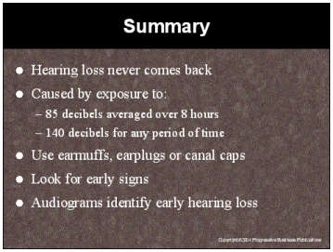

Speaker’s Notes
- Hearing loss from loud noises is 100% preventable. But once you lose your hearing, you will never get it back. Imagine how your life would change if you had trouble hearing.
- You can permanently damage your hearing if you are exposed to noise above 85 decibels for an average of 8 hours or a single exposure to 140 decibels or more for any period of time.
- Hearing protection is anything that reduces the level of the sound entering your ear. Earmuffs, ear canal caps, disposable and reusable ear plugs are the main types of devices used. You are required to wear hearing protection if you are exposed to noise above 85 decibels averaged over 8 working hours.
- Early detection of hearing loss can save you from greater damage down the road. If you encounter any of the following, you may be at risk of hearing loss and you should notify your supervisor immediately:
- Do you have ringing in your ears after you leave the workplace?
- When you leave work, do your ears still feel plugged?
- Do you hear a mild ringing or whooshing noise that goes away after an hour or two?
- If you are exposed to a noise level exceeding 85 decibels, you are required to get an audiogram, within six months of the exposure. You must then receive yearly audiograms to test if there has been damage to your hearing.

