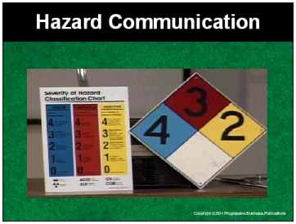

Speaker’s Notes
- Today we’ll be discussing Hazard Communication, sometimes called “HazCom”. This training is required by OSHA’s standard on Hazard Communication (29 CFR 1910.1200). The purpose of our session is to teach you how to recognize and stay safe from chemical hazards in our facility.
- You’ll learn about some of the hazards related to chemicals used in the workplace, their potential effects on your health, and how to protect yourself from them.

Suggestions for the Speaker
Consider kicking off the session with a series of true and false questions. True or false:
- There is nothing you can do ahead of time to protect yourself against emergencies. If something is going to happen, it’s going to happen.
- The only time you have to know about the dangers of hazardous chemicals is when there is an emergency.
- Hazardous chemical safety is the responsibility of your supervisors.

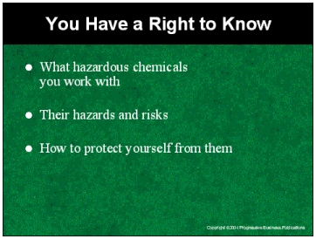

Speaker’s Notes
- Our topic, Hazard Communication, is also sometimes referred to as “Right to Know.” You have the right and need to know about the chemicals you work with on the job. You need to know what they are, their properties, their potential safety hazards and risks, and how to protect yourself from any dangers they present.
- Knowing these things will help you minimize the risk of illness or injury. It may even save your life or the life of a co-worker.

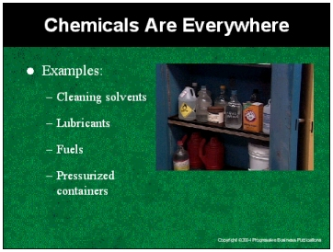

Speaker’s Notes
- Many of the chemicals found on the job are also found in your homes. At home these may not be considered dangerous, but on the job they become much more dangerous. Why?
- You deal with higher concentrations and volumes of these chemicals in the workplace. You’re using them for longer periods of time - sometimes constantly. There may also be many other chemicals in use that can interact with them and create dangerous byproducts.
- Safety starts with knowing what you are using, recognizing the dangers, and knowing how to proceed from there. You must be aware of the chemicals you use everyday.

Suggestions for the Speaker
- OSHA requires employers, as part of their HazCom employee training, to notify employees of the location of hazardous chemicals in the workplace.
- Consider using this time to give an overview of the chemicals most applicable to the workers at your facility.
- Ask your audience to name the chemicals they work with in their jobs.

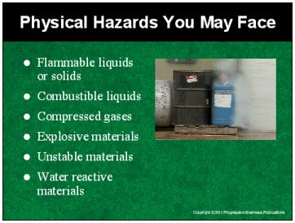

Speaker’s Notes
- You face both physical hazards and health hazards from chemicals on the job. These can kill you or, at best, make you seriously ill.
- Physical hazards are present if you work with any of the following:
  - Flammable liquids or solids are materials that can easily catch fire. Under certain conditions, they can lead to explosions. Some examples of flammable materials include paints, propane and gasoline.
  - Combustible liquids, while not igniting as easily as flammable liquids, still can ignite under certain circumstances.
  - Compressed gases are gases that are stored under high pressure, allowing the gases to rush out quickly if their container or piping is punctured. They may cause serious burns or respiratory difficulties when released.
  - Explosive materials can cause widespread damage to life and property if ignited or pressurized.
  - Unstable materials are highly sensitive to certain conditions such as exposure to air, high pressure, light, high temperatures or sudden shocks, such as dropping them. These conditions cause them to change and become very dangerous.
  - Water reactive materials become highly dangerous when exposed to water.

Suggestions for the Speaker
- For each category, attempt to provide specific examples most relevant and appropriate to your facility.
- You may also consider having examples on hand to use as visual aids.

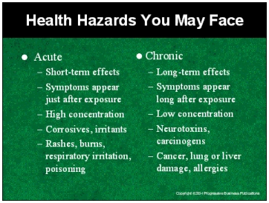

Speaker’s Notes
- If you don’t work with hazardous chemicals in the proper manner, you also face serious health consequences, both short-term and long-term.
- Symptoms from acute, or short-term, health hazards generally start right after you’ve been exposed to a high concentration of a hazardous chemical. Symptoms may include headaches, dizziness and nausea. You may have difficulty breathing or feel a burning sensation when you breathe. You may break out in a rash or have a burning sensation in your eyes. In the most extreme cases, these include chemical burns. Although painful and uncomfortable, these can be treated.
- Illnesses from chronic, or long-term, health hazards are also possible and are much more serious. These occur after you’ve been exposed to chemicals over a long period of time, most of the time in low concentrations. You won’t start to feel sick immediately and your symptoms may not appear for months, if not years. Over time, this type of exposure can result in a wide variety of lifelong illnesses. Some of these include damage to your central nervous system; sterility; heart ailments; liver, kidney or lung damage; and cancer. The effects of some of these are irreversible and many have no known cure. In some cases, these illnesses are deadly.

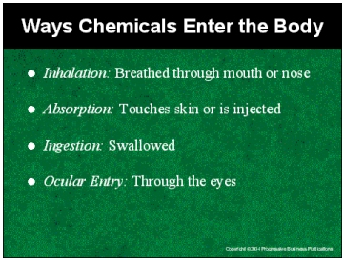

Speaker’s Notes
- We’ve gone over the health risks of chemical hazards, but how do you actually become exposed?
- You don’t need to fall into a vat of chemicals. There are many ways hazardous chemicals can enter your body on the job and cause you harm.
- You can breathe them in through your mouth or your nose. Nearly all materials that are airborne can be inhaled. In fact, the majority of hazardous material exposures occur through breathing vapors or fumes.
- You may be exposed to chemical hazards when materials touch your skin. This is particularly dangerous when it comes to corrosive materials.
- You may be exposed when eating or drinking. No one here would voluntarily eat or drink a chemical. But think about it - if you don’t wash you hands when you take a break to eat, you may unknowingly be contaminating your food with chemicals. If you leave a soda or coffee mug lying where it shouldn’t be, it may become exposed and you could end up drinking small levels of hazardous chemicals.
- Some chemicals can also be absorbed through your eyes. Splashes are the primary route, but there are other ways. For example, if you rub your eyes without washing your hands after working with a chemical. That’s putting you at risk.

Suggestions for the Speaker
Before moving onto the next section, now might be a good time to pause for any questions regarding the session material covered up to this point.

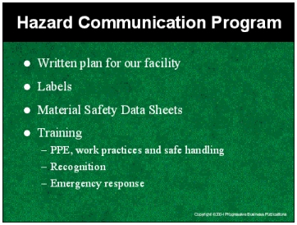

Speaker’s Notes
- So now that we can recognize some of the dangers from working with chemicals, we’re going to talk about what you can do to stay safe. Knowledge is power - the power to prevent serious health risks or accidents on the job.
- As required by OSHA, this facility has a Hazard Communication Plan (HCP) in place. This program is designed to meet the same goals we spoke of earlier: To reduce the risks involved in working with chemical hazards; to give information about potential hazardous substances in the workplace; and to reduce incidents involving hazardous substances. At the end of the session, I’ll tell you where you can get a copy of our HazCom plan.
- We’re going to look at where you will find the information that’ll help you minimize risks and prevent injuries from hazardous substances. We’re going to look at two primary sources - labels and material safety data sheets.
- We’re also going to touch on PPE, work practices, safe handling, hazard recognition and emergency response.

Suggestions for the Speaker
- OSHA requires all employees covered by the standard to have access to the facility’s Hazard Communication Program (HCP).
- Now might be a good time to give information about how employees can get a copy of your HCP or perhaps you may wish to wait for the end of the presentation.

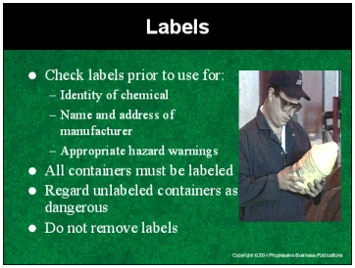

Speaker’s Notes
- How do you protect yourself? One way is to know what you are working with. Start with the label. Never use an unfamiliar chemical or substance before you’ve first read the label.
- Labels will provide the name of the chemical and the name of the manufacturer.
- In most cases the label will indicate if the chemical is hazardous. Look for keywords like hazardous, toxic, dangerous, corrosive, irritant, carcinogen, etc.
- In some cases the label itself will provide information on appropriate PPE, safe handling practices and proper emergency response if something goes wrong.
- Old containers prior to 1985 may not contain hazard warnings.
- All containers must be labeled. Do not work with chemicals stored in unlabeled containers. Do not remove or deface existing labels on containers.

Suggestions for the Speaker
Consider providing workers with labeling examples for chemicals common to your facility.

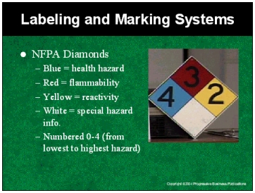

Speaker’s Notes
- In addition to labels on chemical containers, labels are also found on placards on large tanks, doorways and exitways to chemical storage areas.
- The NFPA diamonds are a rating system giving information on certain chemical properties.
- Blue indicates the severity of the health hazard. The corresponding numbers indicate the severity of the risk on a scale of 0-4, with 0 being the lowest and 4 the highest.. Those with 0 are like ordinary material. Those with a 1 are slightly hazardous. Those with a 2 are hazardous - breathing apparatus should be used. Those with a 3 are extremely dangerous and full protective clothing should be worn. Items with a 4 are deadly hazards.
- Red indicates flammability. Items with a 4 are extremely flammable or explosive. 3’s ignite at normal temperatures. 2’s ignite when moderately heated. 1’s must be preheated to burn. Those with 0 will not burn.
- Yellow indicates reactivity. Items with a 4 may detonate and people should be evacuated if materials are exposed to fire. A 3 indicates that a strong shock or heat may detonate the material. A 2 indicates that a violent chemical exchange is possible. A 1 indicates that the substance is unstable if heated but can be used normally. 0’s are normally stable.
- White indicates special any hazard information.
- Labels provide only limited information. If you are not sure whether or not a chemical you are using is hazardous, another tool you can use to find out is its material safety data sheet, which we’ll talk about in a few minutes.

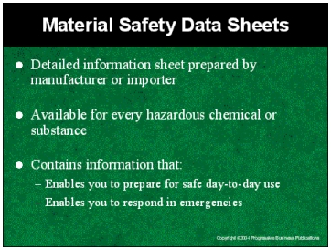

Speaker’s Notes
- Material safety data sheets are your second source of information. They provide a wealth of chemical hazard and safe handling information for chemicals used on the job. These are documents prepared by the chemical’s manufacturer or importer. They contain information that enables you to prepare for safe day-to-day use of the chemical. Our facility has an MSDS for every chemical you work with here.
- We’ll look at an example of an MSDS next, but before we do I’d like to emphasize the following - labels only go so far. If you are not sure whether a chemical you are using is hazardous, again, review the MSDS. If you don’t know what the safe handling procedures are, what PPE to wear, what to do in case of an emergency - if you don’t know that information - then review the MSDS.
- Always review the MSDS prior to working with any new chemicals, even if you plan on working with them for just a short period of time.

Suggestions for the Speaker
Now would be a good time to hand out sample MSDS’s for chemicals at your facility in preparation for the next section, which provides a summary review of the information contained on an MSDS.

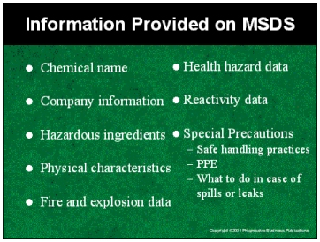

Speaker’s Notes
- An MSDS will have the following information:
- The name of the chemical and the manufacturer’s or importer’s name, address and telephone number
- Hazardous chemical ingredients.
- Physical characteristics of the chemical. This includes a description of the chemical’s general physical appearance and/or odor, important for recognizing exposure situations, as well as boiling or freezing points.
- Fire and explosion data on the MSDS provides the conditions under which chemical may ignite or explode.
- Health hazard data on the MSDS provides info on acute and chronic health hazards, like the ones we reviewed, routes of exposure, and signs and symptoms of exposure.
- MSDS’s may provide reactivity data - information on other substances with which it reacts.
- “Special precautions” is a very important and useful area. It includes information on recommended personal protective equipment, suggested safe handling practices, how to prevent dangerous explosions, info on how to put out a fire, how to handle spills or leaks and hazard recognition.

Suggestions for the Speaker
- OSHA requires every employee to have access to MSDS’s.
- Use this time as an opportunity to tell workers where MSDS’s are stored and/or who they should contact for MSDS.

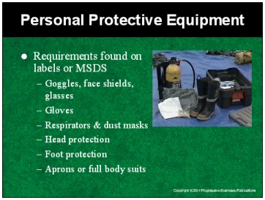

Speaker’s Notes
- A list of the personal protective equipment you’ll need before using each chemical will be found on that chemical’s label or MSDS. Remember - there is no harm in being overprotected. Do not use a hazardous chemical without checking for the specific PPE requirements prior to use.
- In general, glasses, goggles and face shields should be worn for protection from splashes, sprays or mists.
- Gloves should be worn to protect you from chemical hazards when handling them.
- Respirators & dust masks should be used when working in areas where hazardous vapors, fumes or dusts are present.
- Foot, head protection and full body protection are worn to protect against skin contamination if, for example, you are working with strong acids, acid gases, organic chemicals, strong oxidizing agents and the like.
- Remember, first check the label for PPE requirements. If none are given, go to the MSDS.

Suggestions for the Speaker
- Take this opportunity to review the specific PPE requirements for chemicals used by your workers.
- Use this time to make sure workers know how and where to obtain required PPE before starting jobs using chemicals.

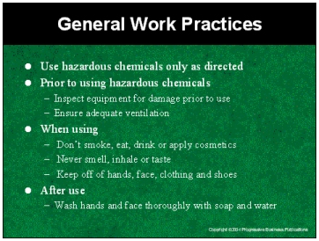

Speaker’s Notes
- Use hazardous chemicals only as directed. Don’t experiment. Don’t take chances.
- Prior to use of hazardous chemicals, inspect your equipment. Make sure there are no leaks or loose connections where chemicals could escape.
- When preparing to use chemicals that form vapors or gases, make sure you have adequate ventilation. Remember, inhalation is the primary route of entry for chemical hazards.
- When using chemicals, don’t eat, drink or apply cosmetics. Remember, the mouth and eyes are primary routes for chemical entry.
- Never smell, inhale or taste. If you want to know what a substance is, check the label or MSDS. If you are unsure, ask a supervisor.
- Attempt to keep chemicals off hands, face, clothing and shoes.
- After use, make sure to wash your hands and face thoroughly with soap and water.

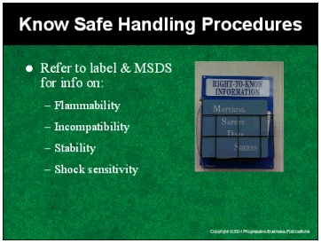

Speaker’s Notes
- Certain chemicals you work with require special precautions during handling and storage. Always refer to the MSDS and follow the instructions there.
- Keep flammable liquids away from heat, flame or direct sunlight.
- Certain hazardous chemicals cannot be safely mixed or stored with other chemicals. That’s because an extremely toxic product can result when two or more are combined. So it’s important to not only know what you’re working with, but the other substances in the vicinity as well.
- Stability refers to the tendency of some chemicals to change and become even more dangerous when exposed to certain conditions. For example, some chemicals can form hazardous byproducts when exposed to air or light.
- Shock sensitive chemicals rapidly decompose or explode when struck, vibrated or are otherwise agitated. Handle with care. Check the MSDS for proper instructions.

Suggestions for the Speaker
Take this time to review the safe handling procedures for the specific chemicals your employees work with on the job. Refer to each chemical’s MSDS for specific instructions.

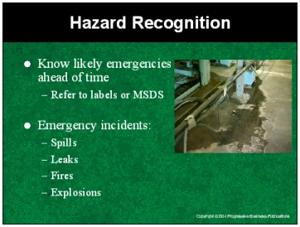

Speaker’s Notes
- Knowing the worst-case scenario will help prevent emergencies. And when an accident does occur, you’ll know what steps to take. The information on labels and MSDS’s will provide you with some of the likely worst-case scenarios for each of the chemicals your are working with. Are they likely to leak? Spill? Catch fire or explode? Do they give off hazardous fumes or vapors during routine use? One of the keys to recognition is knowing what you are looking for in advance.
- In addition, the MSDS will provide the specific types of hazardous emergencies. It’ll also provide ways to recognize them and warning signs for when they have occurred.
- The emergency incidents most likely to happen will depend upon the specific chemicals you’re working with.

Suggestions for the Speaker
Use this time to review appropriate hazard recognition procedures for the chemicals, equipment and work processes in your operation.

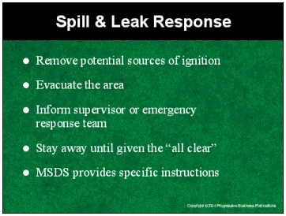

Speaker’s Notes
- Now let’s look at what to do if a spill or leak occurs. First, attempt to remove any potential sources of ignition if possible. Spills and leaks are bad enough; fires or explosions are worse.
- Evacuate the area and immediately inform your supervisor of the situation. If he or she is unavailable, notify our emergency response team. If possible, provide them with the names of the chemicals involved.
- Do not return to the spill scene until given the “all clear” by your supervisor.
- The MSDS will provide specific instructions on spill and leak response. Again, know what chemicals are around you. Read the MSDS ahead of time so you can be ready to act in the event of an incident.

Suggestions for the Speaker
- Give examples the chemicals your workers use that have the highest potential for spills or leaks. Include ways your workers can recognize them.
- Ensure that your employees know your facility’s specific procedures for chemical incidents, including who to notify in the event of an incident and make sure workers are familiar with your facility’s emergency response plan.

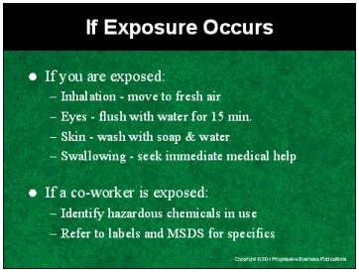

Speaker’s Notes
- In the unlikely event you are exposed to a hazardous chemical, be prepared to react fast. In all cases, report the incident immediately to your supervisor. Tell him what chemicals you were working with when the incident occurred. If possible, bring the MSDS.
- If you have inhaled fumes or vapors, remove yourself from the source and move to an uncontaminated area.
- If materials get into your eyes, flush them with running water for at least 15 minutes.
- If you have a spill on small confined part of your skin, immediately flush with cold water for 15 minutes. Sometimes there may be a delayed reaction - often the next day. If you notice a rash or other types of discoloration, report this to your supervisor and seek immediate medical attention. If a large amount of chemicals are spilled on you, quickly remove all contaminated clothing and use a safety shower or other available source of water to rinse yourself thoroughly.
- If you believe you’ve swallowed or drunk a hazardous chemical, notify your supervisor and seek immediate medical attention.
- If you do not require first aid yourself, you can still help a co-worker. Provide your supervisors or first response team with the names of the chemicals your co-worker was using.

Suggestions for the Speaker
Review your facility’s specific emergency response procedures and the location of any first aid kits, eyewash stations or showers.

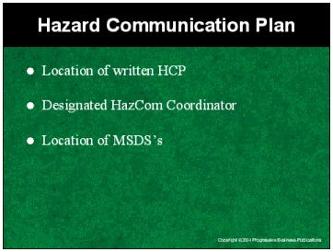

Speaker’s Notes
- As required by OSHA, our facility currently has in place a Hazard Communication Program. It includes the points we just reviewed as well as detailed information on the specific chemicals in use at our facility.
- You have a right to review the plan.

Suggestions for the Speaker
- Consider holding up a copy of your HCP.
- Use this time to notify employees of the procedures for reviewing the plan.

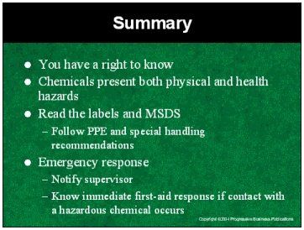

Speaker’s Notes
- We’ll briefly recap what we’ve covered in this session. You have a right and a need to know about the chemicals you work with, what hazards they pose and how to protect yourself from them.
- Chemicals present both physical hazards and health hazards. Hazardous chemicals can enter your body through inhalation, swallowing, contact with skin or through the eyes causing both short-term and long-term health hazards. Physical hazards include dangers presented by flammable liquids, combustible liquids, compressed gases and explosives. Short-term effects include rashes, burns, dizziness and nausea. Long-term health damage may include sterility, cancer and damage to the central nervous system, lungs and kidneys.
- You learn about hazards and how to protect yourself through two primary sources - labels and MSDS’s. Always check labels prior to use for chemical name, information on appropriate PPE, safe handling practices, and proper emergency response. Never use materials from unlabeled containers. Know where MSDS's are stored for the chemicals you work with and check the MSDS prior to working with any unfamiliar chemicals. Pay particular attention to special precautions and PPE requirements.
- Always report leaks, spills, suspicious odors to supervisor immediately. If you do come into contact with a hazardous know immediate emergency response and first aid procedures.

Suggestions for the Speaker
- Consider opening the floor for questions on any aspect of this session.
- Use the quiz accompanying this presentation to test workers’ understanding and retention of the material presented.

