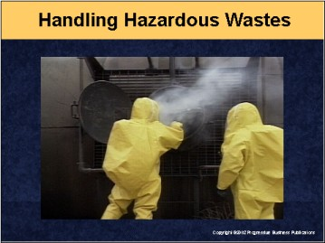

Speaker’s Notes
- Today’s topic is hazardous waste management – specifically the everyday housekeeping chores of properly and safely handling hazardous wastes. A
key term we’ll be referring to throughout this training session is “RCRA”
(pronounced Rick-ra).
- RCRA stands for the Resource Conservation and Recovery Act. It’s the federal law that lays out very detailed management standards for handling, storing, treating and disposing of hazardous wastes. RCRA imposes tight control over hazardous wastes to prevent contamination incidents like the one that occurred at Love Canal in Niagara Falls, NY. In that case, an entire neighborhood was contaminated when buried hazardous wastes seeped into basements, and residents suffered from a variety of serious health effects.
- To prevent these types of incidents, RCRA imposes what’s known as “cradle-to-grave” liability on hazardous wastes. This means any facility that creates a hazardous waste never loses responsibility for that waste, even after it’s properly disposed of.

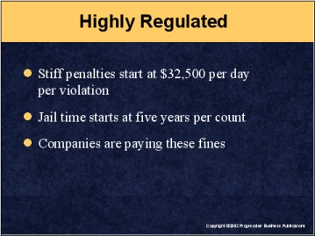

Speaker’s Notes
- We have two reasons to manage hazardous wastes safely: 1) To protect you, the company, our neighbors and the environment from exposure to dangerous wastes, and 2) To avoid severe penalties for mismanaging hazardous wastes.
- Under RCRA, EPA and state agencies can impose very costly fines, starting at $32,500 per violation. If the agency thinks the violations were done on purpose or out of negligence, the penalty is jail time – up to five years in jail for each violation. Here are some typical examples of RCRA penalties:
- An Ohio electroplater paid a $90,000 fine for violating various RCRA requirements, such as failing to label hazardous waste containers.
- An Illinois printed circuit board manufacturer was fined $45,087 for failing to include a complete list of the emergency cleanup equipment in its spill plan.
- A Minnesota metal finishing company faces a $300,000 penalty for failing to keep records of when it inspected its hazardous waste storage area.
- An Arizona recycling company was fined $67,888 for several RCRA violations, including failure to make sure hazardous waste containers were kept closed when not in use.

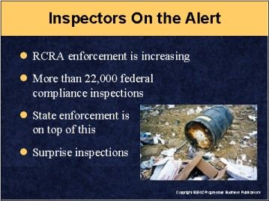

Speaker’s Notes
- We have a lot of work to do to avoid these types of severe fines. EPA and state inspectors will be visiting us and other facilities to check up on our RCRA compliance programs.
- Last year, the feds conducted over 22,000 enforcement inspections. This was 4,500 more compliance inspections than the previous year, and much of this enforcement effort is focused directly on RCRA and hazardous waste management. Each state conducts even more inspections.
- These inspections can be scheduled visits, but increasingly, inspectors are showing up for surprise inspections, and under RCRA or state versions of the federal law, we have to drop everything we’re doing and allow them to inspect our facility.

Suggestions for the Speaker
EPA authorizes many states to run all or parts of the federal RCRA programs. You might want to see which parts of the RCRA program your state runs and explain to workers whether RCRA inspections will be conducted by state and/or federal officials

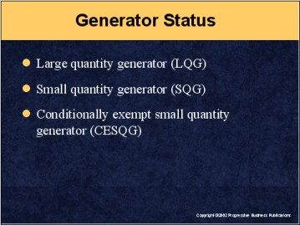

Speaker’s Notes
- We also have to track how much hazardous waste we generate each month and report this to EPA. This is important because EPA regulates facilities based on how much hazardous waste they generate a month. The more you generate, the more stringent the regulations become.
- A key limitation is how long we can store hazardous wastes before we’re required to send them to a treatment facility for disposal. The longer we can store wastes, the better chance we have to accumulate enough material to make it cost effective to send the wastes to a treatment or disposal facility.
- There are three categories of hazardous waste generator status:
- Large quantity generator (LQG) – those that generate more than 2,200 pounds of hazardous waste a month. LQGs can only store wastes for 90 days.
- Small quantity generator (SQG) – those that generate between 220 and 2,200 pounds of hazardous wastes. SQGs can store wastes for 180 days.
- Conditionally exempt small quantity generator (CESQG) – those that generate less than 220 pounds of hazardous waste a month. CESQGs can store wastes longer than 180 days.

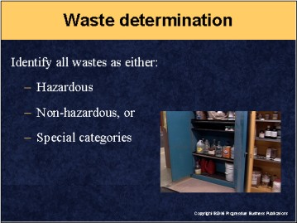

Speaker’s Notes
- Our first task is to identify all wastes we handle here. We’re required to perform a hazardous waste determination on all wastes generated at this facility. We have to decide if our wastes are hazardous or non-hazardous.
- Most non-hazardous solid wastes can be disposed of in a county or private landfill. These wastes include things like paper, wood and building materials.
- EPA defines a hazardous waste as one that has “properties that make it dangerous” or is capable of having harmful effects on human health or the environment. Dangerous means any number of adverse effects, from causing itchy eyes to death.
- There’s a special category of hazardous waste known as universal wastes. Wastes in this category include TVs, computer monitors, batteries and fluorescent light bulbs. These are considered hazardous because they contain lead or mercury. But they’re exempt from some RCRA rules if we recycle them.

Suggestions for the Speaker
Now might be a good time to ask for a show of hands to see how many employees have any experience handling hazardous wastes. Ask them if they know why the waste is “hazardous.”

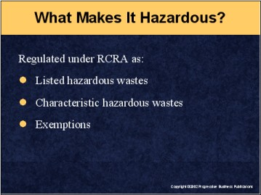

Speaker’s Notes
- Which wastes are hazardous? Under RCRA rules, a waste is assumed to be hazardous unless we can prove otherwise. So it’s our responsibility to conduct a hazardous waste determination. We make this waste determination one of three ways:
- Check to see if our material is on one of EPA’s lists of hazardous waste
- Test the waste to see if it meets any of EPA’s characteristics of a hazardous waste
- Use our process knowledge to decide if a waste is hazardous or non-hazardous.
- EPA specifically identifies some wastes as “listed” hazardous wastes. They’re “listed” simply because they’re on a list EPA compiled of commonly known industrial hazardous wastes. These are wastes from specific industrial processing activities. These wastes are on one of four lists of hazardous wastes (F list, K list, P list or U list).
- The second major category of hazardous wastes are those that meet EPA’s definition of a characteristic waste. These are wastes that are ignitable, corrosive, reactive or toxic. These are labeled as D wastes.
- There are also several types of wastes that are exempt from RCRA coverage. These include domestic sewage and industrial wastewater discharges that are already regulated under the Clean Water Act. Others include certain laboratory wastes, household wastes, agricultural wastes used as fertilizers and certain mining wastes.

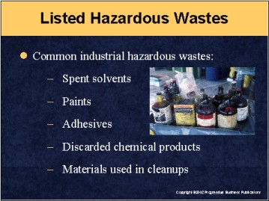

Speaker’s Notes
Listed hazardous wastes include:
- Spent solvents, such as toluene, benzene and methyl ethyl ketone
- Paints and various industrial and architectural coatings
- Cutting fluids and other materials that can pick up metal shavings
- Adhesives, inks, glues
- Hazardous wastes from specific processes or sources, such as
bottom sediment sludge
- Discarded or out-of-date chemicals and products like pesticides
and insecticides
- Discarded containers that held a hazardous waste
- All materials used to clean up a hazardous waste spill, such as gloves,
towels, absorbents, clothing, virtually anything that comes into contact with
the hazardous waste.

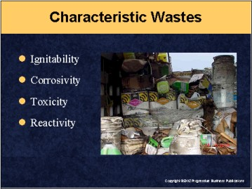

Speaker’s Notes
Characteristic hazardous wastes are those that are:
- Ignitable – wastes that have a low flashpoint and can easily catch fire. The test is if the material’s flashpoint is less than 140°F (60°C).
- Corrosive – wastes that have the ability to eat their way through tanks, drums and containers. These are acids and bases with a pH level less than 2 or greater than or equal to 12.5.
- Reactive – wastes that react with other materials, often spontaneously, to cause explosions or create gas releases when mixed with water.
- Toxic – wastes that can kill or cause serious health effects, such as cancer and lung diseases, or create reproductive problems in adults that usually show up in their children.

Suggestion for the Speaker
This is a good opportunity to ask attendees if they can identify any wastes on site that might fit into any of these categories. Then ask them to explain how they handle these types of materials.

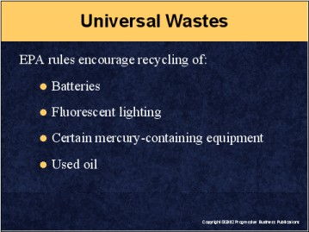

Speaker’s Notes
- There’s a special category of hazardous waste known as universal waste. These wastes include TVs, computer monitors, batteries, mercury-containing equipment, fluorescent light bulbs and ballasts. These materials are considered hazardous because they contain materials such as lead and mercury. EPA relaxes some RCRA rules to encourage recycling instead of disposal. For example, we can store these materials longer than the normal 90-day or 180-day limits for hazardous wastes if we intend to recycle the waste. This allows us to store universal wastes until we accumulate enough material to make it cost-effective to recycle them.
- When we store universal wastes, we must still follow RCRA housekeeping rules, such as marking containers and keeping them closed. And, it’s critically important to keep all the records of when we start accumulating these wastes. We need all the proper paperwork to prove to EPA or state inspectors that we’ve been following RCRA management standards.
- Finally, if we have to dispose of a universal waste, it’s still regulated by RCRA rules. We cannot put universal wastes into the normal solid waste containers. Universal wastes can only be disposed of by sending them to RCRA-regulated treatment, storage and disposal facilities.

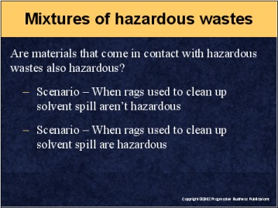

Speaker’s Notes
- EPA also regulates mixtures of hazardous wastes and other materials. For example, in a typical cleanup situation, what happens to the rags used to clean up a spill of an oily, solvent-based liquid?
- The rags would be considered non-hazardous solid waste if:
- The solvent mixture involved has a flashpoint under 160°F
- The mixture isn’t an EPA listed hazardous waste
- The mixture doesn’t contain any other hazardous characteristics, or
- We can use our process knowledge to verify that it’s non-hazardous.
- But the rags would have to be treated as hazardous waste if:
- The spent solvent involved was a listed EPA hazardous waste
- The mixture exhibits any of the hazardous characteristics (ignitability, corrosivity, reactivity, toxicity)
- We know, based on our process knowledge, that the waste
is hazardous.

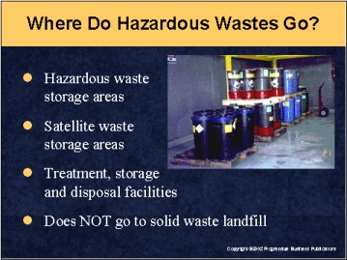

Speaker’s Notes
- Hazardous wastes must be stored in a designated hazardous waste storage area. These areas must be marked and secured.
- These are temporary storage areas where we accumulate wastes until we’re ready
to ship it to a RCRA-permitted treatment, storage and disposal facility.
- Some facilities can also use satellite accumulation storage areas
for hazardous wastes.
- Hazardous wastes can be stored for purposes of reclaiming or
recycling the materials.
- Hazardous wastes cannot go to a municipal solid waste landfill.

Suggestion for the Speaker
This is a good opportunity to share with attendees a map or diagram of your facility that marks the location of hazardous waste storage areas and emergency spill response and safety equipment.

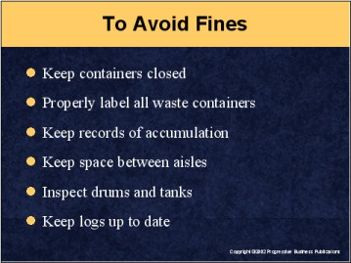

Speaker’s Notes
The first place inspectors will check is our hazardous waste storage area. They want to make sure our drums and containers are in good order and not leaking. Some of the major things they’ll be checking are that:
- The area is marked off and secured as a hazardous waste storage area
- Each container is labeled to identify which types of hazardous waste are
in them
- There’s plenty of aisle space between drums to inspect all containers, especially the ones in the back. We can’t stack drums wall-to-wall to save space. We must keep enough room between drums to allow for easy access by inspectors, emergency responders and their equipment
- Covers are on all our drums and containers
- We have dates and logs of when we started accumulating hazardous waste in each drum or container
- Incompatible wastes are stored separately
- We’ve conducted weekly inspections of our hazardous waste storage areas and have records or logs of these checkups.

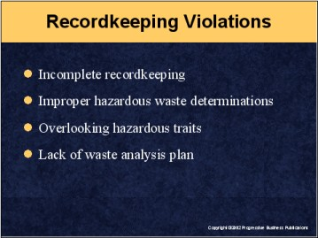

Speaker’s Notes
- Some of the most common RCRA violations involve paperwork. Creating the proper paper trail of our activities is one of the best ways we have of avoiding compliance trouble. Any reporting violation can lead to costly fines – even if we never have any release of a hazardous waste.
- Paperwork violations include failing to:
- Develop a waste analysis plan
- Conduct a hazardous waste determination on each waste stream
- Keep records of each determination showing how we made this decision
- Making a mistake on a waste determination.
- Although we can use in-house knowledge of our process, it’s a risky proposition. EPA field inspectors warn that many experts overlook minor components in a waste stream and mistakenly declare that waste isn’t hazardous.
- That’s why it’s important for us to review our products and waste streams
to be as certain as possible that our process knowledge is as accurate as we
think it is.

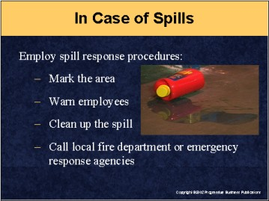

Speaker’s Notes
- In case of hazardous waste spills, we must use standard spill control procedures. We must warn other employees, mark off the area, notify our spill control coordinator and clean up the spill. In addition, those doing the cleanup will likely need to wear personal protective equipment.
- A problem with hazardous wastes is that all sorts of materials used to clean up a spill will likely be treated as hazardous waste, such as rags, gloves, clothing and shoes. Even the wash water can become hazardous when it contains elements of the waste, so it’s imperative to follow proper spill response procedures.
- That’s why it’s important to leave the cleanup to trained employees.
- If the spill requires outside help, we must call local emergency response agencies and let them handle the situation. In this case, we must be prepared to advise outside experts as to what types of materials they’ll be handling.
- In case of spills or other accidental release, we must document the incident, conduct a hazardous waste determination and create a record of how we decided whether the material was a hazardous waste or not.

Suggestion for the Speaker
This would be a good time to review your facility’s emergency response plans and identify which wastes would require PPE when cleanup is needed.

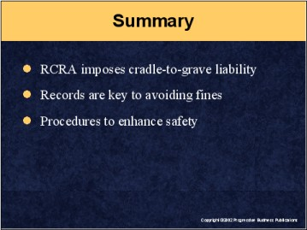

Speaker’s Notes
- To sum up, our handling of hazardous wastes generated at this facility is regulated under RCRA – the federal Resource Conservation and Recovery Act – or our state’s version of these rules.
- RCRA imposes cradle-to-grave liability on us for wastes generated or handled here. This forces us to properly manage all wastes and take precautions to avoid any accidental release of these wastes.
- Violations of RCRA waste management standards lead to costly fines.
- EPA is increasing the number of enforcement inspections.
- The best way to avoid compliance trouble is to adhere to good housekeeping procedures, label all containers, keep them covered, conduct hazardous waste determinations, and keep good records of all our activities.
- In case of spills or releases, follow established spill response plans and call in experts when we need outside help to handle a release.

