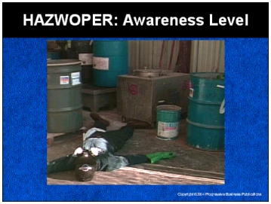

Speaker’s Notes
- Today’s topic is Hazardous Waste Operations and Emergency Response, also known as HAZWOPER. This training is a part of OSHA’s Hazardous Waste Operations and Emergency Response Standard (29 CFR 1910.120).
- You’re all classified as First Responders at the Awareness Level, which means you have a job where you may see or discover a release of a hazardous substance.
- Today, you’ll learn how to:
- Recognize the danger signs of a hazardous chemical spill or release.
- Begin the emergency response process by notifying the proper authorities.
- Evacuate the area to protect you and your co-workers.
- Secure the area so no one gets hurt.

Suggestions for the Speaker
An effective ice breaker is to ask the trainees the following questions:
- Who has seen stories on the news about hazardous
chemical spills?
- Does anyone know what types of damage and injuries can be caused by hazardous chemical spills?

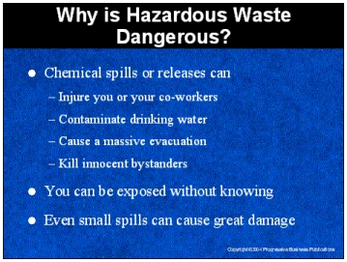

Speaker’s Notes
- Chemicals are hazardous when they are ignitable, corrosive, reactive or toxic. When these hazardous chemicals are spilled or released, they can injure you or your co-workers, contaminate drinking water, cause a massive evacuation of your company premises and surrounding areas or even kill innocent bystanders.
- Hazardous waste can be a gas, liquid, solid or sludge. Whatever form the hazardous waste takes, you can be exposed to the toxic dust or vapor without even knowing it.
- Even a small chemical spill can cause fires, explosions or pollute the air, water and land. It’s not the size of the spill, but the hazards of the chemical that we need to worry about.

Suggestions for the Speaker
- Discuss the specific dangers associated with a release of the types
of chemicals stored or used at your facility.
- Share a story of the types of injuries and illnesses hazardous waste can cause. If you do not have one, you can use the following true story:
- Two employees were disposing of hazardous chemicals by pouring a smaller container into a larger one. The larger container already contained chemicals, and a reaction caused a flash explosion. The explosion ruptured the larger container and caused chemical burns on the hands of the first employee and on the leg of the second employee; 21 others employees were hospitalized for injuries from skin or respiratory exposure to the hazardous chemical.

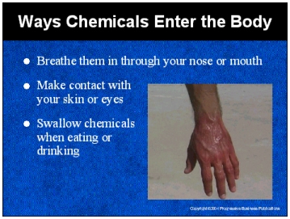

Speaker’s Notes
- It is important you understand how chemicals can harm you so that you can protect yourself and others during a spill or release.
- You don’t need to fall into a vat of chemicals to be injured. There are many ways hazardous chemicals can enter your body and cause you harm.
- The majority of hazardous chemical exposures occur through breathing vapors or fumes. The damage can occur if you breathe them in through your mouth or your nose. Initial symptoms of breathing a hazardous chemical are headaches, nausea or dizziness.
- You can be exposed to chemical hazards when hazardous materials touch your skin or eyes. Splashes are the most common cause, but there are other ways, for example, if you work with a chemical and rub your eyes or skin without washing your hands. This is particularly dangerous when working with corrosive materials that can burn your skin or eyes. Typical symptoms are irritation, itchiness, blisters and hives.
- You can swallow hazardous chemicals when eating or drinking. If you don’t wash you hands when you take a break to eat, you could contaminate your food with chemicals. If you leave a soda or coffee mug in a hazardous area, it may become exposed and you could end up drinking hazardous chemicals. Nausea, vomiting and dizziness are typical reactions.

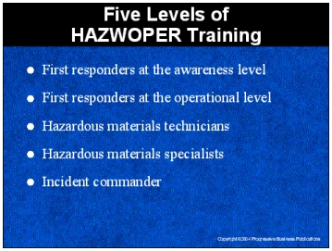

Speaker’s Notes
- There are five levels of HAZWOPER training. You should only respond to an incident according to your level of training.
- First responders at the awareness level are people who are first on the scene of an emergency involving hazardous materials. They are expected to recognize that hazardous materials are present, protect themselves, call for trained personnel and secure the area. Everyone in the room is currently being trained at this level.
- First responders at the operational level respond to releases of hazardous materials with the purpose of protecting nearby persons, the environment, or property from the release. They are trained to respond in a defensive manner and control the release from a safe distance and keep it from spreading.
- Hazardous materials technicians respond to releases of hazardous materials with the purpose of controlling the release. They are trained to respond in an offensive manner and may have to enter the hazardous area.
- Hazardous materials specialists are similar to hazardous materials technicians except that they have specialized knowledge of the response plan, specific personal protective equipment and instrumentation.
- The incident commander is responsible for all decisions related the management of the incident. This individual coordinates the entire response scene and is ultimately responsible for the safety of all involved.

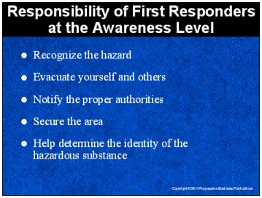

Speaker’s Notes
- As a “First Responder at the Awareness Level” you have a responsibility to:
- Recognize that a hazardous substance has been released.
- Protect yourself and others by alerting your co-workers to the spill and beginning the evacuation procedure.
- Notify the proper authorities to begin the emergency response procedure.
- Secure the area to prevent your co-workers and innocent bystanders from entering the hazardous area.
- Help determine the identity of the hazardous substance that has been
spilled or released.
- Remember that your responsibility doesn’t require you to enter the hazardous area after you have evacuated. Many people have been injured or even killed
trying to do more than they have been trained to do.
- These responsibilities are explained in more detail in our emergency response plan, which describes how to handle any spill or release of a hazardous substance.

Suggestions for the Speaker
Pass out copies of the Emergency Response Plan and point out where additional copies can be found in your facility.

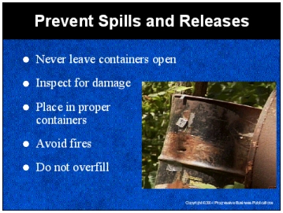

Speaker’s Notes
Many spills can be avoided by following the rules. If we can prevent spills and releases from occurring in the first place, we will not have to put people in danger responding to them. Following are some of the things you can do:
- Never leave chemical containers open. They can easily be knocked over
and spilled.
- When working with chemical containers, inspect them for damage, which includes corrosion, bulging or leaks. If you think something does not look right, report it to your supervisor.
- Hazardous waste must be placed in proper containers. The containers are to be sealed and marked with the words “Hazardous Waste.” Foil or film closures are not acceptable. Do not put hazardous wastes into sinks, drains or out in the trash.
- Keep open flame and sparks away from hazardous waste and its containers. No smoking rules apply. Many types of hazardous waste are flammable and can
cause explosions.
- Do not overfill waste containers. Two inches of space should be allowed at the top of the container.

Suggestions for the Speaker
Point out to the trainees where and how hazardous waste is stored in your facility.

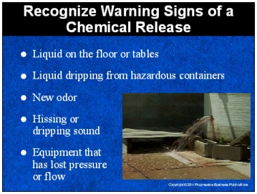

Speaker’s Notes
- Recognizing a chemical release or spill could mean the difference between life and death. You should always be on the look out for something that is out of place or not right. Some of the signs to be aware of are:
- Liquid on the floor or tables.
- Liquid dripping from containers with hazardous substances.
- Any odor that is new to you.
- Sounds, such as a hiss or drip, which may indicate a leak from a container with hazardous substances.
- Equipment that has lost pressure or flow, which may indicate a leak.

- If you recognize any of these signs, you may have discovered a chemical release. If you are unsure of the cause of these signs, immediately report the situation to your supervisor. It is better to be safe than sorry.

Suggestions for the Speaker
Ask the trainees for examples of pipes, pumps or tanks in your facility that contains hazardous substances.

7

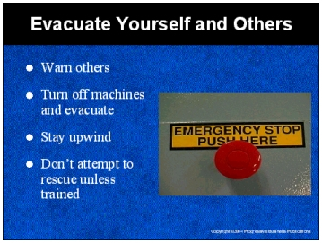

Speaker’s Notes
- If you suspect a hazardous chemical release, warn your co-workers in the immediate area and get out of there. Alert your co-workers by yelling or setting off an alarm.
- Evacuate to an established meeting area that is a safe distance from the spill or release. If you can do so quickly, turn off all machinery that is near the spill. Many types of hazardous materials are flammable and the sparks from machinery can start a fire.
- A chemical release or spill can cause a toxic cloud. When evacuating, protect yourself by staying upwind of the release or spill.
- It may be tempting to go back and help your co-workers, but you must only help if you are trained to do so. If you are not trained in emergency rescue procedures, do not re-enter the hazardous space. Many deaths are from “would-be rescuers.” In some cases, unsuccessful rescuers have died while the initial victim lived.

Suggestions for the Speaker
- Describe the alarms or signals that are to be used in your facility when hazardous materials are identified.
- Now is a good time to discuss your company’s evacuation procedures.

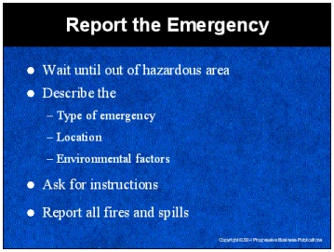

Speaker’s Notes
- After you have evacuated you and your co-workers from the hazardous area, it’s time to report the emergency. Don’t stop to call for help until you’ve safely evacuated. You can be injured or killed if you spend too much time in the hazardous area.
- Start the emergency response procedure by notifying the proper person in the chain of command. Up to this point you have been responsible for the safety of yourself and your co-workers. Once response personnel arrive, they’ll take over responsibility of the incident.
- When reporting a hazardous situation, you should describe:
- The type of emergency condition. Is it a fire, explosion, vapor release,
chemical spill?
- The location of the hazardous condition.
- Environmental factors that may influence evacuation or response procedures, such as wind speed or direction.
- Ask for instruction as to what you should do until help arrives.
- Regardless of size, all fires and spills must also be immediately reported to the
safety manager.

Suggestions for the Speaker
Make sure all of the trainees know who they should notify (internal or external) to begin the emergency response procedure.

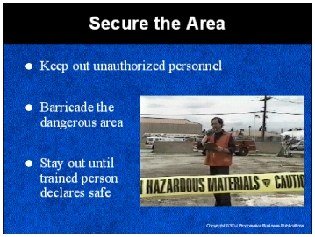

Speaker’s Notes
- The hazardous area must be secured to prevent your co-workers from entering and being exposed to harmful chemicals. Only authorized personnel can enter the hazardous area and it is your responsibility to keep all others out.
- The most effective way to keep out unauthorized people is to set up a barricade. The emergency response plan calls for the use of special equipment, like tape, ropes and cones to secure the area, but you may have to build a barricade out of the materials that are closest to the hazardous scene.
- You and your co-workers may not re-enter the hazardous site until a trained person conducts an evaluation and declares it safe to enter.

Suggestions for the Speaker
Let the trainees know:
- Where the barricading equipment is stored.
- How big an area should be controlled around the incident site?
- Who are the trained people that can enter hazardous areas and declare it safe to re-enter.

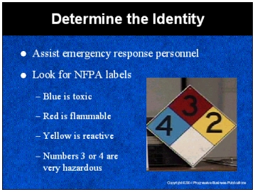

Speaker’s Notes
- Part of being a First Responder at the Awareness Level is identifying and being able to describe a chemical that has been released or spilled.
- The emergency response personnel will need to determine the chemical type once they arrive at the scene. But it will be of great assistance if you can help them understand the hazards of the incident.
- You can determine the risk level of a chemical by examining the National Fire Prevention Association (NFPA) labels. These labels are found on chemical containers, tanks and doorways to chemical storage areas.
- Blue indicates the severity of the health hazard, red indicates flammability and yellow indicates reactivity. If any of the numbers on the colors are 3 or 4, the chemical is hazardous.

Suggestions for the Speaker
Bring in examples of NFPA labels that are used in your facility to identify hazardous substances.

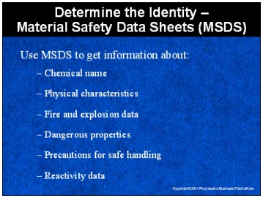

Speaker’s Notes
Material safety data sheets are documents prepared by the chemical’s manufacturer or importer. Our facility has an MSDS for every chemical you work with here. Use these sheets to get more information about:
- The name of the chemical, manufacturer’s or importer’s name, address and telephone number.
- Physical characteristics of the chemical. This includes a description of the chemical’s appearance and odor.
- Fire and explosion data which will tell you the conditions under which the chemical may ignite or explode.
- The dangerous properties of the chemical, including whether the chemical is listed as a carcinogen, which can cause cancer.
- Precautions for safe handling and use of the chemical which include control measures, personal protective equipment and first aid procedures if exposure occurs.
- Reactivity data, which will identify substances that will dangerously react with the chemical.

Suggestions for the Speaker
Now is a good time to hand out sample MSDS for chemicals at your facility.

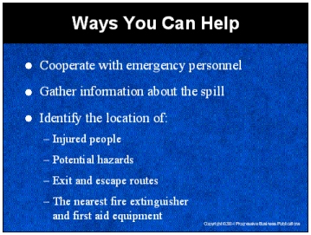

Speaker’s Notes
- You can help by cooperating with emergency personnel when they arrive, and passing on any info you have gathered about the spill. Preparing answers to the following questions will help the emergency response team determine the possible hazards and actions to take:
- Where is the release coming from?
- Are there any identifying marks on the container that is leaking?
- Is there an odor?
- What does the hazardous material look like?

- Other things you can do before help arrives is to identify the location of:
- Injured people in the hazardous area.
- Potential hazards such as electrical cords or wires near the spill.
- Exits and escape routes.
- The nearest fire extinguishers and first aid equipment.

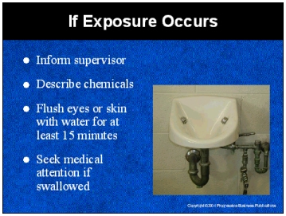

Speaker’s Notes
- If you are exposed to a hazardous chemical, be prepared to react fast. In all cases, report the incident immediately to your supervisor. Describe the chemicals you were working with when the incident occurred. If possible, bring the MSDS.
- If you think you are inhaling fumes or vapors, leave the source of the fumes or vapors and move to an uncontaminated area.
- If hazardous materials get into your eyes, flush them with running water for at
least 15 minutes.
- If you have a spill on your skin, immediately run cold water on the spill for 15 minutes. If you notice a rash or other types of discoloration, report this to your supervisor and seek immediate medical attention. If chemicals are spilled on you in large amounts, quickly remove all contaminated clothing and use a safety shower or other available source of water to rinse yourself thoroughly.
- If you believe you’ve swallowed or drunk a hazardous chemical, notify your supervisor and seek immediate medical attention.

Suggestions for the Speaker
Review your facility’s specific emergency response procedures related to chemical exposure and point out the location of any first aid kits, eyewash
stations and showers.

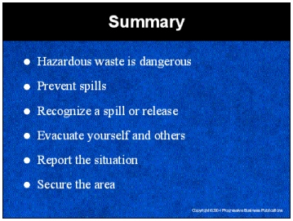

Speaker’s Notes
- Hazardous waste spills or releases can injure workers, contaminate drinking water, cause a massive evacuation of company premises as well as surrounding areas or even kill innocent bystanders.
- Many spills can be avoided by following the rules. If we can prevent spills and releases from occurring in the first place, we will not have to put people in danger responding to them.
- Recognizing a chemical release or spill could mean the difference between life and death. You should always be on the look out for something that is out of place or doesn’t look right.
- If you suspect a hazardous chemical release, warn your co-workers in the immediate area and get out of there. Alert your co-workers by yelling or setting off an alarm.
- After you have evacuated yourself and your co-workers from the hazardous area, it’s time to report the emergency. Don’t stop to call for help until you’ve safely evacuated. You can be injured or killed if you spend too much time in the hazardous area.
- The hazardous area must be secured to protect your co-workers from entering and being exposed to harmful chemicals. Only authorized personnel can enter the hazardous area and it is your responsibility to keep others out.

