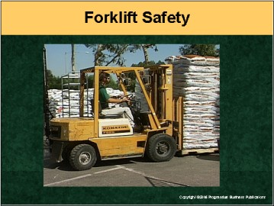

Speaker’s Notes
- Today’s topic is Forklift Safety. This training is a part of OSHA’s PIT (Powered Industrial Truck) Standard (29 CFR 1910.178). The reason we’re here today is because there are many dangers associated with operating a forklift.
- You will learn about:
- Inspecting the controls and instruments of your vehicle.
- Maneuvering your forklift in different environments.
- Handling loads while maintaining stability.
- What to do if your forklift tips over.

Suggestions for the Speaker
An effective icebreaker is to ask the trainees the following questions:
- How long have you been working with forklifts?
- How can forklift safety training make you better at your job?

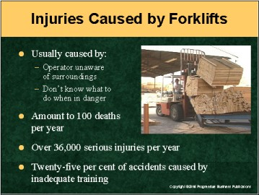

Speaker’s Notes
- There are two main reasons why the number of forklift injuries and fatalities is
so high:
- Operators become unaware of their surroundings, and
- When faced with a dangerous situation, many operators haven’t been trained on how to react properly.
- There are hundreds of stories detailing how workers have been crushed, impaled, struck, or even have fallen to their death from atop a forklift. But with the proper training, you can avoid a similar fate.
- Here’s why properly operating a forklift is important:
- Forklift accidents cause, on average, 100 deaths and 36,340 serious injuries
a year.
- One out of four forklift accidents is the result of inadequate training.

Suggestions for the Speaker
You can ask people to share close calls they’ve had with forklift accidents:
- What are some of the reasons people have forklift accidents?
- How can these types of accidents be avoided?

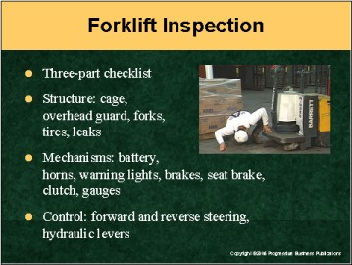

Speaker’s Notes
- Do you thoroughly check your forklift before operating it? Many potential accidents can be avoided by simply checking specific controls and instruments. You’ll want to check the forklift’s structure, mechanisms, and controls.
- Here’s a list of things you should check on a regular basis before using the forklift:
- Check the overall structure. Are the cage and overheard guard strong? Are
the forks in working condition? Check the tires and make sure there are no fluid leaks.
- Is the battery charged and properly connected?
- Do the horn and backup warning lights function properly?
- Check the foot brakes. Remember: The travel of the brake shouldn’t be more than a ½ inch. Also, check the seat brake. If the operator isn’t seated, the seat brake should stop forward or backward movement.
- If the forklift has a clutch, check that it disengages the transmission.
- Ensure the forklift steers properly in forward and reverse with the
engine running.
- Test the hydraulic controls before lifting a load. Verify that the load you’ll be handling is under the maximum capacity for the forklift you’re using.
- It’s your responsibility to make sure that the forklift is in proper working condition before operating it. If you’re short on time, don’t bypass the checklist. Your safety comes first.

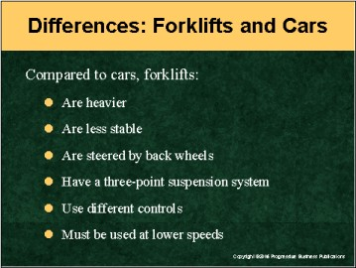

Speaker’s Notes
- Operating a forklift is not the same as driving a car. Forklifts are more complicated due to the nature of hauling heavy loads. That affects the way you start, steer, and stop your forklift, as well as your vision while operating it.
- Forklifts are heavier than most cars. Lifting and carrying loads drastically changes the forklift’s center of gravity, which causes it to be less stable than cars.
- Your forklift is steered solely by the back wheels, and has a three-point suspension system – that means the forklift is supported at three points. This three-point system creates the stability triangle, and we’ll talk about that in detail a little later.
- With cars, there are foot controls for accelerating and braking (and if it’s a manual transmission, a clutch). But forklifts include the above as well as controls for starting, stopping, turning, lifting, lowering and tilting. Because of the variety of operations, you should always proceed slowly, keeping in mind your environment and load capacity. Travel at a speed that will permit you to stop the forklift safely.

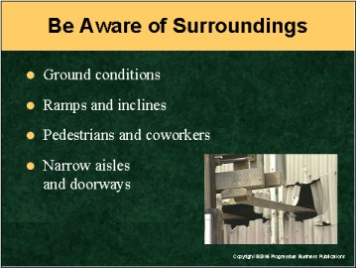

Speaker’s Notes
- Factors in your surroundings can drastically change how you operate your forklift.
- Inspect your travel route before operating the forklift. Know if there are any potholes or other obstructions. Ground conditions such as gravel, dirt, mud,
concrete and asphalt can affect operation. Remember: each condition changes if
it’s wet or dry.
- When traveling with a load, drive up and reverse down inclines and ramps. Without a load, it’s best to reverse up and drive forward down a ramp or incline.
- Always look out for coworkers and pedestrians along your travel route. Never drive toward anyone who’s standing in front of a fixed object. And don’t allow anyone to “catch a ride.”
- All aisles must be free of clutter, marked for forklift operation, and a minimum of six feet wide. Make sure that there is enough headroom clearance for forklift operation indoors. Look out for doorways, pipes, sprinkler systems, lights, etc.

Suggestion for the Speaker
- Now might be a good time to go over specific ground conditions at your operator’s work sites.
- You might want to tell workers this story: A forklift operator was traveling down an incline. He then attempted to make a left turn, but didn’t inspect his travel route and struck a pothole in the road. The forklift tipped over and as the operator wrongly attempted to jump from the truck, he was killed.

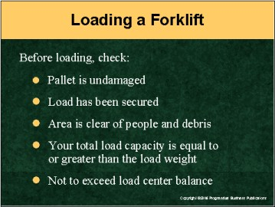

Speaker’s Notes
- Many injuries and mishaps can be avoided by first checking the load before
moving it.
- Here are some things you should pay careful attention to:
- Inspect the pallet. Make sure it’s not damaged. A broken pallet can make moving and stacking loads very unsafe.
- Small items on pallets should be shrink-wrapped in place before moving.
- Make sure the load doesn’t have loose objects or any item that can easily fall from the pallet.
- Take note of the pallet height. Try keeping it at a minimum so you can see clearly. If you can’t change the height of the load, plan to travel your route
in reverse.
- Clear the load and travel area of all debris and be aware of where other people may cross your path. If possible, mark off your travel area.
- Never exceed your total load capacity, in terms of load weight. And make sure you don’t exceed your load center. Doing so will alter the load balance. All loads should be equally balanced on the forks. (Keep in mind that adding fork extenders makes the forklift less stable.)

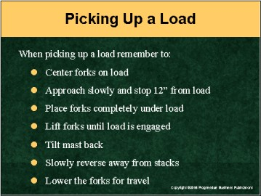

Speaker’s Notes
- The most common type of accident involving forklifts is tip overs. But these accidents can be avoided if you pay close attention to how you pick up the load.
- Always center the forks with the load. Approach it slowly and stop once you’re approximately one foot from what you’ll be picking up. Before lifting a load, apply the hand brake. This prevents the forklift from moving while handling a load.
- Once you place the forks completely under the load, lift until the load is being held by the forklift. Then tilt the mast back so the weight leans in toward the forklift.
- As soon as the load has been securely lifted, slowly reverse away from the stacks. At this point you should lower the forks in preparation for travel.
- No matter how short on time you are, loads should be lifted, moved, and lowered slowly. The faster you go, the more chance you have of disturbing the balance. If the load becomes imbalanced, you are guaranteeing an accident will occur.
- If at any point you notice the rear of the forklift raise up or feel unbalanced, end the
lift immediately.

Suggestion for the Speaker
- This might be a good time to stress how important it is to examine your load before picking it up.
- You might want to tell workers this story: An operator was lifting a load that he had handled numerous times in the past. But this time, the size of the load was different. It was changed to be narrower to allow for greater stacking ability. Since the load balance was different, the operator lost control of the load and it toppled onto a coworker, crushing him.

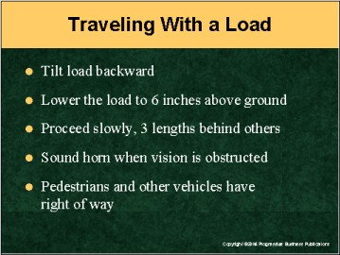

Speaker’s Notes
- The most dangerous part of any forklift operation is traveling with the load. Not concentrating on the path ahead of you can have deadly consequences.
- Once the load is level, tilt it back toward the forklift. Tilting the load forward will make the load less stable and cause damage to the forks.
- Never travel with the load up high. You’re bound to tip over. Instead, the load should be low enough to avoid overhead obstacles and to prevent instability. But it should be high enough to avoid anything jutting up from the ground or the forks contacting the surface, which will create hazardous sparks. It’s best to keep the load lifted six inches above the ground.
- A load should never be lowered or raised during travel.
- Always drive slowly, and maintain a distance of three forklift lengths behind any other vehicle or moving object. Never travel faster than the pace of a normal walk. That means not going faster than 5 mph.
- If your vision is obstructed, either at an intersection, corner, or by a large object, sound your horn to warn others of your presence. And since you’re moving slowly, pedestrians and other vehicles have the right of way.

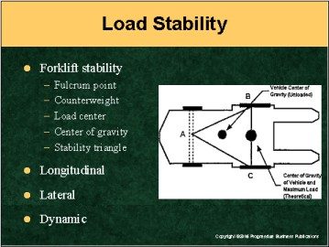

Speaker’s Notes
- To best understand forklift stability, imagine a seesaw (or teeter totter). The seesaw is balanced at a central point – which is called the fulcrum. If there’s too much weight on either end, the seesaw will tip toward the heavier side.
- The fulcrum point on a forklift lies at the front two wheels (front axle). This serves as the base of the stability triangle, and its point reaches toward the rear axle. To the left of the fulcrum is the counterweight – this is the weight of the forklift.
To the right of the fulcrum is the load center – this is the weight of the load. This load center should never be heavier then the counterweight, or else the forklift will tip over.
- The center of gravity refers to the central point at which the forklift is balanced in all directions. Picking up a load creates a new combined center of gravity.
- To avoid tipping over, the combined center of gravity of both the forklift and load should remain near the center of the stability triangle.
- Stability falls under three categories:
- Longitudinal: The truck’s resistance to tipping forward or backward.
- Lateral: The truck’s resistance to tipping sideways.
- Dynamic: The change in stability when the truck is put into motion.
- Remember never to exceed the load capacity, and to travel with the load
low to the ground.

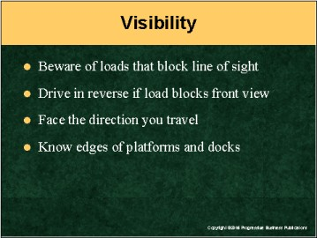

Speaker’s Notes
- Here’s one rule to remember: If you can’t see clearly, you can’t travel safely. You’re putting both yourself and your coworkers at risk of serious injury.
- Avoiding such accidents is possible by following these visibility guidelines:
- Be extra careful with loads that block any part of your line of sight. If possible, avoid these loads, or break it down into smaller units.
- When a load obstructs your front view, travel in reverse.
- Always face the direction you’re traveling. If you’re traveling in reverse, turn your head and shoulders so you can clearly see behind you.
- Know the limits and edges of your work area. If you’re working on a dock or raised platform, make sure you’re well aware of where the raised surface ends, and stay as close to the central area as possible.

Suggestions for the Speaker
To stress the importance of keeping a clear line of sight, you can tell your workers this story:
An operator was driving a forklift forward even though the load was bulky and obstructing his view. He didn’t feel comfortable traveling in reverse and thought that no one else was around. But as he proceeded forward, the operator didn’t see a fellow coworker walking in front of him. He struck her and impaled her with
the forks.

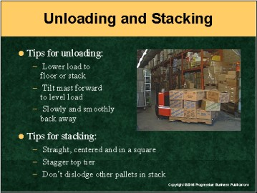

Speaker’s Notes
- When unloading, carefully lower the load to the ground or stacked area. Then set the brake so the forklift won’t move. Tilt the mast forward to the vertical so the load will be level. Slowly set the load down and smoothly back away.
- When stacking, make sure the load is placed straight down, with the weight evenly distributed. The load should be centered and set in a square.
- Always stagger the top tier. This serves to “tie” the pallets into place. Never stack loads so high that the pile becomes unstable.
- Be careful not to hit, move, or dislodge other pallets while stacking. This will compromise the integrity of the whole stack by shifting the weight distribution.

Suggestions for the Speaker
Now might be a good time to ask employees about how they stack items.
Ask them:
- How do you stack round items, or other loads that can’t be stacked smoothly?
- Do you apply wedges to make sure these loads are stable?
- If you see another operator stacking loads improperly, what’s the best way to approach that worker?

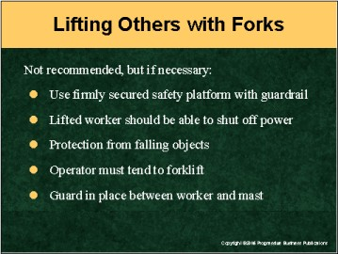

Speaker’s Notes
- It’s not the safest option to raise workers atop the forks on your truck. But in some cases it’s unavoidable. Even though you feel you’ve done it a hundred times without a problem, all it takes is one second for all that to change.
- If you must raise a coworker on the forks, make sure:
- There’s a safety platform firmly secured to the lift. The platform should have guardrails to keep the worker from falling.
- The lifted worker is able to shut off the power to the forklift in case of
an emergency.
- There’s protection for the worker from falling objects.
- That an operator is inside the forklift at all times.
- There’s a guard between the worker and the mast.

Suggestion for the Speaker
To illustrate the importance of safely lifting other workers, you might want to tell
this true story:
A worker was lifted on the forks of his friend’s forklift. The worker had done the job a hundred times and never once had to harness himself to the forklift, so this time he felt it was unnecessary to secure himself. After he was raised to the full extension, the worker lost his balance, fell into a vat of scalding water and died.

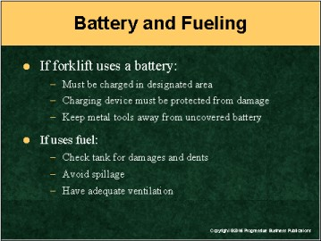

Speaker’s Notes
- No matter if your forklift is powered by a battery or liquefied petroleum gas (LPG), when recharging or refueling you should always:
- Set the brakes on the forklift.
- Turn off the engine.
- Avoid smoking, open flames, or anything that may cause a spark.
- Wear protective equipment.
- Always charge batteries in the designated area. The charging device must
be protected from damage, and metal tools should be kept away from
uncovered batteries.
- Before refueling, check the tank for damages and dents. If there’s damage, don’t start the forklift. Close the valve and keep it out of service until it’s repaired.
- When fueling, avoid spillage. If you do spill gas, immediately wash it away or evaporate it. You should also replace the fuel tank cap before restarting the engine.
- Make sure that the area where you’re refueling has adequate ventilation. You want to avoid the buildup of the noxious gas.

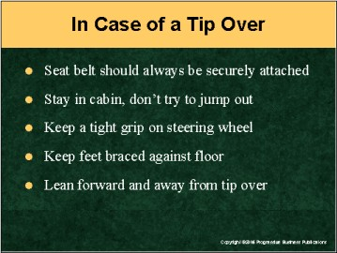

Speaker’s Notes
If you follow all of the precautions, you should never have to worry about tipping
over. But just in case you find yourself in a situation where your forklift is about to
tip over, remember:
- Your seatbelt should always be fastened securely.
- Never attempt to jump from the forklift. The majority of injuries and deaths resulting from tip overs are caused when the operator tries to jump clear of the forklift. Workers are never able to jump far enough, and they get crushed under the truck. The cabin is built to protect you, so stay inside of it.
- Keep your hands firmly on the steering wheel and keep your feet braced against the floor.
- Lean your body forward and away from the direction of the tip over.

Suggestion for the Speaker
Now might be a good time to bring up the topic of close calls again. See if trainees are surprised by the idea that the best way to avoid injury in a tip over is to stay inside the forklift. Ask them: How can you avoid tipping over?
To make sure they know what to do in case of a tip over, move to the next slide
and ask them what steps they should keep in mind if their forklift tips over.

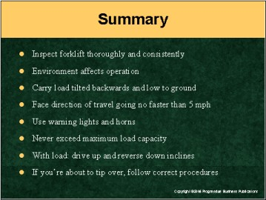

Speaker’s Notes
- Operating a forklift can easily become second nature. But just one misstep can lead to an accident that can cause serious injuries or even death.
- There are tips you can remember to ensure the safety of you and your coworkers. Some of these tips are:
- Inspect your forklift thoroughly and consistently.
- Your environment affects how you operate your forklift.
- Carry all loads low to the ground and tilted backward.
- Always face the direction you’re traveling.
- Never go faster than 5 mph.
- Use warning lights and horns around other workers, pedestrians
and forklifts.
- Never exceed maximum load capacity.
- When carrying a load, drive up and reverse down inclines. Without a load, reverse up and drive forward down inclines.
- If your forklift is about to tip over, follow the procedures we discussed.

Suggestion for the Speaker
Thank your workers for attending this training session and ask them if they have any questions.

