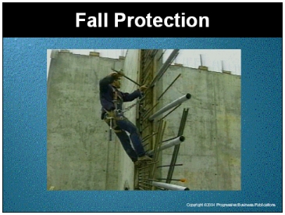

Speaker’s Notes
- Welcome. Today’s topic is Fall Protection in the workplace.

- You will learn about:
- Serious injuries that can occur as the result of a simple trip or fall.
- How to work safely at ground level and above the ground.
- The equipment you need to stay safe when working above the ground.
- Is there anybody here who enjoys getting hurt OR having to rehab an injury?

Suggestions for the Speaker
- This training is required by OSHA’s Fall Protection Standard
(29 CFR 1926.500-503).
- Share a story of an injury or death that occurred in your workplace or use this true case report below:
- An employee of a tire company was working at an elevated height near two pieces of a metal floor that had been temporarily removed. The worker was not wearing equipment to protect him in the event of a fall. The employee fell several floors through the opening in the floor -- and was killed instantly.

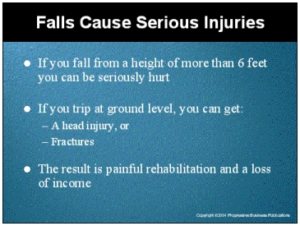

Speaker’s Notes
- As the story suggests, nobody plans to be seriously hurt or have a fatal injury from a slip or a fall, but it happens all too often.
- Falls can occur on the same level, on stairs and from elevation. They all hurt, some of them cause death!
- If you are working in an area six feet or more above the ground, you must use protective equipment to stay safe from fall hazards.
- Believe it or not, falling from only six feet can kill you! Falls can also result in head injuries and fractures.
- And it’s not just falls from height you need to worry about. Your life can be changed from something as simple as falling on a wet floor and breaking a bone or spraining, straining or pulling something. Some slips or falls can result in long term, not to mention painful, rehabilitation. Nobody likes to lose their source of income, but slips and falls cause that too, if you have to stay out of work for long periods to recover.

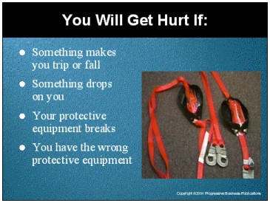

Speaker’s Notes
- What might cause you to trip or fall? (collect answers such as:
- People leaving tools out.
- Slippery floors.
- Items strewn in the path where you walk, such as a skid you need to walk
around or over).
- If something drops on you from above, like one of these hammers, you may not walk away from the accident!
- (Show the damaged harness) When your protective equipment is damaged like this one, it’s not going to stop your fall is it? More likely that the floor or the object that you land on is going to stop your fall…and you may not survive! The equipment is designed to keep you safe only if it is working.
- Each job requires equipment designed for that job. If your equipment doesn’t fit or isn’t strong enough for the job you are on, it’s like not having any equipment at all.
- For example, to play baseball effectively, the batter needs the correct size bat. In order to stay safe, you need the correct size protective equipment [Hold up the protective equipment] and correct type for the job you are doing!

Suggestions for the Speaker
- Have some examples around you such as: a harness that is obviously damaged, tools (hammer, screwdrivers, wrenches) placed around you in a manner that causes you to trip and fall, a broken board, with the sharp edge on its upper side, protective equipment that is an obvious improper fit.
- Have some tools in the path between you and participants.

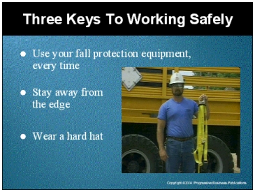

Speaker’s Notes
- There are three keys to working safely at heights. The first is using fall protection equipment every time. We have many excuses for not using protective equipment such as: I’ll only be up there for a minute. I left my protective equipment behind.
- You need to wear your fall protection equipment every time you are working at least 6 feet above the ground.
- The second key to working safely up high is to know your work area. If you don’t know your work area: you can fall over the edge, you can bump into a co-worker and he/she can fall over the edge, or you can trip and fall onto a tool that can impale you. Any of these things can break, sprain or otherwise damage limbs or even kill you. Learning your work area can keep you safe…in fact it might save you or one of your friends.
- The third key is wearing your hard hat. If this hammer falls above you, it could hit you on the head and cause a concussion or even kill you. Wearing a hard hat will give you a better chance of avoiding head injuries.
- Finally, we tell our children all the time: Walk, don't run! Why? It keeps them safe. It’s the same for us. Walking gives more time to react if you lose your balance and saves injuries.

Suggestions for the Speaker
- Have some warning tape out as an example of the signs that an area is restricted.
- Have the tools back on the floor, hold up the hammer.
- Suggest to the group that you should always walk around your work area before beginning work for the day. Identify any potential safety hazards and report them to your supervisor

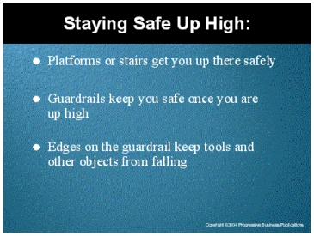

Speaker’s Notes
- Look for the method you need to use to get up to your work area. There may be stairs to climb. There may be a platform to walk up. There may be a ladder or lift device needed to get there. If you don’t know the method to get to your work area, you don’t know how to stay safe on the way up. A fall on the way up hurts just as much when you land … the bones will break the same as from a fall from your work area.
- If you need to climb stairs, are there stair rails? If not, do you need your fall protective equipment on? If you need to use a platform, what obstacles do you have to navigate and how far could you fall if you don’t know where they are? Be sure to check with your supervisor if you are in an unfamiliar area.
- Once you get to your work area, look for guardrails or safety tape to show you the boundaries of safety for you.
- Is there a toe plate on the guardrail? The toeplate will keep tools like your hammer from falling. Remember - tell your supervisor if something doesn’t look right.

Suggestions for the Speaker
- Collect some pictures of areas around the workplace where there are stairs, platforms, guardrails or stair rails.
- If they are large enough, post them for the meeting participants to see. If that is not possible, hand the pictures out to the meeting participants.

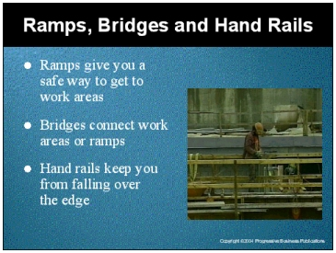

Speaker’s Notes
- Let’s look at some other things in the workplace that can keep you safe from fall hazards.
- A ramp is used between areas of different heights, to safely get you from one place to another. Of course, trying to jump from one level to another can cause painful injuries.
- A bridge fills a gap between areas. It may be stationary, powered, unpowered, adjustable or even just a board. Again, use bridges to move between areas, instead of jumping from one place to another.
- Hold onto the hand rails if they are there. They will also keep you from falling. When there are no handrails, you need protective equipment and must be even more careful when moving around.

Suggestions for the Speaker
Ask for examples of ramps, bridges and hand rails from your workplace. Let meeting participants point out how they keep them safe from injury.

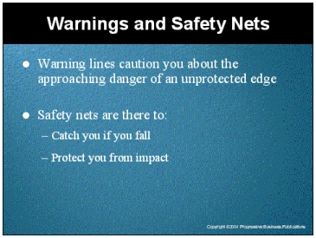

Speaker’s Notes
- [Show the warning tape/line to the meeting participants.] The warning line cautions you not to go into certain areas without fall protective equipment. Otherwise, you risk falling over the open edge.
- Safety nets are the last resort to keep you safe. They catch you if you fall, protecting you from impact with the surface below.

Suggestions for the Speaker
- Ask participants for examples of your workplace.
- Emphasize that safety nets are there to save them and must work and that warning lines are cautions to keep them safe.

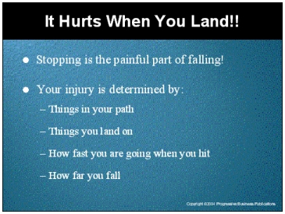

Speaker’s Notes
- Stopping is the painful part of falling! It is the impact that kills!
- What can hurt you when you land? (Ask why for each answer offered) (if they miss anything listed in the slide, mention it...things in your path, things you land on, how fast you are going, how far you fall)
- If there are things you can land on, ask your supervisor if they can be moved. Either way, work with your supervisor to make sure your fall arrest system won’t allow you to impact the ground.
- Work with your supervisor to be sure your equipment is certified for a person your weight and for the height you’ll be working at. Remember it doesn’t hurt to fall, it hurts to land!
- The remainder of this program will show you what a fall arrest system is. You will also learn how and when to use it.

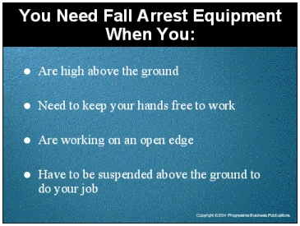

Speaker’s Notes
- The best way to limit the forces that can hurt you in a fall is to use a device that slows or stops the speed at which you fall. By slowing your speed and momentum you will be less likely to get injured. (hold up a harness and lifeline)
- That’s why you need a safety harness and a lifeline if you are working high above the ground. By law you must use one if you are 6 feet or more above the ground.
- You need a harness and a lifeline when you are exposed to fall hazards.
- If you need to keep your hands free.
- If you are working near an open edge. In this case, there is nothing to hold on to in the event of a slip. Your equipment is the only thing that saves you if you fall.
- If you need to be suspended above the ground to complete your job. All that stands between you and serious injury is your fall arrest equipment; you need it on every time … your life depends on it.

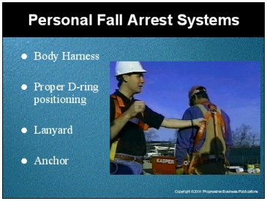

Speaker’s Notes
- What are some situations that you’d need a personal fall arrest system? (Hold up a harness) If you are working on an open edge above six feet.
- A fall arrest system is a harness that is attached to a lanyard, which is attached to an anchor. Work with your supervisor to pick an appropriate anchor. The anchor is a rigid object connected to the ceiling and/or floor. The anchor has to hold you in all situations or you fall!
- (Hold up a line, connect it to the harness. Show how the D-rings are positioned for safety.) A lifeline uses a flexible line connection to attach the harness to an anchor. The lifeline connects to the harness using a metal ring.
- A self-retracting fall arrest system is used in more dangerous situations. At the start of a fall, this type of device will automatically lock.
- You want to reduce the forces that can injure you in a fall. Consider how far you can potentially fall and how much you weigh when determining the type of protection you need to stay safe!
- Work with your supervisor to choose the appropriate lifeline.

Suggestions for the Speaker
- Have an entire personal fall arrest system with you to demonstrate. This includes a harness, lanyard, different types of D-rings and a couple of anchors.
- Give examples from your facility.

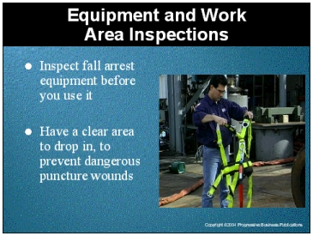

Speaker’s Notes
- Of course, your personal fall arrest system is of no use to you if it fails or your potential landing area is unsafe.
- Here are some things to consider: Your rescue line should not cause you to swing back and forth. You could get a puncture wound if there’s an object in your path. If your line sways, seek help from your supervisor in re-anchoring your line.
- Your system should be certified to work with weight similar or greater than yours. If you have any question about the condition of your system, including the anchor points, check with your supervisor.
- Always ask your supervisor for help if you think you are anchored in an unsafe manner. After all, it’s your life on the line!

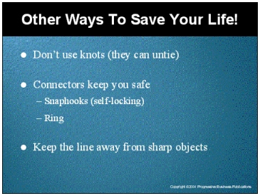

Speaker’s Notes
- [Show how a rope tied in a knot will come apart under the pressure of a fall.] This isn’t going to keep you very safe if it unties on the way down. Your line should always be connected using a self-locking connector. The self-locking connector will attach to a ring on your harness.
- [Show the connectors.] The rings are self-locking to keep them from slipping during a fall. The self-locking rings connect to a solid ring to reduce the amount of movement or shock to you during a fall.
- You don't want the rope to untie or be cut. You still end up falling just as far. If the rope unties or is cut, you might as well not even have a personal fall arrest system. The fall will kill you just the same as without one. If you observe a rope tied in a knot or one that looks as if it may be cut, tell your supervisor.

Suggestions for the Speaker
- Have a rope to use for demonstration.
- Have some different types of connectors.

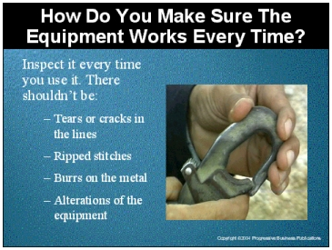

Speaker’s Notes
- How often do you want your fall arrest equipment to work? Collect answers such as: all the time, enough to make sure I am safe, etc.
- How do you make sure that happens? By checking for tears, cracks or ripped stitches in your line. You also want to make sure there are no burrs in the metal of the rings that can cut your line.
- Check for alterations that can make the line unsafe. You want to make sure that all parts move freely.
- When working at heights, there is no room for error, is there? Your equipment has to work when you need it. Since you don’t know when that will be you need to make sure it’s in good working order all the time.
- It is your life, stay safe!

Suggestions for the Speaker
- Bring equipment in good condition and also some broken equipment.
- Ask workers to point out problems with the equipment.

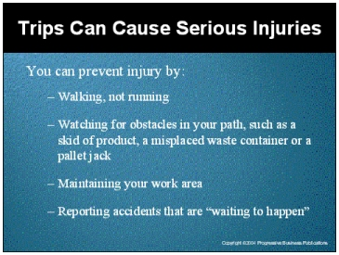

Speaker’s Notes
- How can you prevent an injury from a slip? Collect answers such as: watching for obstacles, putting things away when finished, walking, reporting hazards.
- Slips can occur when you encounter unexpected obstacles. An obstacle can be a misplaced waste container, a pallet left in the wrong place or an unattended pallet jack. You can help avoid slips by watching for these types of obstacles. You can also help by arranging for their removal if you encounter them.
- Of course, you want to avoid leaving things out while working in areas others pass through.
- Serious injuries can come from simple falls. They take a long time to recover from and affect your lifestyle! Rehabbing injuries is painful and time consuming. Worker’s Compensation isn’t a full salary.
- If you observe an “accident waiting to happen” tell the nearest supervisor.

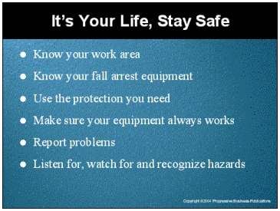

Speaker’s Notes
- Know your work area: where are the bridges, ramps, stairs, rails or obstacles in your area?
- Remember how to use your fall arrest equipment properly. This equipment will keep you safe from serious injury only when you know how to use it the right way.
- Use safety devices. The equipment only helps keep you safe if you use it.
- Make sure that your equipment works. A harness with ripped stitches, a line with tears or cracks, a ring with burrs that can cut your line are all items that lead to equipment failure. If your equipment fails, you get hurt.
- Use the right equipment for the location/job. Your equipment has to be certified for your weight and the height you work at.
- And look for, watch for and report problems.

