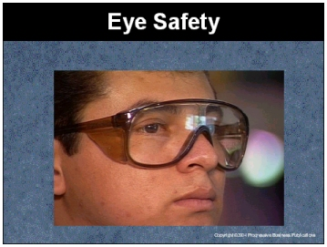

Speaker’s Notes
- Today’s topic is Eye Safety. This training is required by OSHA’s Standards on Personal Protective Equipment (29 CFR 1910.132 and 29 CFR 1910.133).

- You will learn about:
- The risks to your eyes in the workplace.
- Types of protective eyewear to guard your eyes.
- First aid procedures if you damage your eyes.

Suggestions for the Speaker
An effective ice breaker is to ask the trainees the following questions:
- Has anyone ever had an eye injury?
- Could that injury have been prevented with protective equipment?
- Can anyone name a task in this facility that could damage your eyes?

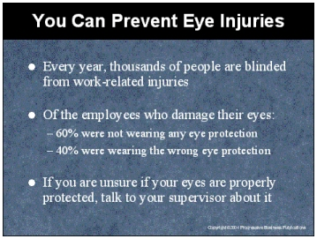

Speaker’s Notes
- Your eyes are very delicate and can easily be damaged from injury. If the injury is severe enough, you may lose your vision or need to have your eyes removed.
- Thousands of people are blinded each year from work-related eye injuries. These are injuries that could have been prevented if people would have used the proper eye protection.
- About 60% of the employees who suffer eye injuries were not wearing any eye protective equipment at all. When asked why they were not wearing protection at the time of the accident, employees typically responded that protection was not normally used in their type of work.
- The rest of the eye injuries occurred while employees were wearing the wrong kind of eye protection for the job. An example of this is someone who was wearing protective eye glasses with no side shields, and a foreign object hit their eye from the side where there was no protection.
- Make sure you protect your eyes from all hazards. If you are unsure if your eyes are properly protected, talk to your supervisor about it.

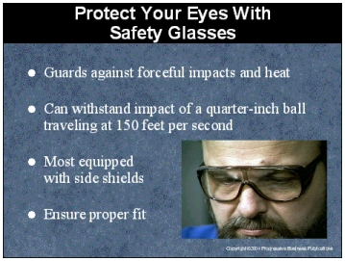

Speaker’s Notes
- Safety glasses are the most widely used type of eye protection. While they may look
similar to regular glasses, they are much stronger and more resistant to impact and heat
than regular glasses.
- Most safety glasses are equipped with side shields that give you protection from hazards
that may not be directly in front of you. Examples of these hazards are small flying particles from grinding, chiseling, sanding or hammering.
- The required strength of safety glasses is for them to withstand the impact of a quarter inch steel ball traveling 150 feet per second. You cannot depend on your prescription glasses for this kind of protection, which is why there are safety glasses with prescription lenses.
- Ensure your safety glasses fit properly. You should have your own pair that is individually assigned and fitted. Do not share them with anyone else. Wear safety glasses so that the glasses fit comfortably over the ears. The frame should be as close to the face as possible and adequately supported by the bridge of the nose.

Suggestions for the Speaker
- Demonstrate how to put on, take off and adjust safety glasses.
- Point out where the safety glasses are stored.

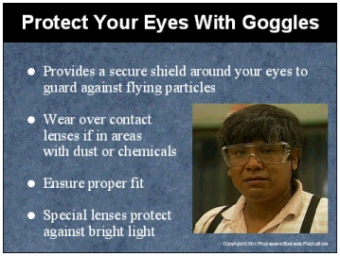

Speaker’s Notes
- Like safety glasses, goggles are impact resistant and protect your eyes against hazards from many directions in the workplace.
- But goggles provide more protection than safety glasses because they fit closer to your face. They provide a secure shield around the entire eye to protect against hazards coming from different directions. Examples of these types of hazards are splashing liquids, fumes, vapors, powders, dusts and mists.
- Goggles should fit snugly over the bridge of your nose and the center of the lens in front
of your eye. Adjust the strap and place it low on the back of your head for a good fit. Make sure your goggles are comfortable and fit correctly. You do not want to be in a dangerous situation and have your eye protection fall off and damage your eyes.
- You should not wear contact lenses in areas with dust or chemicals. It is easy for these hazards to get under the contact lenses and cause damage. Some chemicals can react with contact lenses and cause permanent injury. You will be safer wearing glasses instead of contact lenses under your goggles.
- Absorptive lenses offer additional protection if you must work where there is bright light or glare. This is especially important for welders. There are a wide variety of absorptive lenses available for use in both safety glasses and goggles.

Suggestions for the Speaker
Demonstrate how to put on, take off and adjust safety goggles.

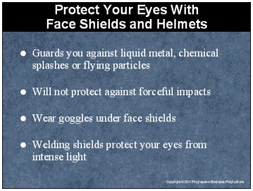

Speaker’s Notes
- Face shields offer you full face protection and are often used around operations which expose you to liquid metal, chemical splashes or flying particles. Face shields are not built as strongly as glasses or goggles, and will not protect you against forceful impacts.
- Face shields by themselves will not properly protect your eyes. To protect against dust, gases and mists, you need tight fitting goggles under face shields to protect your eyes. Without the additional protection, hazardous materials can penetrate the face shields, causing damage to your eyes.
- Welding shields provide both face and eye protection. These shields use special absorptive lenses that filter the intense light that is produced during welding operations. As with face shields, safety glasses or goggles should be worn when using a welding helmet.

Suggestions for the Speaker
Demonstrate how to put on, take off and adjust face shields.

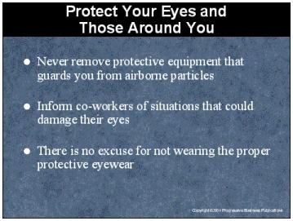

Speaker’s Notes
- Certain equipment, such as grinders, sanders and welding equipment produce dust vapors and flying particles that can damage your eyes. Many of these machines are equipped with guards, shields and screens to protect your eyes. Never remove this protective equipment when operating this type of machinery.
- When working in situations that can damage your eyes, protect your co-workers by informing them of these risks. If possible, place barriers where the work is being
performed so that your co-workers will not accidentally walk into a hazardous situation
and damage their eyes.
- If you are working in a situation that requires protective eyewear, there is no excuse for
not wearing it. Regular glasses or contacts do not provide proper protection from eye hazards and should not be substituted for protective eyewear.

Suggestions for the Speaker
- Show examples of guards, screens, shields that should never be removed from dangerous equipment.
- Ask the trainees if they can name any activities in the workplace that require protective eyewear.

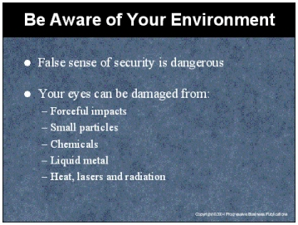

Speaker’s Notes
- Once you are wearing eye protection, it is easy to develop a false sense of security that your eyes will be safe wherever you are working in the facility. Protective eye equipment should only be used for the hazards they are designed to protect against. Management will provide you with eye protection specifically for the tasks that you need to perform.
- There are many different types of eye hazards that you need to be aware of. Following are the most common:
- Forceful impacts
- Small particles
- Chemicals
- Liquid metal
- Heat, lasers and radiation

Suggestions for the Speaker
Given an example of eye protection that is used for one task in your facility that will not protect an employee performing a different task. For example, eye protection used for working with a sander will not protect you if you walk into a room where welding is occurring.

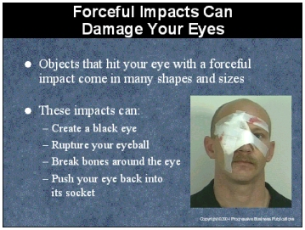

Speaker’s Notes
- Eye injuries from forceful impacts can be caused by swinging chains, cables, tools that are thrown or fall, any sharp object or walking or falling into obstacles.
- A forceful impact can push the eye back into the socket, possibly damaging the structures at the surface and those at the back of the eye. Such an impact may break bones around the eye as well. In severe injuries, the eyeball can rupture.
- In the first 24 hours after an eye injury, blood leaking into the skin around the eye usually produces a bruise, commonly known as a black eye. If a blood vessel on the surface of the eye breaks, the surface will become red.

Suggestions for the Speaker
Discuss the types of tasks in your facility that can cause forceful impacts and damage eyes.

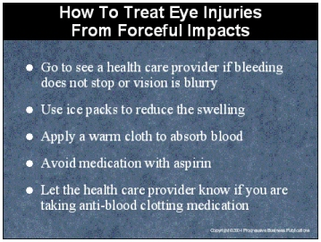

Speaker’s Notes
- If the skin around the eye or on the lid has been cut and does not stop bleeding or if your vision is blurred, you should go and see the nearest health care provider.
- Damage to the inside of the eye is often more serious than damage to the surface. Recurring bleeding and increased pressure within the eye may lead to blood staining of the cornea, which can reduce vision and increase the risk of glaucoma.
- Ice packs will help reduce swelling and ease the pain of a black eye. Applying warm cloths will help the body absorb the excess blood.
- Any medication that contains aspirin should be avoided because aspirin can increase bleeding in the eye. Make sure you tell the health care provider if you are taking any anti-blood clotting medication.

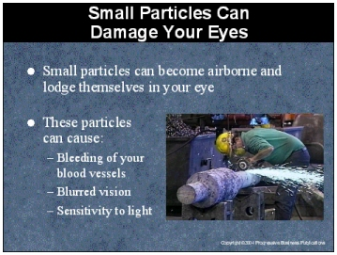

Speaker’s Notes
- The most common eye injuries in the workplace are those caused by small particles becoming airborne and lodging themselves in your eye. Grinding, chiseling, sanding, hammering and spraying are examples of activities that can create the types of airborne particles that will damage your eyes.
- When a small particle causes an injury to the surface of the eye, there may be pain, blurred vision and the feeling that there is something on your eye. The particle may also produce redness, bleeding from the surface blood vessels of the eye, sensitivity to light or swelling
of the eye and eyelid.

Suggestions for the Speaker
Ask the trainees if they can name any activities in your facility that can cause flying particles that could damage their eyes.

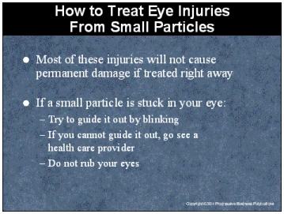

Speaker’s Notes
- Most of the injuries caused by small particles will not cause permanent damage if treated right away. If not treated, the injury could become very serious, such as the development
of an infection from a cut or scratch on the cornea.
- If you get a small particle stuck in your eye, you must remove it.
- Do not rub your eyes. Rubbing your eyes may scratch or embed particles deep into your
eye, causing more serious injuries.
- The first thing to do if you get a particle in your eye is try to guide it out naturally by blinking. If you cannot get it out, close and cover the eye and go see a health care provider who will remove it quickly and painlessly.
- There are special eyedrops that can be applied to make the object more visible and reveal any surface abrasions. Other drops may be applied to numb the surface of the eye. Using a special lighting instrument to view the surface in detail, the health care provider then removes the object. Often the foreign object can be lifted out with a moist sterile cotton swab. Sometimes it can be flushed out with sterile water.

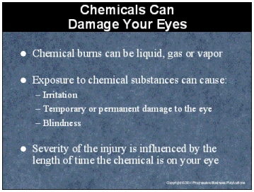

Speaker’s Notes
- Burns can occur when a chemical substance gets into your eye. Even mildly irritating substances can cause substantial pain and damage to your eye.
- Exposure of the eye to chemical substances in any form can result in irritation, temporary
or permanent damage to your eyes or blindness. It is important to note that the chemical does not have to be a liquid; significant damage can be done to your eye from gasses and vapors.
- When exposure to chemicals occurs, the eyelids close quickly in a reflex reaction to protect the eyes from the burn, keeping the dangerous substance against the eye for a prolonged period of time. The severity of the injury and the amount of pain are influenced by the length of time the dangerous substance is left on your eye.

Suggestions for the Speaker
Describe some of the chemicals in your facility that can cause chemical burns on your eyes.

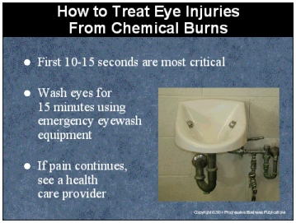

Speaker’s Notes
- The first 10 to 15 seconds after exposure to a hazardous substance are critical. Delaying treatment for even a few seconds can cause serious injury.
- The initial first aid treatment should be to wash the eyes for 15 minutes using emergency eyewash equipment. Even though you may have difficulty keeping the injured eye open during this painful treatment, quick removal of the chemical is essential.
- Water does not neutralize contaminants - it only dilutes and washes them away. This is why large amounts of water are needed. If pain still exists after rinsing your eye, go to see a health care provider immediately.
- To treat burns on the eyelids, a health care practitioner washes the area with a sterile solution and then applies an antibiotic ointment or a strip of gauze saturated with petroleum jelly. The treated area is covered with sterile dressings held in place with a plastic bandage to allow the burn to heal.

Suggestions for the Speaker
Let everyone know the location of the emergency eye wash equipment and how to properly use it.

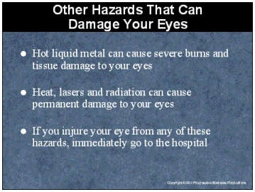

Speaker’s Notes
- Activities which involve hot liquid metal are extremely dangerous. If the metal is splashed, splattered or dripped into your eye, severe burns and tissue damage will occur.
- Activities such as welding, metal cutting and working around furnaces and lasers can expose your eyes to heat, ultraviolet and infrared radiation. These hazards can burn your eyes causing permanent damage.
- If you experience an eye injury from any of these hazards, immediately go to the hospital. These are serious injuries that need specialized treatment.

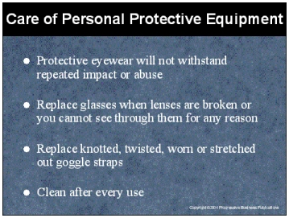

Speaker’s Notes
- Protective eyewear is designed to guard against accidental injury. They will not withstand repeated impact of abuse. Inspect them regularly for scratches, cracks or other wear and replace them if they are scratched, bent or uncomfortable. Scratches not only interfere with your ability to see what you are doing, they can weaken the structure of the lenses and its resistance to impact.
- Clean lenses after every use with soap or mild detergent and water or special solution designed for that purpose. Never use abrasive soaps, rough paper or cloth towels. These items will scratch and damage your equipment. Avoid rough handling that can scratch lenses. Scratches impair vision and can weaken lenses.
- Store your eye protection equipment in a clean, dry place where it cannot fall or be stepped on. Keep it in the case when they are not worn.
- Disinfect eyewear if it’s contaminated by a hazardous chemical, or if it may be worn by another person.
- Replace glasses when lenses are scratched, broken, bent or you cannot see through them for any reason. Replace knotted, twisted worn or stretched out goggle straps. Damaged glasses interfere with vision and do not provide protection.

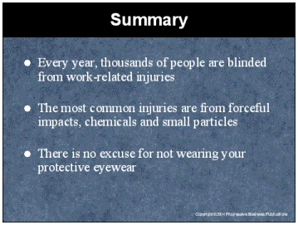

Speaker’s Notes
- Thousands of people are blinded each year from work related eye injuries. These are injuries that could have been prevented if the proper eye protection was worn.
- Eye injuries from forceful impacts can be caused by swinging chains, cables, tools that are thrown or fall, any sharp object or walking or falling into obstacles.
- The most common eye injuries in the workplace are those caused by small particles becoming airborne and lodging themselves in your eye. Grinding, chiseling, sanding hammering and spraying are examples of activities that can create the types of airborne particles that will damage your eyes.
- Burns can occur when a chemical substance gets into your eye. Even mildly irritating substances can cause substantial pain and damage to your eye.
- Safety glasses are the most widely used type of eye protection. While they may look
similar to regular glasses, they are much stronger and more resistant to impact and heat
than regular glasses.
- Goggles provide more protection than safety glasses because they fit closer to your face. They provide a secure shield around the entire eye to protect against hazards coming from different directions. Examples of these types of hazards are splashing liquids, fumes, vapors, powders, dusts and mists.
- Face shields offer you full face protection and are often used around operations which expose you to molten metal, chemical splashes or flying particles.

