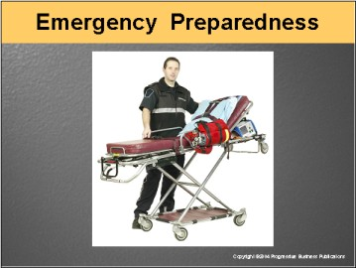

Speaker’s Notes
- Today’s topic is Emergency Preparedness. This training incorporates OSHA’s Emergency Action Plan and Fire Prevention Plan standard
(29 CFR 1910.38); OSHA’s Hazard Communications standard (29 CFR 1910.1200); and OSHA’s Fire Extinguishers Types and Uses standard
(29 CFR 1910.157).
- You will learn about:
- Key things to remember in an emergency situation.
- Why drills are critical.
- Hazards to look for and report.
- Basics of fire extinguisher use.
- Recognizing a leak or spill in the building.

Suggestions for the Speaker
To get the ball rolling, you can ask trainees:
- Have you ever been involved in a workplace emergency?
- Did you and those you worked with know how to respond?

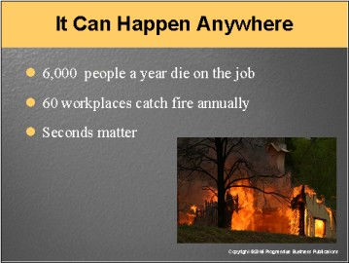

Speaker’s Notes
- When people hear the words “workplace emergency,” their first thought’s usually “That’ll never happen here.”
- The statistics tell a different story:
- Nearly 6,000 people per year die on the job.
- About 200 people a year die in workplace fires, and more than
2,000 suffer from burns and smoke inhalation.
- There are more than 60 workplace fires a day, and dozens of daily chemical spills and gas leaks.
- If we don’t practice emergency preparedness, we’re more likely to make mistakes. When the real emergency occurs, practice could mean the difference between life and death.
- The bottom line: Seconds matter.

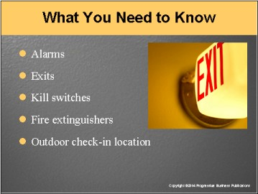

Speaker’s Notes
- The difference between staying safe and being injured in emergency situations depends largely on your actions.
- You can be hurt if you don’t know:
- What the alarm in your area sounds and looks like. If you aren’t aware of an alarm, you may not have time to get to safety.
- Where all the exits are. You might not have time to search for another exit if debris or heavy objects block one. Learn where exits are ahead of time. Think about the route you’d take to reach it.
- Where the kill switch is on your equipment. If the equipment is shut down, there is less chance for it to explode and hurt someone.
- When to use a fire extinguisher. If you don’t know how to use a fire extinguisher properly, you can put yourself in greater danger. If you aren’t trained, find someone who is.
- Meet at the designated check-in area once you’re outside. Someone may go back into the building to search for you if you don’t check in. Don’t re-enter the building until the “all clear” has been given.

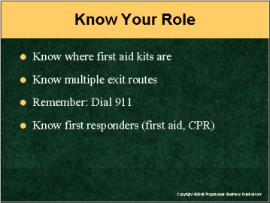

Speaker’s Notes
- Being ready to help means being prepared to respond properly in an emergency. Know your role.
- Know the location of your nearest first aid kits.
- Know more than one exit out of the building.
- Remember: Dial 911 to report an emergency.
- Some of your coworkers have first aid training or are designated “first responders.” Know the name and location of the first responder closest to your work area.
- Some of your coworkers may know CPR. Be aware of who they are and where they’re located too.

Suggestions for the Speaker
Using a floor map of your facility, you can highlight:
- Where all exits are located
- Where all fire alarms and fire extinguishers are located, and
- Where the emergency assembly areas are located.

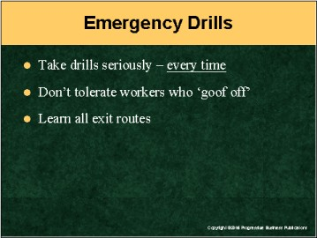

Speaker’s Notes
- They say, “Practice makes perfect.” That’s true with emergencies and practice drills. Treat every drill like it’s the real thing. Look at that 10-to-15-minute drill as the potential lifesaver that it is.
- Don’t tolerate others who don’t take emergency drills seriously. If you notice employees taking their time during an emergency drill or preventing others from exiting the building, speak up about it. Their horsing around could affect you and your coworkers if the real thing occurs.
- Once again, keep in mind where all the emergency routes and exits are in the building. You can greatly increase your chances of escaping an emergency by learning several routes to safety and where all exits are.

Suggestions for the Speaker
Now might be a good time to hand out your company’s emergency plan.
You may want to take a few minutes to scan it over and discuss.

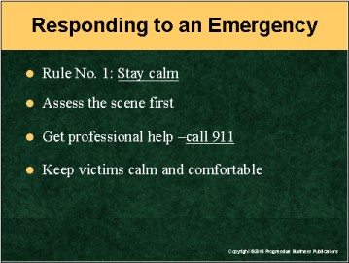

Speaker’s Notes
- Every emergency is different, but there are some general rules you should follow when responding to one. Rule No. 1 – Stay calm. Don’t panic. Stress and emotions can make you take the wrong action.
- Before providing care for an injured person, assess the scene. Make sure that you and the victim are not in any other danger. For example, are there other hazards present, machinery that’s still moving, exposed electrical wires, fire, spills, chemicals, or fumes?
- Once you’ve stabilized the situation, get professional emergency help ASAP. Call 911. If possible, have someone stay with the victim while calling for help. Make sure whoever calls can give accurate info.
- Keep the victim as calm and comfortable as possible until helps arrives.

Suggestion for the Speaker
Find out among trainees who’s trained in first aid and CPR. Make trainees aware of which employees are best equipped to handle medical emergencies.

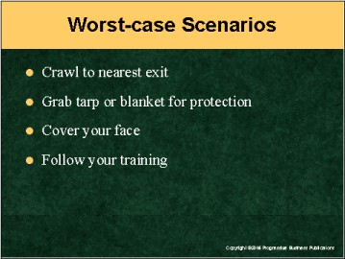

Speaker’s Notes
- What about worst-case scenarios? Emergencies can turn from bad to worse in a heartbeat. If you are in an uncontrolled emergency situation with fires burning and no protection available, crawl to the nearest exit. This will give you the greatest chance of getting out safely by keeping below the intense heat and smoke.
- In a situation such as the building collapsing around you, look for anything that might be able to help you get out safely. Here are some examples:
- Use materials, such as blankets or heavy tarps, to act as a shield
to protect yourself from heat, smoke and fumes while you get to a
safe area.
- An item as small as a wet towel, cloth or handkerchief over your nose could cut down on the intake of toxic smoke. You want to increase your chances of getting out unhurt.
- Under extreme stress like this, it’s important to follow your training and take a posted escape route to the nearest unblocked exit.

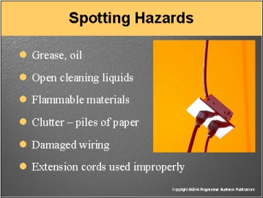

Speaker’s Notes
- Spotting hazards early before they lead to an emergency is everyone’s responsibility. Good housekeeping plays a big part in preventing workplace fires. Work areas should be kept free of:
- Open grease or oil
- Combustible solvents (like cleaning liquids)
- Flammable chemicals, and
- Clutter, like stacks of newspapers, boxes and trash left out in the open,
and so on.
- Keep an eye out for frayed or damaged electrical wiring, as well as extension cords used as permanent cords. Extension cords along the ground can get damaged from foot traffic and lead to exposed wires. They’re only meant for temporary use.
- When you see something that’s not right: Speak up about it. Let your supervisor know or alert Facilities.

Suggestion for the Speaker
Stress that last point about personal responsibility strongly. It dovetails into the next page.

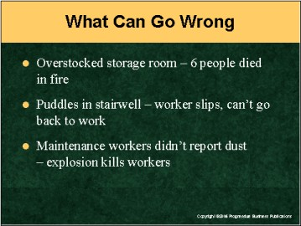

Speaker’s Notes
What can go wrong when people don’t speak up about hazards in the workplace? Think about these real-life stories:
- Company A stuffed boxes and other supplies up to the ceiling of a cluttered storage room. When a light fixture overheated, the supplies caught fire and it spread quickly. Six people died trying to escape the fire.
- Water frequently accumulated in a stairwell at Company B, and that caused slip-and-fall hazards. One day someone slipped and fell on the steps and permanently damaged his shoulder. The company ended up having to pay $150,000 for his medical bills, and the worker couldn’t go back to his original job.
- At Company C, two workers were cleaning ceiling tiles and saw a buildup of dust above the tiles. They didn’t know the dust was explosive. Two weeks later, a spark ignited the dust and the building exploded. Six employees died in the blast, and most of the building burned down.

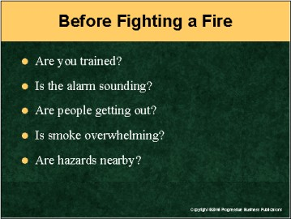

Speaker’s Notes
- Let’s say you spot a small fire in the workplace. Should you immediately grab a fire extinguisher to put it out?
- In most cases, the answer is NO – especially if you’re not trained to use one. There are four safety points you should consider before fighting a fire:
- Make sure that a fire alarm has been sounded. That alerts your local fire department there’s a problem at your facility and gets help on the way. If somebody else isn’t there to sound an alarm, then call the Fire Department. Dial 911.
- Make sure that people are evacuating the building. Even a small fire can grow quickly, and that puts people in danger.
- Watch for smoke. As a fire grows out of control, so does smoke. That can distort your vision and hide the true size of the fire you’re facing. Smoke inhalation can also overcome you and cause unconsciousness.
- Look for hazardous conditions that could cause the fire to spread.
For example: Are there flammable materials nearby? Or electrical equipment? In those cases, if you can’t get the fire out quickly, you could be putting yourself in grave danger.

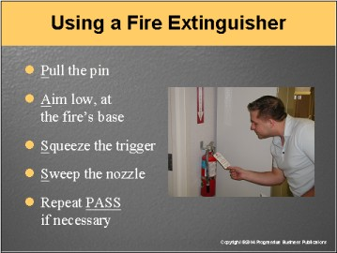

Speaker’s Notes
- Before using a fire extinguisher, ensure there’s at least 8 feet between yourself and the fire so you’ve got room to move away.
- Then follow the PASS System: Pull, Aim, Squeeze and Sweep.
- After removing the extinguisher from the wall, your first step is to PULL the pin. The pin’s located at the top of the extinguisher. The pin keeps the handle from being accidentally pressed.
- Next, AIM low. Point the nozzle at the base or bottom of the fire and SQUEEZE
the trigger.
- Finally, SWEEP the nozzle from side to side at the fire’s base. If the fire goes out and re-ignites, repeat the AIM, SQUEEZE and SWEEP steps.

Suggestion for the Speaker
Get a show of hands from trainees: Who’s been trained to use a fire
extinguisher? Ask them if they have any comments or suggestions regarding
fire extinguisher use.

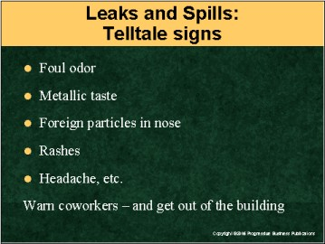

Speaker’s Notes
- Gas leaks, chemical spills and other kinds of accidents can quickly lead to an emergency situation. Some of the telltale signs of a leak or spill are:
- Foul odors
- A metallic taste in your mouth
- Foreign particles in your nose
- Rashes
- Burns
- Watery eyes
- An irritated throat
- A headache, and
- Dizziness.
- If you suspect a hazardous chemical spill or leak, warn your coworkers in the immediate area. Then get out of the building immediately.
- Evacuate outside a safe distance away from the spill or release. Meet at our
check-in location.

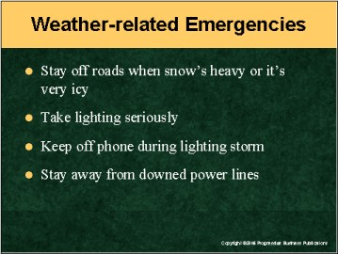

Speaker’s Notes
Let’s talk just a bit about weather-related emergencies. There are some good rules of thumb to follow when Mother Nature hits hard.
- Winter storms make for poor driving conditions. Listen for road warnings before coming to and leaving the building. Wait out a storm if necessary.
- Lightning leads to electrocution deaths and facility fires every year. When lightning starts, get under cover immediately or inside immediately. Also: Stay off the phones. Two years ago a worker sitting at a metal desk got killed by lightning while talking on the phone.
- Storms knock down power lines all the time. Remember: Stay away from a downed line. Don’t walk or drive by a downed line until it has been removed.
- Tornadoes strike suddenly and with power. Go to the lowest floor possible during a tornado. And stay away from windows. Flying glass can kill you.

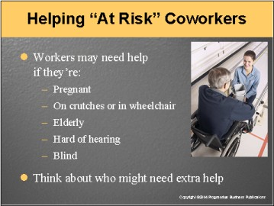

Speaker’s Notes
- In an emergency, certain people may be at a disadvantage and need your assistance. “At risk” coworkers could be:
- Pregnant
- On crutches or in a wheelchair
- Elderly
- Hard of hearing, or
- Partially or fully blind.
- Think about who might need extra assistance in an emergency. Then let your supervisor or Facilities know about it. They can come up with ways to ensure “at risk” people get the help they need.
- If an “at risk” person works in your area, volunteer to be his or her “ally” in emergency situations. We’re all in this together.

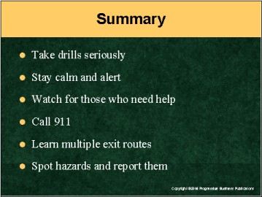

Speaker’s Notes
Let’s wrap up: Workplace emergencies can happen anywhere. Here’s what you must always remember:
- Treat drills seriously. They can save our lives in an emergency.
- Stay calm and alert in an emergency. Stress and panic can lead to tragedy. You also want to keep an eye out for coworkers who may need help.
- Call 911 as quickly as possible.
- Learn multiple routes and exits out of the building. Practice taking them during drills or during a work break.
- Keep an eye out for hazards – that means anything that doesn’t belong in the workplace – and report them immediately.

Suggestion for the Speaker
Ask trainees if they have any other questions or comments. Then thank them for their time.

