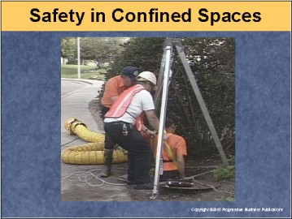

Speaker’s Notes
- Today’s topic is Confined Space Safety. This training is a part of OSHA’s Regulation 29 CFR, Part 1910.146.
- You will learn about:
- The definition of a confined space.
- The dangers associated with confined spaces.
- Your and our responsibilities with confined spaces.
- Ways to prevent confined space incidents.
- Procedures for emergencies in confined spaces.

Suggestions for the Speaker
An effective icebreaker is to ask the trainees the following questions:
- What's a confined space?
- Why do you think it’s important to work safely in confined spaces?
- Has anyone been involved in an accident in a confined space? What
happened, and what happened afterward?

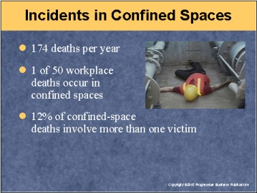

Speaker’s Notes
- Research has shown that on average, 174 workplace deaths are attributed to confined spaces each year – about 2% of all work fatalities.
- Another sobering fact: 12% of workplace deaths in confined spaces involve
multiple victims.
- These figures may actually underestimate the number of deaths due to confined space work, as this type of fatality typically isn't identified on death certificates.
- Still, this data provides sobering evidence that confined spaces can put you at risk of dying, and not necessarily only one of you at a time.
- Pointing out the serious risks presented by confined space work will help emphasize the importance of following safety procedures in these areas.

Suggestion for the Speaker
This may be a good time to mention the story of two workers who died while on the job in a confined space in the Bronx, New York. They were overcome by fumes as they cleaned an oil tank. The company was fined more than $134,000
by OSHA for failing to provide air-testing equipment, not maintaining entry permits, failing to implement confined space entry procedures and other confined space violations.

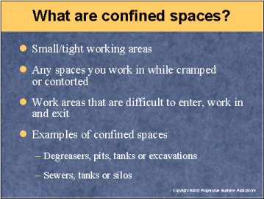

Speaker’s Notes
- Confined spaces are defined by OSHA by their size or dimensions as small or tight working areas.
- But confined spaces also can be defined by the way you work in them: If you're in a cramped or contorted position while working in a certain area, it can be considered a confined space.
- In addition, any work area that you have difficulty entering, doing your job in, and getting out of can be considered a confined space.
- Examples of confined spaces commonly found at many companies include areas in which the natural movement of air is restricted, such as degreasers, pits, some types of tanks and excavations.
- The other common type of confined space are areas with limited openings for entry and exit, such as sewers, tanks and silos.

Suggestion for the Speaker
Now might be a good time to list areas in your facility that have been designated confined spaces.

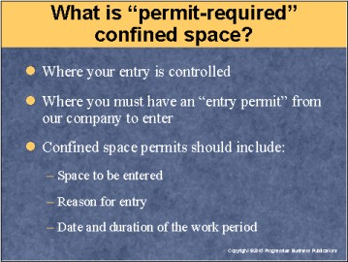

Speaker’s Notes
- OSHA takes confined space safety seriously – so seriously, in fact, that it requires us to control your entry into them.
- We must restrict entry into confined spaces by only allowing workers with entry permits (issued by us) to go in.
- Requiring permits for entry enables us to control who goes into confined spaces. This helps ensure that only those of you trained in confined space safety are allowed to work in these areas.
- In the case of these "permit-only" confined spaces, we must provide permits to designated workers.
- These permits should include:
- The name of the specific area that the employee will work in.
- The exact reason for the entry – namely, the task or tasks the worker's going to perform in the space.
- A detailed listing of the start date and length of the work period.

Suggestion for the Speaker
Now might be a good time to give an example of which workers in your company would be issued permits to enter specific confined spaces at your facility.

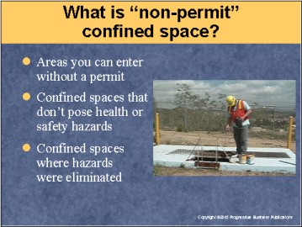

Speaker’s Notes
- Some confined spaces can be reclassified as having "non-permit" status, meaning you don't have to require permits for entry into them.
- Non-permit spaces are:
- Areas that meet the definition of confined space, but don't pose any health or safety risk to workers.
- Confined spaces that used to have hazardous conditions that have since been eliminated.
- While, in theory, anyone can work in a non-permit confined space, that doesn't mean everybody should. Accidents can happen anywhere, so only designated personnel should work in these areas.
- Reclassification as a non-permit confined space can only last as long as the area remains safe. For example, if a threat such as toxic gas can be eliminated for a set period of time but will return, the classification only stands for that period. If the threat returns, the area must go back to permit-required status.

Suggestion for the Speaker
Now might be a good time to discuss if there are any non-permit confined spaces in your facility, and who's allowed to work in them.

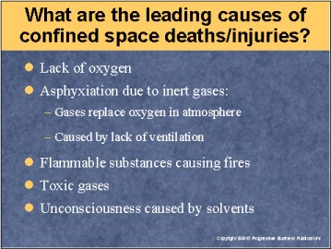

Speaker’s Notes
- Lack of oxygen
- Welding, cutting or brazing can deplete oxygen.
- Bacterial action (such as fermentation) also can deplete oxygen.
- Asphyxiation caused by inert gases
- Inert gases (such as nitrogen) that are non-toxic, colorless and odorless, can displace (reduce and replace) the oxygen in a confined space.
- Other gases that can cause asphyxiation: carbon dioxide, argon and helium.
- Fires started by the space's flammable substances
- Flammable liquids, by-products of chemical reactions, high-oxygen atmospheres or combustible dust can ignite in confined spaces.
- Three components are needed to start a confined space fire: fuel, oxygen and a source
of ignition.
- Toxic gases
- These can be present in confined spaces when they're used in manufacturing, biological or
chemical processes.
- The work done in a confined space (like welding, for example) can actually release toxic gas.
- Unconsciousness due to solvents
- Solvents are often used for degreasing, but their fumes can cause unconsciousness by attacking
the central nervous system.
- Some solvents can be toxic to the heart when inhaled.

Suggestion for the Speaker
This might be a good time to mention the case in which a worker was welding in a tank that contained explosive vapors.
He was killed when the welding caused the vapors to ignite and explode. The company in
Benson, Minnesota, was fined for failing to ensure safe welding operation and implement a
lockout-tagout program.

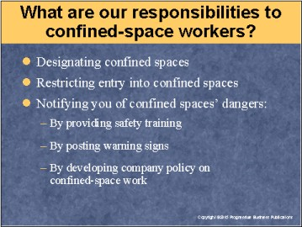

Speaker’s Notes
- Companies are responsible for finding, testing, confirming and designating confined spaces in their facilities.
- After we've designated confined spaces, we must restrict entry into them through permits (if required) and company rules.
- After identifying confined spaces, we must notify you of potential health risks. This can be achieved by:
- Seeing and being seen are very important to safe night driving. So make
sure headlights, taillights, signal lights and windows -- inside and out –
are clean.
- Training you on how to work safely in confined spaces.
- Posting warning signs to make you aware, and remind you, of the
potential hazards.
- Including language in our company policies about the rules for working in
confined spaces.

Suggestions for the Speaker
To illustrate what happens when a company doesn't fulfill its responsibilities to workers in cases of confined spaces, you can talk about a company in Portland, Maine, that was socked with a $122,000 fine after an employee's hand was ripped off when a boiler exploded. The explosion occurred as the worker was placing charges in the boiler as part of a deslagging process.

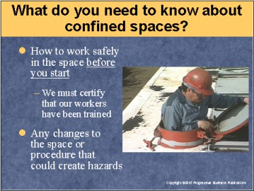

Speaker’s Notes
- OSHA requires us to train each of you assigned to work in confined spaces so you have the knowledge and skills needed to work safely.
- You should be trained in safe confined-space practices before you begin working in these areas. Training shouldn't be held back until after work begins for any reason.
- We're required to certify confined-space workers have received this training. This certification should include:
- The certified employee's name.
- Trainers’ signatures or initials of the trainer(s).
- The dates of training.
- We're also responsible for alerting you of any changes made to the confined area or the working procedures that could create hazards.

Suggestions for the Speaker
It’s probably a good time to ask trainees what kind of changes to confined
spaces they feel they should be made aware of to ensure their safety.

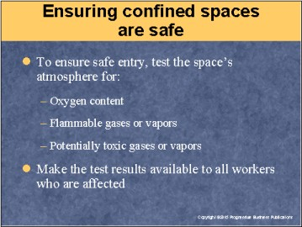

Speaker’s Notes
- How do we test a confined space to make sure it's safe for you to work in? We test to determine if the space:
- Has abnormal oxygen content.
- Has any flammable gases or vapors.
- Has any gases or vapors that could be toxic.
- Results of the testing, showing the potential hazards of our confined spaces, must be made available to all the people who need to enter the space, via posting, e-mail or another means.

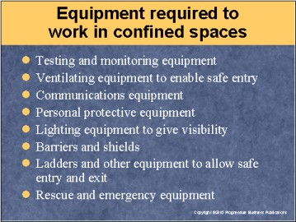

Speaker’s Notes
The following types of equipment are required by OSHA for people working in
confined spaces:
- Testing equipment to make sure the area's safe to enter, as well as monitoring equipment to ensure that conditions are safe for the entire stay in the area.
- Ventilation equipment so you can enter the area safely.
- Communications equipment (walkie-talkie, cell phone or other means) so workers can alert their co-workers or supervisor of any problem, warning sign
or emergency.
- Personal protective equipment such as goggles, gloves or padding to prevent injury due to conditions in the confined space.
- Lighting equipment so you can see well enough to work in the space and, if necessary, exit it in the event of an emergency.
- Barriers and shields (such as railings) to keep people outside the space from accidentally falling into it. These also protect workers inside the space from objects that could accidentally fall in.
- Ladders and other equipment that will enable you to enter and exit the confined
space safely.
- Rescue and emergency equipment, such as ropes or pulleys, so you can be removed quickly from the space if there's an emergency.

Suggestion for the Speaker
It might be an appropriate time to tell the story of the incident that happened at a grain storage company in Tamora, Nebraska. A worker there suffocated when a pile of soybeans collapsed on him while he was in a grain bin. OSHA fined the company $168,000 for failing to make sure workers used harnesses and lifelines while in the bins.

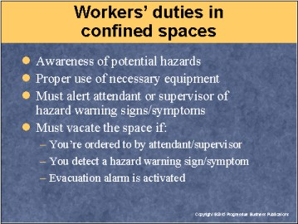

Speaker’s Notes
- OSHA requires workers assigned to confined spaces to be:
- Aware of all the space's potential hazards (gases, fire, falling
objects, etc.) .
- Able to properly use the needed equipment.
- Knowledgeable of what to do if they detect warning signs or symptoms (such as an odor or sparks) of a hazard. Their immediate response should be to alert their attendant or supervisor.
- You must immediately get out of the confined area if:
- You’re ordered to do so by the attendant or supervisor.
- You smell, see or hear a warning sign or symptom of a potential hazard.
- You hear an evacuation alarm.

Suggestions for the Speaker
This may be a good point to tell trainees the story of what can happen if workers don't vacate an area immediately after detecting a warning sign. Instead of evacuating after they saw a reddish-brown cloud of smoke, workers at a chemical plant in Dayton, Ohio, located and tried to seal a leak when an explosion suddenly occurred. Only one person was injured, but 2,000 people had to be evacuated from their homes after concrete and metal were blown 1,000 feet into the area surrounding the facility.

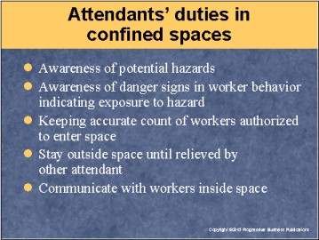

Speaker’s Notes
- An attendant is a supervisor or co-worker who is assigned to monitor your safety as you work in a confined space.
- OSHA requires attendants assigned to monitor confined spaces to:
- Be aware of all the space's potential hazards (gases, fire, falling objects, etc.).
- Know and watch for danger signs in behavior that indicate a worker's been exposed to a hazard (for example, if you're dizzy or act strangely).
- Keep an accurate count of who's authorized to enter the confined space.
- Stay outside the confined space, even in the event of an emergency, until they're relieved by another attendant.
- Maintain communication with workers inside the confined space by
walkie-talkies, cell phones or another means.
- In extreme cases, confined-space incidents could pose a threat to the surrounding community (for example, if toxic gases are released). As necessary, alert police to such potential hazards so people in the area can be evacuated.

Suggestion for the Speaker
You might want to ask trainees what signs of trouble attendants and workers think
they should look out for.

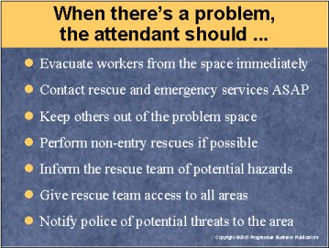

Speaker’s Notes
- If there's a problem in the confined space, attendants are responsible for:
- Evacuating all personnel from the confined space as soon as possible.
- Keeping others from entering the space that the problem's occurring in.
- Immediately contacting rescue and other emergency services as needed.
- Performing any rescue procedures that are possible without entering
the space.
- Giving rescue/emergency workers the background on the potential hazards upon their arrival.
- Giving rescue/emergency team access to all areas, even confined spaces for which permits are required.

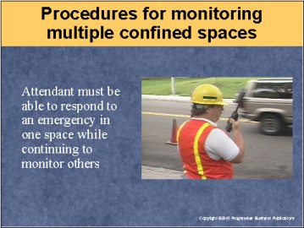

Speaker’s Notes
- Confined-space permit programs must include language on the means and procedures for attendants monitoring more than one space.
- Attendants must be able to take appropriate action if there's an emergency in one area without neglecting their duties to the other areas.
- The program should designate people who could provide assistance to the attendant in the event of an emergency to help them address the situation.

Suggestion for the Speaker
You might want to ask trainees how they'd respond if they had to address an issue in one space while continuing to monitor others.

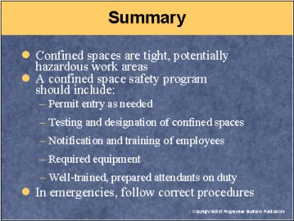

Speaker’s Notes
- It’s important to understand what constitutes a confined space. These are spaces
in which the size, or the position the employee must work in, create the potential
for harm.
- To comply with OSHA requirements, we have established a confined-space safety program that includes:
- Permits that regulate who enters the confined spaces, if needed.
- Testing to see if areas in question are confined spaces, and designating them as such based on the results.
- Notifying you of the designation of a confined space, and training you on how to work safely in the space.
- Distribution of the required safety equipment.
- Trained, knowledgeable attendants who know how to respond to problems or emergencies in the confined space, as well as procedures for monitoring multiple confined spaces.
- It's vital that all employees, in addition to attendants or supervisors, are aware of the correct procedures to follow when emergencies occur in the confined space.

