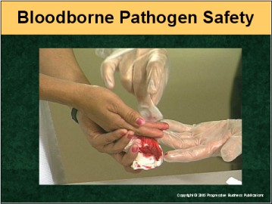

Speaker’s Notes
- Today’s topic is Bloodborne Pathogens. This training is designed to
help you meet the requirements of the Occupational Safety and Health Administration’s (OSHA’s) Bloodborne Pathogen Standard,
29 CFR 1910.1030.
- You’ll learn about:
- Precautions you can take to avoid exposure to bloodborne pathogens.
- How to control transmission of bloodborne pathogens.
- What to do if you’re exposed to bloodborne pathogens.

Suggestion for the Speaker
An effective icebreaker is to ask the trainees the following questions:
- Ask for a show of hands: Has anyone ever worked with a bloodborne pathogen?
- What are some of the reasons people are exposed to bloodborne pathogens?
- How can these types of accidents be avoided?

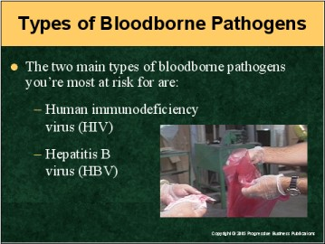

Speaker’s Notes
- Bloodborne pathogens are potentially infectious materials that, when transmitted into someone’s blood, could lead to disease or death.
- OSHA developed its Bloodborne Pathogens standard to prevent incidents in which employees accidentally are exposed to such materials.
- The primary bloodborne pathogens OSHA wants to protect workers from are:
- Human immunodeficiency virus (HIV), the virus that causes Acquired Immune Deficiency Syndrome (AIDS). It attacks the body’s immune system, weakening it so it can’t fight other diseases that cause death. It may take years for AIDS to develop after a person’s infected with HIV. Symptoms of HIV infection include weakness, fever, sore throat, nausea, headaches, diarrhea, white coating on the tongue, weight loss and swollen lymph glands.
- Hepatitis B (HBV), a virus that infects the liver and is primarily transferred through blood-to-blood contact. A common symptom of HBV is inflammation of the liver, but it can lead to potentially deadly conditions like cirrhosis and liver cancer. This virus is very durable and can survive in dried blood for up to seven days. Symptoms of HBV infection include fatigue, stomach pain, loss of appetite, nausea, jaundice and darkened urine. It can take one to nine months for symptoms to appear after HBV exposure.

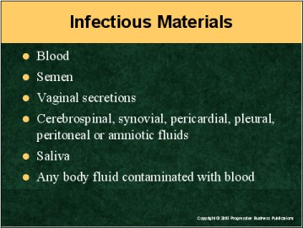

Speaker’s Notes
Bloodborne pathogens like HIV and HBV are most commonly transmitted by contact with infected human blood. But you can be infected by a number of other infectious human body fluids, including:
- Semen
- Vaginal secretions
- Cerebrospinal (brain or spinal cord) fluid
- Synovial (joint lubrication) fluid
- Pericardial (heart) fluid
- Pleural (lung and chest) fluid
- Peritoneal (gastrointestinal) fluid
- Amniotic (fetal) fluid
- Saliva, or
- Any body fluid that could be contaminated with blood.

Suggestion for the Speaker
This might be a good time to give workers an example of how people can be exposed to infectious materials. You could mention the commercial laundry business in Batavia, NY, that was fined over $140,000 by OSHA for exposing employees to bloodborne hazards including blood and feces on soiled laundry, discarded sharp objects and contaminated walking surfaces; and for failing to disinfect these potentially infectious hazards.

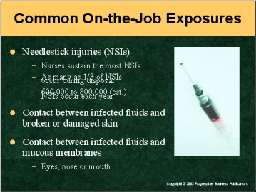

Speaker’s Notes
- The most common type of workplace exposure to bloodborne pathogens occurs when workers’ skin is accidentally punctured by contaminated needles. Broken glass and other sharps also frequently lead to exposure.
- By the nature of their jobs, nurses are most at risk for exposure to bloodborne hazards due to needlestick incidents (NSIs). Research shows that as many as one-third of NSIs happen when needles are disposed of. These aren’t isolated incidents: Between 600,000 and 800,000 NSIs happen each year.
- Another common cause of bloodborne pathogen infection is contact between hazardous fluids and breaks or damage in workers’ skin. Infected fluids can
enter your body through open sores, cuts, abrasions, acne, sunburn or blisters.
- Bloodborne pathogens also could be transmitted through contact between infected fluids and the mucous membranes of the eyes, nose or mouth.

Suggestion for the Speaker
Now might be a good time to explain your policy concerning sharp objects such as needles, and the measures you have in place to prevent accidental punctures. To illustrate the importance of safe use of sharps, you could talk about the hospital in Los Angeles that was cited by OSHA for failing to use devices that had adequate sharp protection. In fact, inspectors determined that the sharps injury protection device the hospital was using actually caused splashing, spraying and spattering of blood.

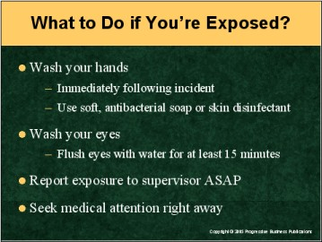

Speaker’s Notes
If you’re exposed to bloodborne infection while on the job, you should:
- Wash your hands
- This should be done immediately following the incident.
- You should use a soft, antibacterial soap or skin disinfectant and
running water.
- If infectious fluid is splashed in an eye or other mucous membrane, flush the affected area with running water for at least 15 minutes.
- Report the exposure to your supervisor as soon as possible (this can include filling out an exposure report form), and
- Seek professional medical attention right away.

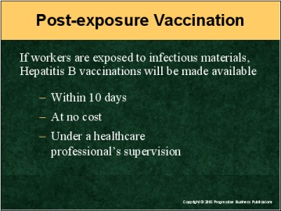

Speaker’s Notes
- OSHA stipulates that immediately following exposure, we make a Hepatitis B vaccination available to the infected worker within 10 days after the incident. This is to be given at no cost to the employee, and must be administered under the supervision of a licensed healthcare professional.
- Although we’re required to offer the vaccine to you, you don’t have to accept it.
If you choose to decline it, you can decide to get the shots anytime during your employment. Even if you decline the offer, we’re still required to offer it in the event of subsequent exposure.
- The Hepatitis B vaccine is given in a series of three shots. The second shot is
given a month after the initial one, and the third shot is administered five months after that.
- The vaccine is made of yeast culture. You can rest assured you won’t be in danger of catching the disease from the shots.
- This is a one-time vaccine. Once it’s been adminstered, you won’t need to have it again. But there are booster shots for it that may be warranted in certain circumstances (for example, if there’s an outbreak of HBV).
- Note: This vaccine has been found to be extremely effective in preventing HBV if administered immediately following exposure to the virus.

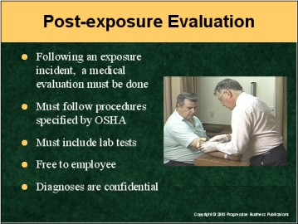

Speaker’s Notes
- Under the OSHA standard, a medical evaluation must also be made available to you immediately following an exposure incident.
- This evaluation must be conducted by healthcare professionals. To perform the evaluation, they must be supplied with information on the incident and the employee’s medical history. Then they can offer their opinion on the necessity of Hepatitis B vaccination.
- Evaluations also can include lab testing conducted by an accredited lab.
- The evaluation and lab tests must be offered at no cost to you.
- All diagnoses resulting from these evaluations remain confidential.

Suggestion for the Speaker
Now might be a good time to ask employees what they’d do immediately following exposure to a bloodborne pathogen. You may want to reiterate all the services (such as medical evaluation, lab testing and vaccination) your company makes available in such instances, all at no cost to them.

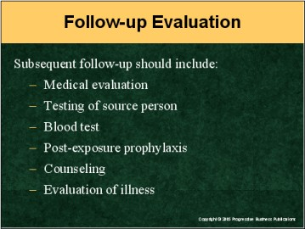

Speaker’s Notes
The company also must make follow-up evaluations available to exposed employees. Such evaluations must include:
- A confidential medical evaluation documenting the circumstances of the exposure
- Identification and testing of the source (infecting) individual, when feasible
- Testing of the exposed worker’s blood if he or she agrees to it
- Post-exposure prophylaxis (prevention of or protective treatment for disease)
- Personal counseling by a trained professional, and
- Evaluation of illnesses resulting from the exposure.

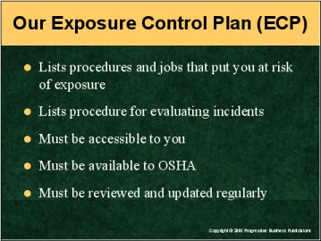

Speaker’s Notes
- All businesses that could possibly expose workers to potentially infectious materials are required by OSHA to have an Exposure Control Plan (ECP)
in place.
- Our ECP identifies tasks and job classifications at your workplace that could put employees at risk of contact with infectious substances. It should also include your full procedure for evaluating exposure incidents.
- Our ECP must be: accessible to workers; made available to OSHA for its approval or reference; and reviewed and, if necessary, updated regularly. OSHA suggests that this be done at least once a year, and possibly more often to accommodate workplace changes (new location, equipment, etc.) when necessary.

Suggestion for the Speaker
Now might be a good time to review your ECP for bloodborne pathogens with your employees. Emphasize how important maintaining an accurate and up-to-date ECP is to your business. To drive this point home, you could mention the ambulance service in Buffalo, NY, that was fined $65,000 by OSHA for, among other violations, failure to review and update the company’s written ECP. The inspection that resulted in this fine was prompted by an employee complaint.
Let your people know you welcome their suggestions for any ways to improve your ECP.

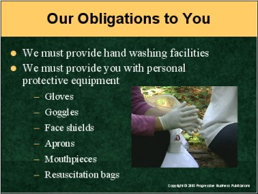

Speaker’s Notes
- In its standard, OSHA stresses handwashing as one of the major precautions you can take to prevent the spread of infectious fluids. So it’s no surprise that we’re required to provide you with handwashing facilities. As your employer, we’re also responsible for making sure you use these facilities following exposure to bloodborne pathogens.
- We also must provide you with, and require you to use personal protective equipment (PPE) such as:
- Gloves
- Gowns
- Masks
- Protective mouthpieces, and
- Resuscitation bags.
- OSHA also requires us to clean, repair and replace this Personal Protective Equipment whenever necessary.
- In addition to specifying handwashing procedures and requiring PPE, the OSHA standard also specifies how we’re supposed to dispose of contaminated sharps, including what types of containers we’re to use for them and other regulated waste.

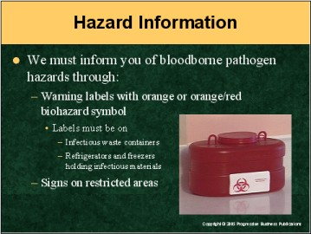

Speaker’s Notes
- OSHA requires us to use warning labels on waste containers, refrigerators,
freezers and other containers used to move blood or other potentially infectious substances. These labels must include the orange or orange/red biohazard symbol to alert you to potential hazards.
- Red bags or containers can also be used in place of the labels.
- There are exceptions to this rule. For instance, blood that’s been tested and found to be free of HIV or HBV and released for clinical use, as well as decontaminated regulated waste, need not be labeled.
- Signs must be used to identify restricted areas where hazardous materials are handled, such as in research labs.

Suggestion for the Speaker
To illustrate the importance of warning employees about bloodborne pathogen hazards, you could mention the teaching hospital in New York City that was fined after residents complained the facility didn’t take sufficient steps to alert them of the dangers inherent in certain procedures.

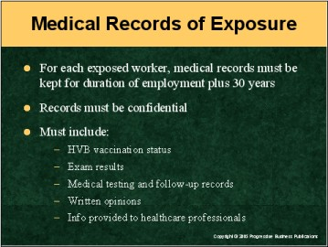

Speaker’s Notes
- Besides stressing precautionary measures to prevent exposure to bloodborne pathogens, OSHA also has established procedures for what to do in the unfortunate event that a worker is infected.
- For each employee who’s exposed to hazardous fluids while on the job, we must keep thorough medical records for 30 years after the incident. These must be kept strictly confidential and include:
- Worker’s name and Social Security number
- Hepatitis B vaccination status (including dates)
- Results of all related exams
- Records of all medical testing and follow-up procedures
- Copies of healthcare professionals’ written opinions, and
- Copies of all information provided to healthcare professionals.

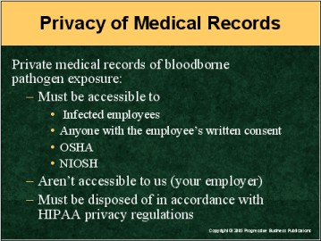

Speaker’s Notes
- There are strict regulations governing who has access to your records if you’re infected with a bloodborne pathogen. In such circumstances:
- You’ll have full access to your records
- Anyone who has your written consent (such as a doctor or attorney) can have access to your records
- OSHA has full access, as does the National Institute for Occupational
Safety and Health (NIOSH).
- Your private medical records aren’t accessible to us (your employer).
- If the records are to be disposed of, it must be done so in accordance with the Health Insurance Portability and Accountability Act (HIPAA) privacy rules.

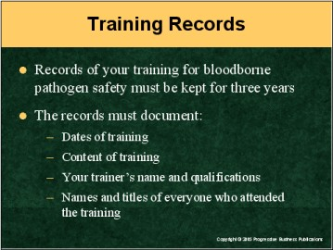

Speaker’s Notes
- As your employer, we’re required to conduct safety training on working with bloodborne pathogens within 90 days of your hiring, or initially upon reassignment, and once a
year thereafter.
- OSHA also requires us to keep good records of this training, for your and
our protection.
- These records are required to document:
- The dates the training was given
- The content of the training provided
- The name and qualifications of your trainer, and
- The names and titles of everyone else who attended the same training.

Suggestion for the Speaker
Now might be a good time to discuss your training program in greater detail. Ask your trainees if there’s anything they specifically want you to cover concerning bloodborne pathogens and their tranmission. To send the message that safety training is a priority to your company, you could talk about the poultry processing plant in Taimo, GA, that was penalized by OSHA for its lack of safety training. You could say that your company would never let this happen, as training its people on how to work safely with bloodborne pathogens is very important to it.

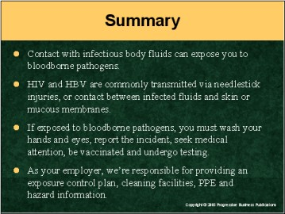

Speaker’s Notes
- On-the-job exposure to infectious body fluids can lead to employees contracting pathogens such as HIV or HBV, leading to illness or death.
- These pathogens are most often transmitted by needlestick punctures. Other common causes of exposure include contact between hazardous fluids and broken or damaged skin, or contact with mucous membranes such as the eye or nose.
- If you’re exposed to hazardous body fluids while working, you must wash your hands and/or eyes as necessary, report the incident to your supervisor, seek immediate medical attention, get HBV vaccination if warranted and undergo testing by healthcare professionals.
- We’re responsible for providing you with an exposure control plan, sanitation facilities, protective personal equipment such as gloves or goggles, and warnings of potential hazards.
- We also must provide medical evaluations and follow-ups, lab tests and related services at no cost to you. You have access to your personal medical information, which is otherwise kept confidential at your discretion.

