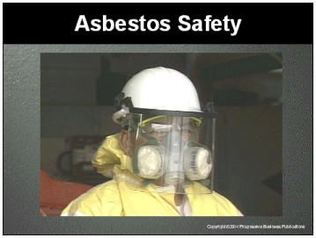

Speaker’s Notes
- Today’s topic is Asbestos Safety. This training is a part of OSHA’s Asbestos Standard
(29 CFR 1910.1001).

- You will learn the:
- About the dangers of asbestos.
- How to identify asbestos.
- How to protect yourself against asbestos.
- The location of the emergency eye wash equipment.

Suggestions for the Speaker
- Hold up a copy of your written Asbestos Safety Program and let the trainees know where it is kept in your facility
- An effective ice breaker is to ask the trainees the following questions:
- Does anyone know if you can see asbestos?
- Has anyone ever knowingly worked with asbestos?
- Does anyone know the risks of working with asbestos?

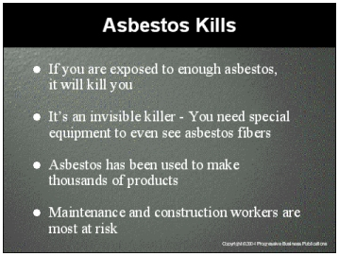

Speaker’s Notes
- Exposure to asbestos causes deadly diseases. Some people will develop a disease very quickly while others may take 30 years to develop a disease after they have been exposed to asbestos. But one thing is certain, if you are exposed to enough asbestos, it will kill you.
- Unlike other substances, you can’t see, smell or taste asbestos. Asbestos fibers are so small that you need special equipment to see them. That is why it is important to be aware of the dangers and take precautions to protect you.
- Asbestos has been used in thousands of products because it is easy to acquire, cheap, strong, does not burn, is a poor conductor of heat and electricity and is resistant to chemical corrosion. Asbestos fibers are virtually indestructible and are probably the best insulator known to man. Because it has so many useful properties, asbestos has been used in over 3,000 different products, including half of all multi-story buildings built in the US between 1950 and 1970.
- The people who are most at risk of asbestos exposure are maintenance and construction workers. They are most likely to come in contact with asbestos when they are cleaning, demolishing or remodeling buildings.

Suggestions for the Speaker
Ask trainees if they know what materials in your facility are likely to contain asbestos. Gather answers like the roof, ceiling, floor tiles and insulating material.

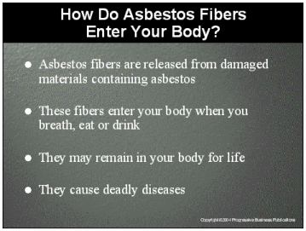

Speaker’s Notes
- If a material containing asbestos becomes damaged, the asbestos will break into very tiny fibers. Some may be 700 times smaller than a human hair. Because of the size of these fibers, they can float in a room for hours or even days.
- Once the asbestos fibers are airborne, it is very easy for them to enter your body when you breath, eat or drink. You will not be able to feel or taste the hazardous particles entering your body.
- The human respiratory system will try to filter the air you breathe. Even with
your natural defenses at work, some of the dangerous particles will attach themselves to the walls of your lungs. Once attached, the asbestos fibers will
be trapped in your body.
- Once asbestos has attached to the walls of your lungs, it may remain for the rest of your life. Because it is so hard to destroy asbestos fibers, scar tissue will begin to form around it, causing many health problems. If enough asbestos accumulates in your lungs, you will develop a deadly disease.

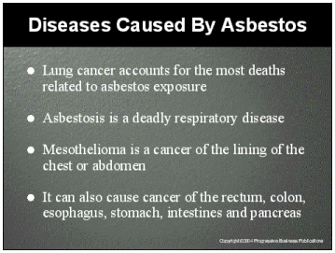

Speaker’s Notes
- Lung Cancer. This disease causes the most deaths related to asbestos exposure. The most common symptoms of lung cancer are coughing, a change in breathing patterns, shortness of breath, persistent chest pains, hoarseness, and anemia.
- Asbestosis. This is a deadly, non-cancerous respiratory disease. Asbestos fibers in your lungs can cause a build-up of scar-like tissue, reducing lung elasticity and limiting your ability to breathe. Symptoms include shortness of breath and a dry crackling sound in the lungs when inhaling. In the later stages of the disease you may experience a heart attack. There is no treatment for asbestosis; the disease is usually disabling or fatal.
- Mesothelioma. This is a rare form of cancer that occurs in the lining of the chest or abdomen. This type of cancer spreads rapidly and is always fatal. All cases of this disease are linked to asbestos exposure.
- Other Cancers. Asbestos has also been linked to cancer of the esophagus, stomach, intestines, rectum, colon and pancreas.

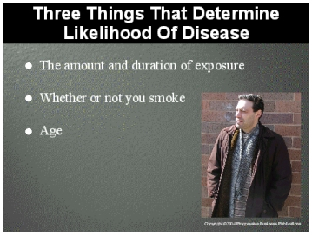

Speaker’s Notes
Research has shown that there are three things that determine your likelihood of developing asbestos-related disease:
1) The amount and duration of exposure. Employees who have been exposed to asbestos more often and for longer periods of time are more likely to develop diseases. This is because your body can’t remove asbestos fibers, which means each exposure increases the amount of asbestos in your body and the likelihood
of developing an asbestos-related disease.
2) Whether or not you smoke. If you are a smoker and you have been exposed to asbestos, you are 90 times more likely to develop lung cancer than someone who does not smoke and who has been exposed to asbestos. If you work with asbestos or have been exposed to it, the first thing you should do to reduce your chances of developing lung cancer is to stop smoking.
3) Age. The younger you are when you inhale asbestos, the more likely you are to develop mesothelioma. There have been cases of mesothelioma that have occurred in the children of asbestos workers whose only exposure was from the dust brought home on the clothing of family members who worked with the asbestos.

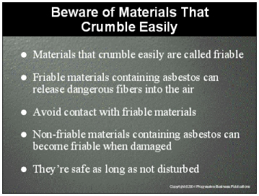

Speaker’s Notes
- Materials containing asbestos are most dangerous when they are in a friable condition, which means that the materials can be easily crumbled by hand. This releases dangerous asbestos fibers into the air. An example of a friable material is asbestos insulation that is sprayed on.
- Try to avoid contact with this type of material since even the slightest contact can cause the material to crumble and release dangerous asbestos fibers into the air.
- Materials that are not friable are usually safe to be around, as long as the asbestos fibers are not disturbed and released into the air. Examples of non-friable materials are asbestos floor tiles, ceiling tiles, cabinet tops, shingles, fire doors, and siding shingles.
- Non-friable materials can crumble when damaged, releasing asbestos into the air. Examples of activities that can damage the materials are water damage, continual vibration and aging. Drilling, grinding, buffing, cutting, sawing or striking can also release asbestos.

Suggestions for the Speaker
- Ask trainees if they know the location of likely friable and non-friable asbestos in your facility.
- Describe an activity in your facility that could damage non-friable asbestos, such as drilling a ceiling tile or cutting the protective canvas covering of
pipe insulation.

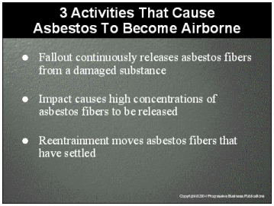

Speaker’s Notes
Asbestos fibers are most dangerous when airborne. Protect yourself by understanding how asbestos becomes airborne and knowing how to avoid airborne fibers. The following three activities can cause asbestos to become airborne:
- Fallout. Over time, products that contain asbestos can deteriorate causing fallout – the release of dangerous asbestos fibers into the air. That puts you at risk of inhaling these fibers. This fallout is continuous and increases as the structure of the material ages.
- Impact. Actions such as cutting or striking materials containing asbestos can cause the release of high concentrations of asbestos fibers. Other activities, such as spraying with adhesives or paints, can also cause fibers to be released. Highly friable forms of asbestos are even more likely to release fibers after impact.
- Reentrainment. When settled fibers are disturbed, they become airborne
– and dangerous. For example, sweeping, dusting and other normal
building activities can cause reentrainment of asbestos fibers. When
released into the air, these fibers will move into other parts of your
building, endangering others.

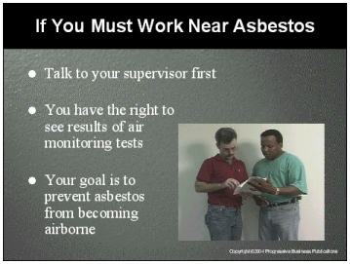

Speaker’s Notes
- If you must enter an area containing asbestos, ask your supervisor if it is safe. It is management’s responsibility to periodically monitor the air for asbestos. The results of these tests should be made available to you.
- If you must work near asbestos, your goal is to prevent asbestos fibers from becoming airborne. Here are some rules of thumb. Do not:
- Saw, sand, scrape or drill holes in asbestos material.
- Use abrasive pads on power strippers to strip wax from asbestos flooring.
- Sand or try to level asbestos flooring or its backing.

Suggestions for the Speaker
- Show examples of test results from air monitoring done in your facility.
- Ask the trainees for examples of activities that should not be performed near asbestos in your facility.

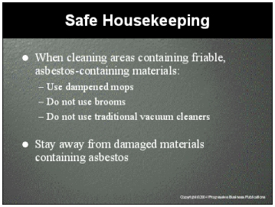

Speaker’s Notes
- When cleaning areas with friable, asbestos-containing materials:
- Use dampened mops and dust cloths. Dampened mops will collect the fibers much better than dry mops, and will reduce the number of fibers put back in the air.
- Do not use a broom. Asbestos fibers could be on the ground and a broom will stir up fibers, placing you at risk of inhaling them.
- Do not use a vacuum cleaner unless it is equipped with a High Efficiency Particulate Absolute filter. The fibers are so small they can pass through an ordinary vacuum cleaner.
- If you find damaged materials that you suspect may contain asbestos, stay away from them and report the situation to your supervisor. You can be certain that asbestos fibers are being released from these damaged materials. Examples of the types of damage you should be looking for are: finger marks, graffiti, pieces missing, scrape marks from equipment or furniture or an accumulation of friable materials on floors or shelves.

Suggestions for the Speaker
- Point out damaged materials that may contain asbestos in your facility.
- Show pictures of damaged materials containing asbestos.

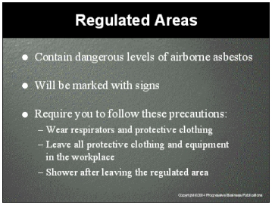

Speaker’s Notes
- Regulated areas have dangerous levels of airborne asbestos and employees should not enter without wearing proper protective equipment. There will be signs identifying these areas with messages such as, “Danger, Cancer and Lung Disease Hazard or Respirators and Protective Clothing Required in this Area.”
- If you must enter a regulated area, management will provide you with protective clothing and a filtered respirator. Dust masks or a disposable respirator will not properly protect you and should not be used.
- After working in a regulated area, do not leave the workplace wearing any of the protective clothing or equipment you wore during the shift. The fibers remaining on your clothing could harm other employees or even your family members.
- There are designated change rooms with showers where your clothing should be removed. You should always shower after leaving a room with dangerous levels of asbestos exposure.

Suggestions for the Speaker
- Let the trainees know the location of all regulated areas in your facility.
- Show examples of respirators and protective equipment used in your facility to protect employees in regulated areas.
- Inform the trainees where the change room is located and let them know what they should do with the protective clothing after wearing it.

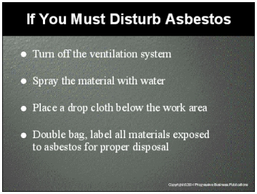

Speaker’s Notes
- Sometimes you may have to perform a task that will damage materials containing asbestos. Before beginning the task, you should put on your protective equipment and make sure the ventilation system has been shut off. This will stop asbestos fibers from being distributed throughout the facility.
- Before beginning work, the material containing asbestos should be sprayed with water. Wet asbestos will not release as many fibers. Wait 15 to 20 minutes after wetting to let the water penetrate thoroughly.
- Place a drop cloth below the work area. After the job, clean all ladders and tools used with a wet cloth. Roll up the drop cloth and clean the floor below the work area with a wet mop.
- It is best to use mops with disposable heads and to throw them away while still wet. Asbestos fibers will release as mop heads dry.
- Double bag all materials that may contain asbestos fibers such as the drop cloth, mop heads and cloths used to clean ladders and tools. After sealing the bags, label them as hazardous and dispose of them through proper hazardous waste haulers.

Suggestions for the Speaker
- Show examples of the bags, seals and labels used to dispose of asbestos and let the trainees know where they can be found.
- Let the trainees know your policies on disposing asbestos.

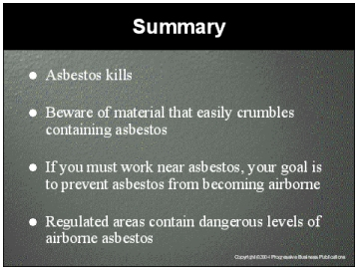

Speaker’s Notes
- If you are exposed to enough asbestos, it will kill you. Unlike other dangerous substances, you can’t see, smell or taste asbestos. Asbestos fibers are so small that you need special equipment to see them.
- Materials containing asbestos are most dangerous when they are in a friable condition, which means that the materials can be easily crumbled by hand, releasing dangerous asbestos fibers into the air. Try to avoid contact with this type of material since even the slightest contact can cause the material to crumble and release dangerous asbestos fibers into the air.
- If you must work near asbestos, your goal is to prevent the asbestos fibers from becoming airborne. Here are some rules of thumb. Do not:
- Saw, sand, scrape or drill holes in asbestos material.
- Use abrasive pads on power strippers to strip wax from asbestos flooring.
- Sand or try to level asbestos flooring or its backing.
- When cleaning in areas with friable, asbestos-containing materials:
- Use dampened mops and dust cloths.
- Do not use a broom.
- Only use High Efficiency Particulate Air vacuum cleaners.
- Regulated areas have dangerous levels of airborne asbestos and should not be entered without proper protective equipment. There will be signs identifying these areas with messages such as, “Danger, Cancer and Lung Disease Hazard, or Respirators and Protective Clothing Required in This Area.”

