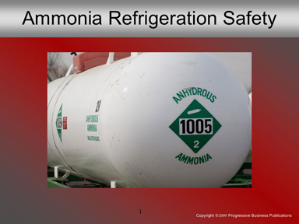

Speaker’s Notes
- Today’s topic is Ammonia/Refrigeration Systems Safety. This training is required by OSHA’s General Industry Standard (29 CFR 1910), also known as the General Duty Clause.
- Today you’ll learn about:
    - Health hazards associated with ammonia contact.
    - Compliance issues with refrigeration systems.
    - Maintenance keys for preventing leaks.
    - Detecting leaks.
    - Emergency response basics.

Suggestions for the Speaker
To kick off the conversation, ask trainees about their experiences with ammonia and refrigeration systems. Also ask them what are the common problems they worry about.

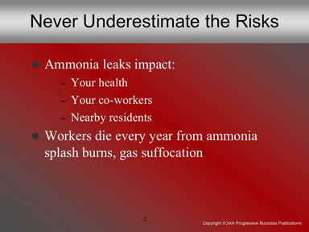

Speaker’s Notes
- Ammonia leaks can impact:
    - Your health
    - Your co-workers, and
    - Residents who live near our workplace.
- Accidents happen all the time. Recently workers were draining refrigerant oil from collection traps on an anhydrous ammonia refrigeration system. They used hand tools to open the valves and drain the oil when ammonia escaped. Two employees died before they reached the emergency room.
- Another example: A worker was disconnecting a line from an ammonia valve. He didn’t isolate the line first. Liquid ammonia splashed all over his face and body. He died a painful death.
- OSHA inspected and fined both these companies. We don’t want to be in their shoes – ever.

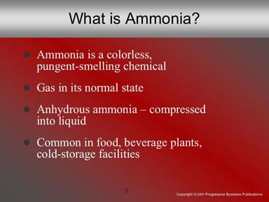

Speaker’s Notes
- Let’s start with the basics. Ammonia is a colorless, pungent-smelling chemical that can harm or kill you.
- In its normal state, ammonia is a gas, commonly known as anhydrous (Latin for “without water”) ammonia. Ammonia can also be compressed into a liquid. Overexposure to ammonia gas can suffocate and kill you. Exposure to liquid ammonia will burn and potentially kill you too.
- Ammonia is used primarily in refrigeration systems. The industries most at risk are:
    - Meat, poultry and fish processing plants
    - Dairy and ice cream facilities
    - Cold storage warehouses
    - Wineries and breweries
    - Soft drink and fruit drink processing plants
    - Petrochemical facilities, and
    - Other food processing buildings.

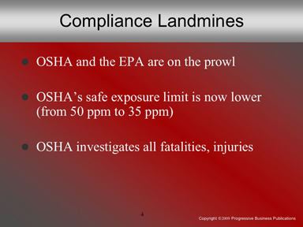

Speaker’s Notes
- Every company has compliance issues to worry about. With ammonia refrigeration systems, companies like ours face the dreaded double-whammy: OSHA and the EPA!
- OSHA’s standard for safe exposure to ammonia was 50 parts per million (ppm) over an
eight-hour workday. That was until the courts ruled it didn’t go far enough. Now the standard is 35 ppm. Companies that don’t reduce ammonia exposure put their workers’ health at risk.
- State EPA offices investigate ammonia leaks and fine companies for compliance problems. OSHA will come out and investigate an ammonia leak only when one or more people get hurt or killed.

Suggestions for the Speaker
Ask trainees about their safety training. Did training cover all the bases for them? Did they learn valuable lessons after training? Which safety lessons would they can share with less experienced co-workers?

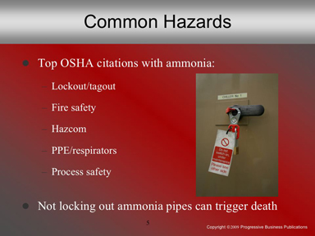

Speaker’s Notes
- Typically OSHA will fine companies for problems with:
    - Lockout/tagout
    - Fire safety
    - Hazard communication
    - PPE (personal protective equipment)
    - Process safety, and
    - Respiratory protection (specifically respirators).
- Lockout/tagout – controlling hazardous energy, such as leaks – is the No. 1 OSHA citation for manufacturing. More often than not, lockout/tagout deficiencies trigger ammonia-related deaths. Case in point:
    - Two workers at the Oscar Meyer plant in Madison, Wisconsin, were repairing a refrigeration pipe. Nobody locked out the pipe, so ammonia was still flowing. Nearly
400 pounds of liquid ammonia sprayed both.
    - One worker was seriously injured. His partner, Tim Hubacher, died at age 44. OSHA fined the company $211,000. The lawsuits from both workers’ families will dwarf that number.

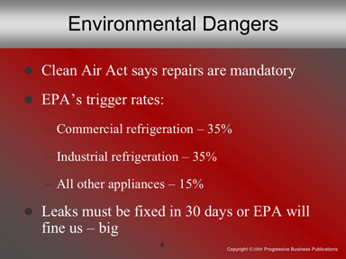

Speaker’s Notes
- Safety compliance is key. But environmental compliance can’t be overlooked either. Section 608 of the Clean Air Act mandates companies repair refrigerant leaks, such as ammonia.
- The Clean Air Act also says: “When an owner or operator of an appliance that normally contains a refrigerant charge more than 50 pounds discovers that refrigerant is leaking [above] the applicable trigger rate during a 12-month period, the owner or operator must take corrective action.”
- The trigger rates are:
  - Commercial refrigeration: 35%
  - Industrial refrigeration: 35%
  - All other appliances: 15%
- Companies must repair detected leaks within 30 days from the day they’re discovered. The EPA can fine companies $32,500 per day when they don’t meet the deadline.

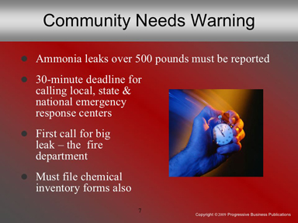

Speaker’s Notes
- The EPA also nails companies for emergency response non-compliance. The Environmental Planning and Community Right-to-Know Act says we must report any ammonia release over 500 pounds within 30 minutes of the leak’s detection! That means calling the National Response Center, our state’s emergency response center, and local officials. We must call even if we bring the leak under control within a half hour. Calling our local responder, namely the fire department, should always be the first step.
- We also must file emergency and hazardous chemical inventory forms with our state and local agencies. The fire department, for example, can’t respond to an emergency here if they don’t know about our ammonia use.

Suggestions for the Speaker
Share this story: House of Flavors, an ice cream maker in Luddington, MI, had a 600-pound ammonia leak recently. Amid all the hubbub, the company didn’t call national, state and local emergency responders within 30 minutes. The EPA fined the company nearly $19,000 (http://snipurl.com/icecream351).

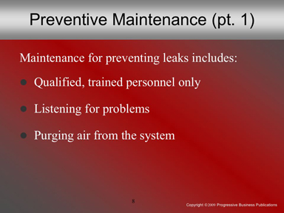

Speaker’s Notes
- Now let’s ask an important question: What’s the No. 1 key for spotting and preventing ammonia leaks? [wait for answers]
- The answer: Preventive maintenance! You can’t wait for problems to develop, not with a toxic chemical like ammonia. Let’s go over some maintenance “best practices”:
- Only qualified, experienced, trained in-house engineers or contractors should redesign a refrigeration system. Periodic inspections by a qualified refrigeration expert are a must too.
- The system should run quietly and efficiently. Loud noises and pipe movement are signs that pressure is building up. Don’t just trust your eyes when inspecting the system – perk up your ears too.
- Prevent high pressure in the lines by purging air out of the system. Follow all lockout/tagout procedures first.

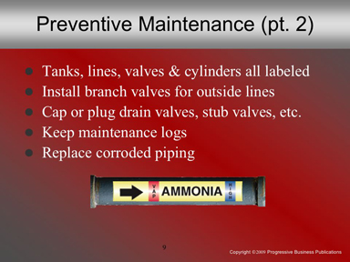

Speaker’s Notes
- Periodically check that all ammonia tanks, lines, valves and cylinders are clearly labeled. Labels can become unreadable over time. Every worker who comes in contact with our system must know the risks.
- Locate ammonia piping outside the building (on the roof, for example) and install branch valves to isolate parts of the system if something goes wrong.
- Cap or plug drain valves, stub valves for future loads, service valves used during repairs or maintenance, and valves that isolate unused parts of the refrigeration system.
- Keep maintenance logs. That way you can check when oil is added to a compressor, for example. Oil buildups can lead to system failure.
- Replace badly corroded piping. Missing or inadequate insulation usually causes corrosion, especially in areas where piping is exposed to the elements.

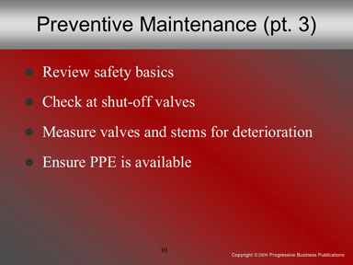

Speaker’s Notes
- Review safety know-how with system operators. Operators should understand:
  - Refrigeration cycles and pressure and temperature characteristics
of ammonia
  - Basic control operation, control wiring and relay logic
  - Safety procedures, including working in pairs and using PPE, and
  - What safety interlocks and safety controls are involved.
- Hydrostatic relief valves should be installed in each section of piping between shut-off valves. This relieves pressure that can trap ammonia.
- Note deteriorating valves and stems. Measure them against manufacturer specifications. For example: Stems can deteriorate in size over time.
- Ensure that PPE is easily accessible. Respirators, protective clothing, face shields and goggles fit the bill.

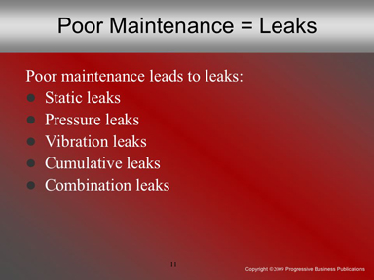

Speaker’s Notes
- What happens when we don’t stay on top of preventive maintenance? [wait for answer] Leaks happen!
- Sometimes the design is off. But more often than not, poor maintenance causes leaks. Joints are brazed wrong. Connections aren’t flared properly. They’re accidents waiting to happen. Let’s go over the kinds of leaks:
  - Static leaks are the most common. Low humidity (below 30%) can lead to system malfunctions.
  - Pressure leaks: These don’t appear until pressure builds in the
system. Trapped air and liquid ammonia left unchecked will lead
to major problems.
  - Vibration leaks: Unit rotation, valve actuation and refrigerant flow show up while the system’s running.
  - Cumulative leaks are small, individual leaks that aren’t detected with standard tools.
  - Combination leaks: More than one cause, such as vibration combined with high temperature.

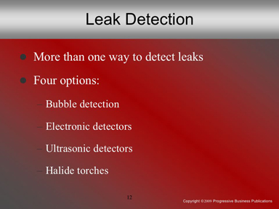

Speaker’s Notes
Just like there are multiple kinds of refrigerant leaks, there are multiple methods for detecting leaks. Let’s go over them briefly:
- Bubble detection means applying liquid soap where leaks are suspected. If ammonia is leaking, soapy bubbles will form.
- Electronic detectors: These are sensors that detect gases from leaking ammonia and other kinds of refrigerants. The detectors then sound an alarm.
- Ultrasonic detectors: Believe it or not, leaking ammonia makes a sound! We can’t hear it, but ultra-sensitive detectors can pick up the high-pitched sound of leaks and set off an alarm.
- Halide torches turn green when they come in contact with refrigerants like ammonia. Hydrochlorofluorocarbons (HCFCs) and chlorofluorocarbons (CFCs) change the color of the torch’s flame.

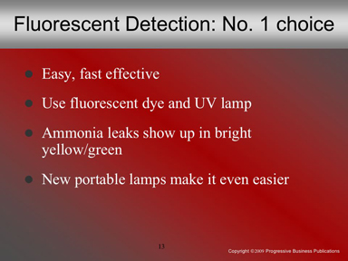

Speaker’s Notes
- The easiest and fastest way to spot leaks? Fluorescent leak detection.
- First you inject fluorescent dye into the system and let it circulate for a few minutes. Then using an ultraviolet lamp, you can quickly spot leaks in the lines, at valve points, and so on.
- All fluorescent dye should be inside the system, not outside! The UV light will make the dye glow bright green and yellow.
- UV leak detection has quickly become the most popular method. It’s cheap, and effective. Newer portable UV lights prevent electrical cords from becoming snagged on the refrigeration system. So now UV testing is even easier than before.

Suggestions for the Speaker
Discuss which method your company uses for spotting leaks and its effectiveness with trainees.

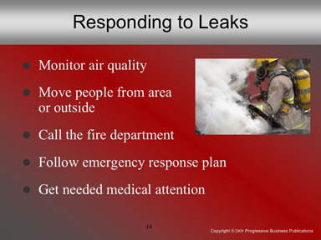

Speaker’s Notes
- Let’s say we’ve detected a leak. What next?
- The first step is air monitoring. If ammonia is at or above 25 ppm, everyone in the area must leave. Only employees wearing supplied-air respirators who are working on the system and taking air samples should remain in the area. Subsequent air tests should be done every five minutes.
- For larger leaks, we must contact the fire department immediately. All employees should exit the building. Only employees wearing appropriate PPE should re-enter the area, until air monitoring shows ammonia has dropped below 25 ppm.
- Our emergency response team must also contact our state’s and the national emergency response center for a large leak, 500 pounds or higher.
- Anyone who’s breathed in ammonia gas needs immediate medical attention.

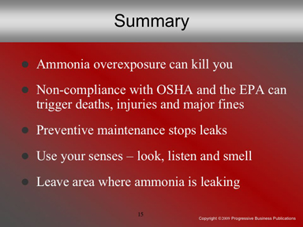

Speaker’s Notes
- Now let’s wrap up our discussion. Ammonia is a colorless, pungent-smelling chemical that can kill you.
- OSHA and the EPA have strict requirements for ammonia refrigeration systems. Non-compliance, injuries, fatalities, major leaks and failing to contact emergency response centers lead to large fines.
- Preventive maintenance is critical for preventing leaks and accidents. Look for corroded or deteriorated valves, stems, etc. See that all lines, valves, etc. are properly labeled. Listen for unusual sounds or excessive noise from the system. Smell ammonia? Report it immediately.
- Only trained workers wearing appropriate PPE should remain in an area where ammonia is leaking. Anyone else must leave immediately.

Suggestions for the Speaker
- Ask trainees if they have any questions or would like to share an observation about ammonia.
- Then thank them for their time.

