This written notice and signoff acknowledgement must be retained in each driver’s personnel file indicating full understanding of the MVR criteria and their respective consequences.

MINOR OFFENSES:

- Within any 12 consecutive month period:

  - 1st Offense – Written warning and counseling
  - 2nd Offense – Three-day suspension from work without pay
  - 3rd Offense – Termination or removal from position requiring driving 

- Within any 24 consecutive month period:

  - 2nd Offense – Written warning and counseling
  - 3rd Offense – One week suspension without pay
  - 4th Offense – Termination or removal from position requiring driving 

MAJOR OFFENSES:

- Major Offenses are defined below and carry a consequence per the following: 
  - Any felony conviction in which a vehicle is used – Termination
  - failure to stop, report, or comply with state statutes when involved in an accident – Suspension Without Pay or Termination
  - Any display or evidence of reckless driving, excessive speeding, endangerment of others, etc.) – Suspension Without Pay or Termination

- D.U.I. (driving under the influence), D.W.I. (driving while intoxicated) or O.U.I. (operation under the influence or Major Offenses as defined above. 
  - 1st Offense – Suspension or termination

PREVENTABLE ACCIDENTS:

As defined by the National Safety Council regarding what actions the driver took to do “everything reasonable to avoid the accident, etc.” A formal review by management and the employee’s supervisor will convene to evaluate the circumstances of the crash.

- Within 36 months:

  - 1st accident – Evaluation and counseling
  - 2nd accident – Written warning, remedial driver training 
  - 3rd accident – Termination or removal from position requiring driving

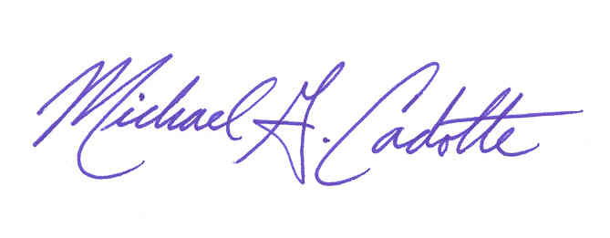
I acknowledge and fully understand the consequences of my driving performance as evident by my accident and/or violation history.

(Driver’s Signature) (Director of Safety)

Omni Facility Services
(Date)

