- Seat belts must be used by driver and all passengers.

- Properly installed child safety seats or booster seats must be used for all children under 80 lbs.

Note: Children or passengers not employed by Omni, or conducting business with Omni are not authorized to drive or ride in company vehicles unless expressly authorized by management.

- Never leave the keys in the vehicle. Never leave materials or inventory in plain view where they will be susceptible to theft or damage. Drivers are responsible for the security of vehicles and cargo.

- Lock an unattended vehicle. Spare keys are to be kept in the office or at your home.

- Observe posted speed limits and rules of the road.

- Maintain company vehicles in accordance with our company policy and specifications. You will be responsible for damage to company vehicles resulting from reckless or abusive handling or operation.

- Be courteous to other drivers and pedestrians. Observation reports may be utilized to identify your driving habits and will be used in your evaluation.

- Do not use controlled substances or alcohol prior to or when operating a motor vehicle. Be aware of possible adverse effects of prescription drugs.

- Only the assigned driver or other company personnel engaged in the course of their employment are permitted to drive company vehicles.

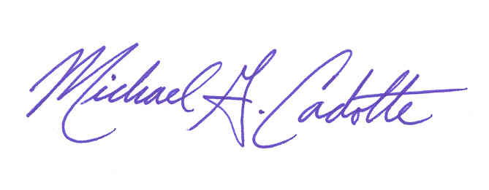

(Driver’s Signature) (Director of Safety)

(Company Name) (Date)

