EMPLOYEE DIRECT DEPOSIT AUTHORIZATION FORM

To enroll or cancel Direct Deposit, complete this form & attach ONE of the following for EACH new account set-up
(This additional documentation will help ensure correct set-up of each direct deposit account requested)

- Voided check (no deposit slips) for checking accounts only
- A letter from your Financial Institution or Bank specification sheet that includes:
  - Routing/Transit/ABA number and Account number.
    - This is not always the same as the numbers on deposit slips.

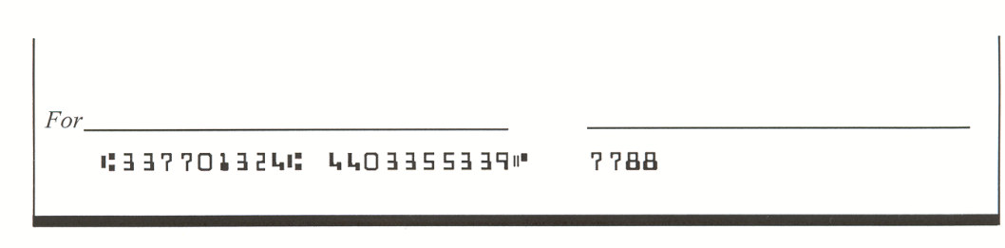
Below is a sample check MICR line, detailing the required information that must be included with this completed form.

Check #
(This number matches the number in the upper right corner of the check – not needed for sign-up
Routing/Transit #
(A 9-dight number)

Checking Account #

IMPORTANT! Please read and sign before completing and submitting.
I hereby authorize ADP to deposit any amounts owed me, as instructed by my employer, by initiating credit entries to my account at the Financial Institution indicated on this form. Further, I authorize the Financial Institution to accept and to credit any credit entries indicated by ADP to my account. In the event that ADP deposits funds erroneously into my account, I authorize ADP to debit my account for an amount not to exceed the original amount of the erroneous credit.

This authorization is to remain in full force and effect until GDI Omni Inc. has received written notice from me of its termination.

Employee Name: Social Security #

Employee Signature: Date:

Account Information: Direct Deposit must be for 100% of your net pay, which may be distributed to multiple accounts.
- Please indicate the account type and amount to be deposited, if less than your total net paycheck.
- For additional accounts, please complete another form.

- Financial Institution Name/City State:

ADD/NEW ACCOUNT Checking (pay card) Savings

CANCEL/ STOP ACCOUNT I wish to deposit $ or Entire Net Amount

- Financial Institution Name/City State:

ADD/NEW ACCOUNT Checking (pay card) Savings

CANCEL/ STOP ACCOUNT I wish to deposit $ or Entire Net Amount

- Financial Institution Name/City State:

ADD/NEW ACCOUNT Checking (pay card) Savings

CANCEL/ STOP ACCOUNT I wish to deposit $ or Entire Net Amount

